Graphical Methods
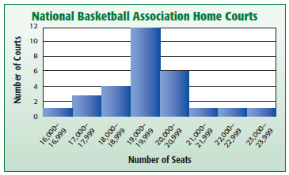
- What interval represents the most number of courts?

- How many courts have less than 20,000 seats?

- How many courts have between 17,000 and 19,000 seats?

- How many courts have at most 20,000 seats?

- How many courts have at least 21,000 seats?

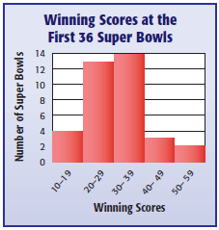
- How big is each interval?

- What is the percentage of winning super bowl
games is interval 10-19.

- How many winning teams score less than 30
points.

______________________________________________________________________________

37-41
1-5
20-25
12-16

- Identify the interval above that is not equal to the other three. EXPLAIN answer choice.

