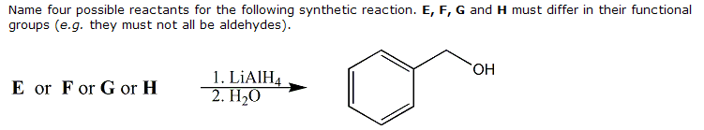

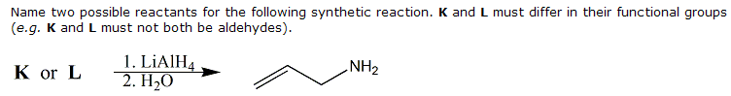

NOTE: MECHANISM NOT NEEDED

