Here are the instructions as well as (Help and Explanations) examples. Please follow each of the instructions (a through d 100%)
(a). Develop a Research Question: In your area of interest, think about a research question that could be answered using a hypothesis test. Write down this research question, and explain what your research is trying to investigate. HINT: Try to come up with a question that compares two means or groups. For example, you might hypothesize that walking reduces cholesterol. Next, you might get a sample of people and have them walk. You would then calculate your sample group’s mean cholesterol and compare this sample mean with the overall population mean of cholesterol levels. Your goal would be to show that your sample mean cholesterol in the walkers group is significantly less than the overall population cholesterol mean. The key here is to create a hypothesis that can be tested!
Write your hypothesis here:
What are the two means you are comparing?
(b). State the Hypotheses: Using your research question, create a two-tailed hypothesis test and state your null hypothesis and alternative (research) hypothesis. Be sure to use Ho and Ha.
Rewrite your hypothesis here
Write your Ho or null hypothesis here
Write your Ha or alternative hypothesis here
Indicate whether your hypothesis test is one-tailed or two-tailed.
Explain if your hypothesis is one-tailed or two –tailed and why
(c). Determine the Conclusion: Provide a conclusion about your research hypothesis, assuming that you reject the null hypothesis.
(d). The Rejection Region: Suppose you run a two-tailed hypothesis test to examine your research question. Give a possible p-value, as well as a possible critical value, that would justify your decision to reject the null hypothesis. Assume that you choose to reject the null hypothesis as too unlikely if the results of your research occur less than 5% of the time when the null hypothesis is actually true. Please explain your choices. (Note: there are many possible correct answers).
Is the hypothesis test one-tailed or two-tailed?
Using alpha = .05, the rejection region or regions (is) are

What value of z can be used to reject the null hypothesis in this case?

Help and Explanations
My research question might be to investigate whether hospital ambulances arrive within their expected time frame of 15 minutes. Therefore, my null hypothesis would be that the response time is equal to 15 minutes. Note: the null ALWAYS includes the equality. My alternative or research hypothesis would be the opposite of my null, and would investigate whether ambulances do arrive in significantly less than or more than15 minutes, as expected.
Ho: mean Hospital Ambulances response times = 15 minutes
Ha: mean Hospital Ambulances response times ≠ 15 minutes
This is a two--tailed hypothesis test because my alternative “Ha” research hypothesis is looking at ambulance-times that are not equal to (significantly different from) 15 minutes.
Next, suppose I choose to run a special type of hypothesis test, using SPSS, called a single sample t-test. Suppose my sample size is 15 ambulance times.
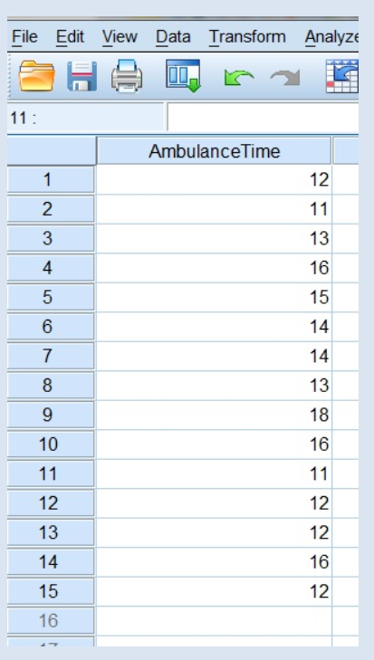

If I reject the null hypothesis, I can suspect that ambulances might be taking either more or less than 15 minutes to arrive. Using the actual sample mean, I can then determine whether ambulances, on average, might be taking longer than 15 min or less than 15 minutes to arrive. This result might lead me to feel confident about the response times of ambulances, assuming that my sample mean is less than 15 minutes.
If I reject the null hypothesis, this means that the p-value (called Sig.(2-tailed) in SPSS) was less than my alpha value of .05. This also means that my hypothesis test (t-test) result was inside of a rejection region.
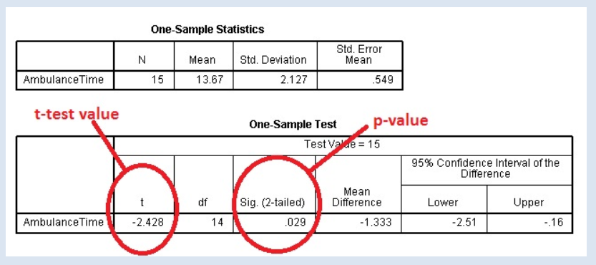
Here, you can see that my sample mean is 13.67. We can also see that the t-test value is -2.428 and the p-value (called Sig (2-tailed)) is .029.
My t-test value is in the rejection region and is less than the critical value cut-off.
How do I know where the rejection region is?
I have to look it up on a t-table. This is the same idea as the z-table discussed in Chapter 3.
To look up the cut-off value (critical value) for the rejection regions of a two tailed t –test, I need a few things.
1) I need an alpha value, which is commonly .05. An alpha value of .05 (5%) means that I will reject the null hypothesis as too unlikely if the results of my research occur less than 5% of the time when the null hypothesis is actually true.
2) I need the degrees of freedom df, which is 14 in this case. The degrees of freedom can be calculated by hand by finding the sample size n – 1.
3) I need a t-table which is in the Appendix of your book and in Doc Sharing.
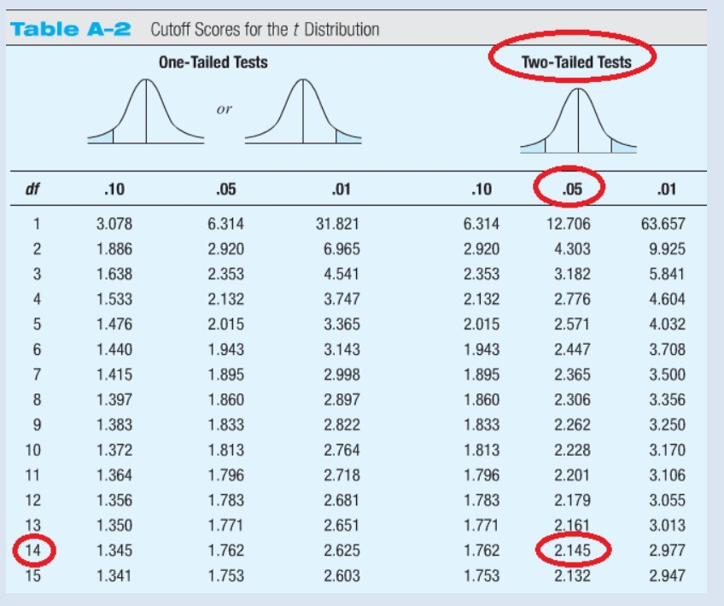
Now, using the t-table and alpha is .05, and df is 14, I find that the cutoff value is 2.145 and -2.145. Because my t-test value is in the rejection region, I can reject Ho.
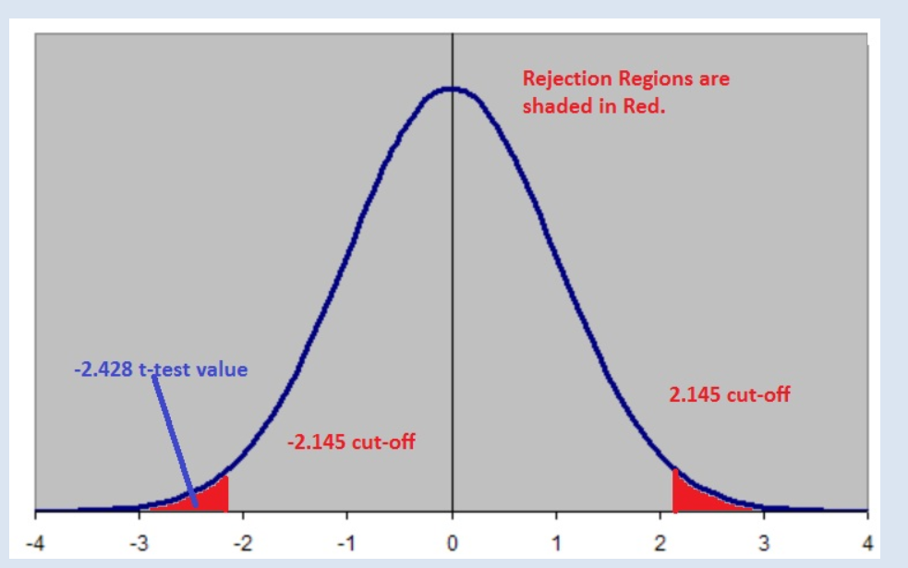
In addition, I can also use the p-value to make this same determination. My p-value here is .029. Because .029 < alpha of .05, I can reject the null hypothesis Ho. The p-value is calculated during the t-test hypothesis test and is always calculated by SPSS. Therefore, both the p-value and the hypothesis test t-test value results will always lead to the same conclusion. You can use either to make your decision about whether to reject your null hypothesis!

