Page 1 Front Page  Page 2 Stocks & Bonds  Page 3 Financial Summary Page 4 Production Analysis | Page 5 Thrift Segment Analysis  Page 6 Core Segment Analysis  Page 7 Nano Segment Analysis Page 8 Elite Segment Analysis | Page 9 Market Share Page 10 Perceptual Map Page 11 HR/TQM Report

Annual Report Andrews | Annual Report Baldwin | Annual Report Chester | Annual Report Digby

PRINT

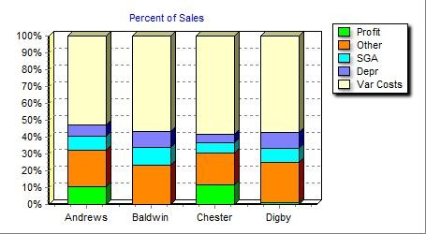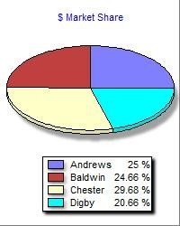

Top
EsEfcreoton
Efren Escoto
Efren Escoto
"  Round: 3  Dec. 31, 2016 |  |  | Student:
Andrews | Baldwin |  | Chester
Digby
Selected Financial Statistics
 | Andrews | Baldwin | Chester |  | Digby
ROS | 11.4% | 0.1% | 12.7% |  | 1.1%
Asset Turnover | 1.07 | 0.73 | 1.25 |  | 0.70
ROA | 12.2% | 0.1% | 15.8% |  | 0.8%
Leverage (Assets/Equity) | 1.6 | 2.4 | 1.7 |  | 2.6
ROE | 18.9% | 0.2% | 27.1% |  | 2.0%
Emergency Loan | $0 | $0 | $0 |  | $0
Sales | $175,632,153 | $173,267,527 | $208,540,626 |  | $145,174,072
EBIT | $37,162,468 | $16,687,922 | $48,328,275 |  | $17,513,532
Profits | $20,010,181 | $174,269 | $26,388,967 |  | $1,614,471
Cumulative Profit | $34,336,393 | $4,703,625 | $55,581,059 |  | $4,975,742
SG&A / Sales | 9.2% | 12.3% | 6.5% |  | 9.2%
Contrib. Margin % | 43.1% | 36.7% | 38.0% |  | 36.2%
COMP-XM® INQUIRER | Page 1

Stocks & Bonds
Top

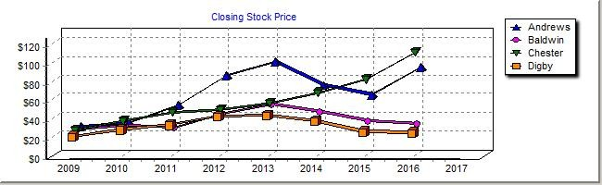Round: 3
December 31 , 2016

Stock Market Summary
Efren Escoto

Company | Close | Change | Shares | MarketCap ($M) | Book Value | EPS | Dividend | Yield | P/E
Andrews | $90.17 | $29.73 | 2,050,942 | $185 | $51.56 | $9.76 | $0.00 | 0.0% | 9.2
Baldwin | $31.64 | ($2.69) | 3,210,804 | $102 | $30.89 | $0.05 | $0.00 | 0.0% | 572.5
Chester | $109.99 | $29.48 | 1,896,197 | $209 | $51.36 | $13.92 | $0.00 | 0.0% | 7.9
Digby | $25.88 | ($0.83) | 3,207,515 | $83 | $25.22 | $0.50 | $0.00 | 0.0% | 51.3

 |  | Bond Market Summary
Company | Series# | Face | Yield | Close$ | S&P
Andrews | 11.2S2020 | $8,837,000 | 11.2% | 100.00 | A
 | 11.9S2021 | $7,072,000 | 11.6% | 102.57 | A
 | 10.9S2024 | $12,000,000 | 11.1% | 98.47 | A
 | 11.0S2025 | $13,000,000 | 11.1% | 98.90 | A
 | 11.8S2026 | $10,000,000 | 11.4% | 103.50 | A
Baldwin | 11.2S2020 | $8,632,724 | 12.0% | 92.95 | CC
 | 12.4S2021 | $5,825,802 | 12.9% | 95.84 | CC
 | 12.0S2023 | $15,610,279 | 12.9% | 93.05 | CC
 | 12.6S2024 | $17,788,546 | 13.2% | 95.30 | CC
 | 13.1S2025 | $34,902,738 | 13.4% | 97.49 | CC
 | 13.8S2026 | $19,645,689 | 13.7% | 101.06 | CC
Chester | 11.1S2022 | $2,509,600 | 11.5% | 96.70 | BBB
 | 11.2S2023 | $5,662,814 | 11.6% | 96.80 | BBB
 | 11.5S2024 | $1,377,976 | 11.7% | 98.01 | BBB
 | 11.6S2025 | $18,600,072 | 11.8% | 98.39 | BBB
 | 12.6S2026 | $10,904,257 | 12.1% | 103.97 | BBB
Digby | 11.3S2020 | $10,417,600 | 12.2% | 92.69 | CC
 | 12.5S2021 | $14,665,611 | 13.1% | 95.52 | CC
 | 12.5S2022 | $7,963,435 | 13.2% | 94.92 | CC
 | 12.5S2023 | $9,569,958 | 13.2% | 94.39 | CC
 | 12.9S2024 | $14,262,838 | 13.5% | 95.80 | CC
 | 13.4S2025 | $28,649,980 | 13.7% | 98.01 | CC
 | 14.2S2026 | $2,456,436 | 13.9% | 102.10 | CC
Next Year's Prime Rate 9.00%
COMP-XM® INQUIRER Page 2

Efren Escoto

 | Top | Round: 3  December 31, 2016
Financial Summary
Cash Flow Statement Survey  Cash flows from operating activities  Net Income (Loss) |  | Andrews  $20,010 | Baldwin  $174 | Chester Digby  $26,389 $1,614
Adjustment for non-cash items:
Depreciation |  | $12,058 | $17,849 | $10,617 | $15,687
Extraordinary gains/losses/writeoffs Changes in current assets and liabilities:  Accounts payable |  | ($109)  $11 | $0  $2,394 | $0  $309 | $0  $674
Inventory |  | $1,813 | ($10,029) | ($711) | ($10,029)
Accounts receivable |  | ($1,240) | ($2,676) | ($2,586) | $457
Net cash from operations |  | $32,543 | $7,712 | $34,018 | $8,403
Cash flows from investing activities  Plant improvements (net) |  | ($22,631) | ($48,980) | ($36,000) | ($19,800)
Cash flows from financing activities  Dividends paid |  | $0 | $0 | $0 | $0
Sales of common stock |  | $0 | $18,373 | $0 | $8,668
Purchase of common stock |  | $0 | $0 | ($1,584) | $0
Cash from long term debt issued |  | $10,000 | $19,646 | $10,904 | $2,456
Early retirement of long term debt |  | $0 | $0 | $0 | $0
Retirement of current debt |  | ($11,300) | ($33,255) | ($30,661) | ($41,485)
Cash from current debt borrowing |  | $0 | $26,832 | $20,522 | $29,290
Cash from emergency loan |  | $0 | $0 | $0 | $0
Net cash from financing activities |  | ($1,300) | $31,595 | ($818) | ($1,070)
Net change in cash position |  | $8,612 | ($9,673) | ($2,800) | ($12,467)
Balance Sheet Survey  Cash |  | Andrews  $26,062 | Baldwin  $25,970 | Chester  $29,787 | Digby  $38,303
Accounts Receivable |  | $14,436 | $14,241 | $17,140 | $11,932
Inventory |  | $11,674 | $18,354 | $21,368 | $14,088
Total Current Assets |  | $52,171 | $58,564 | $68,296 | $64,323
Plant and equipment |  | $180,868 | $267,740 | $159,260 | $235,300
Accumulated Depreciation |  | ($68,442) | ($88,249) | ($60,121) | ($93,158)
Total Fixed Assets |  | $112,426 | $179,491 | $99,139 | $142,142
Total Assets |  | $164,597 | $238,055 | $167,434 | $206,465
Accounts Payable |  | $7,950 | $9,651 | $10,468 | $8,296
Current Debt |  | $0 | $26,832 | $20,522 | $29,290
Long Term Debt |  | $50,909 | $102,406 | $39,055 | $87,986
Total Liabilities |  | $58,859 | $138,888 | $70,045 | $125,572
Common Stock |  | $12,081 | $55,651 | $10,915 | $45,786
Retained Earnings |  | $93,657 | $43,516 | $86,474 | $35,107
Total Equity |  | $105,738 | $99,167 | $97,389 | $80,893
Total Liabilities & Owners' Equity |  | $164,597 | $238,055 | $167,434 | $206,465
Income Statement Survey  Sales |  | Andrews  $175,632 | Baldwin  $173,268 | Chester  $208,541 | Digby  $145,174
Variable Costs (Labor, Material, Carry) |  | $99,940 | $109,592 | $129,213 | $92,598
Depreciation |  | $12,058 | $17,849 | $10,617 | $15,687
SGA (R&D, Promo, Sales, Admin) |  | $16,130 | $21,237 | $13,563 | $13,319
Other (Fees, Writeoffs, TQM, Bonuses) |  | $10,341 | $7,901 | $6,819 | $6,056
EBIT |  | $37,162 | $16,688 | $48,328 | $17,514
Interest (Short term, Long term) |  | $5,749 | $16,414 | $6,901 | $14,979
Taxes |  | $10,995 | $96 | $14,499 | $887
Profit Sharing |  | $408 | $4 | $539 | $33
Net Profit |  | $20,010 | $174 | $26,389 | $1,614
COMP-XM® INQUIRER |  |  |  |  | Page 3

Production Analysis
Top

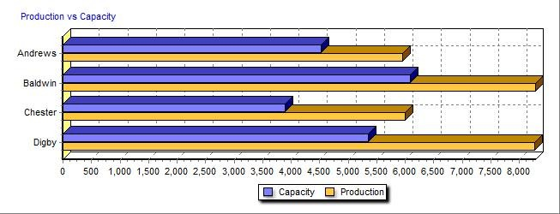Round: 3
Efren Escoto
December 31, 2016

Production Information

Unit

2nd Shift
&

Auto
mation Capacity

Name
Primary Segment
Units Sold
Inven
tory Revision Date
Age
Dec.31 MTBF
Pfmn Coord
Size
Coord Price
Material Cost
Labor Cost
Contr. Marg.
Over- time
Next Round
Next Round
Plant Utiliz.

Ark Elite 1,376 22 10/27/2016 1.2 26000 15.9 7.2 $38.00 $13.76 $7.99 43% 54% 6.5 914 153%
Able Thrift 1,647 66 12/1/2016 1.6 20000 7.9 12.0 $20.70 $7.41 $3.80 47% 86% 9.5 1,330 184%
Acre Core 1,613 389 10/7/2016 1.3 20000 10.9 9.4 $25.00 $9.45 $4.23 40% 0% 8.2 1,450 96%
Awe Nano 1,359 238 9/21/2016 1.2 22000 12.9 4.3 $36.00 $12.67 $7.36 43% 19% 6.0 1,228 118%

Buzz Thrift 971 380 12/19/2016 2.2 14000 8.5 11.7 $17.00 $6.82 $1.79 52% 0% 10.0 1,250 99%
Brat Core 1,848 315 12/7/2014 3.1 16000 9.4 10.8 $19.00 $8.14 $4.10 33% 43% 10.0 1,500 142%
Baker Nano 1,182 220 12/16/2016 1.0 18000 12.9 4.6 $30.00 $12.74 $6.89 34% 47% 7.0 950 146%
Bead Elite 837 279 12/16/2016 1.0 20000 16.0 7.1 $36.00 $13.59 $6.28 43% 12% 7.0 950 111%
Bid Core 1,566 117 12/24/2016 0.9 16000 10.8 9.3 $21.00 $9.31 $5.67 30% 63% 8.0 1,040 162%
Bold Core 1,053 0 2/10/2016 0.9 16000 10.5 9.7 $22.00 $9.03 $4.44 38% 100% 8.0 1,040 176%

Cute Nano 1,763 43 11/4/2016 1.2 23000 13.5 4.7 $34.00 $13.66 $7.91 38% 100% 7.0 1,150 198%
Crimp Elite 1,351 171 8/23/2016 1.9 25000 16.3 6.7 $34.00 $14.56 $6.69 35% 53% 7.0 850 151%
Cake Nano 1,248 341 7/2/2016 1.3 23000 14.0 4.2 $37.00 $14.04 $7.08 40% 30% 7.0 1,200 129%
Cedar Elite 1,527 427 7/24/2016 1.3 25000 16.1 6.4 $37.00 $14.57 $7.31 38% 43% 7.0 1,350 142%

Dug Thrift 1,964 264 6/10/2017 3.7 17000 7.8 12.4 $16.00 $6.80 $2.99 36% 55% 10.0 1,450 154%
Drat Thrift 2,053 324 6/10/2017 3.6 17000 8.0 12.2 $16.00 $6.96 $2.97 35% 50% 10.0 1,600 149%
Deal Core 1,595 279 12/16/2015 2.1 18000 10.9 8.7 $24.00 $9.72 $4.57 38% 67% 8.0 1,150 165%
Dell Core 1,776 268 12/18/2015 2.1 20000 11.6 9.2 $24.00 $10.36 $4.50 36% 56% 8.0 1,350 154%

COMP-XM® INQUIRER Page 4

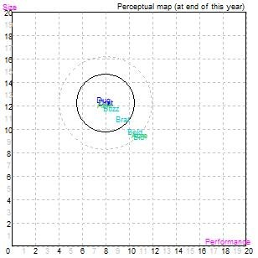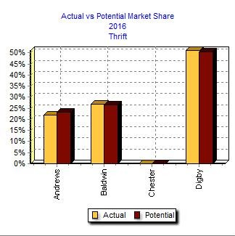

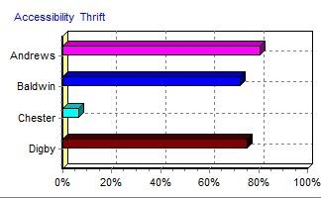Top
Efren Escoto
Thrift Market Segment Analysis |  |  |  |  |  |  |  |  |  |  |  |  | Round: 3  December 31, 2016
Thrift Statistics  Total Industry Unit Demand  Actual Industry Unit Sales Segment % of Total Industry  Next Year's Segment Growth Rate  Thrift Customer Buying Criteria  Expectations  1. Price $14.00 - 26.00  - Reliability MTBF 14000-20000  - Ideal Position Pfmn 8.0 Size 12.2  - Age Ideal Age = 3.0 |  |  |  |  |  | 6,985  6,985  26.1%  11.0%  Importance  55%  20%  15%  10%
Perceptual Map for Thrift Segment
Top Products in Thrift Segment
 | Market | Units Sold | Revision |  | Pfmn | Size | List |  |  | Age | Promo | Cust. Aware- | Sales Cust. Access- Dec. Cust.
Name | Share | to Seg | Date | Stock Out | Coord | Coord | Price |  | MTBF | Dec.31 | Budget | ness | Budget ibility Survey
Dug | 26% | 1,787 | 6/10/2017 |  | 7.8 | 12.4 | $16.00 |  | 17000 | 3.74 | $1,250 | 78% | $1,400 75% 54
Drat | 26% | 1,782 | 6/10/2017 |  | 8.0 | 12.2 | $16.00 |  | 17000 | 3.64 | $1,250 | 79% | $1,400 75% 55
Able | 21% | 1,445 | 12/1/2016 |  | 7.9 | 12.0 | $20.70 |  | 20000 | 1.58 | $1,400 | 95% | $2,000 81% 46
Buzz | 14% | 948 | 12/19/2016 |  | 8.5 | 11.7 | $17.00 |  | 14000 | 2.25 | $1,140 | 66% | $1,000 72% 31
Brat | 10% | 719 | 12/7/2014 |  | 9.4 | 10.8 | $19.00 |  | 16000 | 3.11 | $1,140 | 67% | $1,000 72% 24
Bid | 3% | 190 | 12/24/2016 |  | 10.8 | 9.3 | $21.00 |  | 16000 | 0.88 | $1,140 | 58% | $900 72% 0
Acre | 1% | 86 | 10/7/2016 |  | 10.9 | 9.4 | $25.00 |  | 20000 | 1.28 | $1,200 | 83% | $1,000 81% 0
Bold | 0% | 29 | 2/10/2016 | YES | 10.5 | 9.7 | $22.00 |  | 16000 | 0.89 | $1,140 | 51% | $900 72% 3
COMP-XM® INQUIRER |  |  |  |  |  |  |  |  |  |  |  |  | Page 5

Core Market Segment Analysis
Top

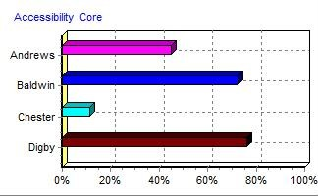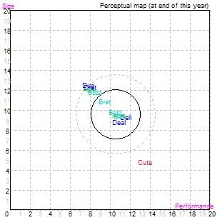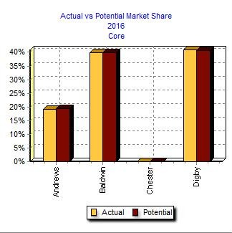Round: 3
Efren Escoto
December 31, 2016

Core Statistics
Total Industry Unit Demand | 8,898
Actual Industry Unit Sales | 8,898
Segment % of Total Industry | 33.3%
Next Year's Segment Growth Rate 10.0%

Core Customer Buying Criteria
Expectations Importance
1. Price $20.00 - 32.00 46%
- Age Ideal Age = 2.0 20%
- Reliability MTBF 16000-22000 18%
- Ideal Position Pfmn 11.0 Size 9.2 16%

Perceptual Map for Core Segment

Top Products in Core Segment

COMP-XM® INQUIRER Page 6
Name | Market Share | Units Sold  to Seg | Revision Date | Stock Out | Pfmn Coord | Size Coord | List Price | MTBF | Age Promo Cust. Aware- Sales Cust. Access- Dec. Cust. Dec.31 Budget ness Budget ibility Survey
Dell | 19% | 1,694 | 12/18/2015 |  | 11.6 | 9.2 | $24.00 | 20000 | 2.10 | $1,250 | 78% | $1,100 | 76% | 50
Acre | 17% | 1,502 | 10/7/2016 |  | 10.9 | 9.4 | $25.00 | 20000 | 1.28 | $1,200 | 83% | $1,000 | 45% | 39
Deal | 17% | 1,496 | 12/16/2015 |  | 10.9 | 8.7 | $24.00 | 18000 | 2.09 | $1,250 | 78% | $1,100 | 76% | 44
Bid | 15% | 1,376 | 12/24/2016 |  | 10.8 | 9.3 | $21.00 | 16000 | 0.88 | $1,140 | 58% | $900 | 72% | 38
Brat | 13% | 1,129 | 12/7/2014 |  | 9.4 | 10.8 | $19.00 | 16000 | 3.11 | $1,140 | 67% | $1,000 | 72% | 26
Bold | 12% | 1,024 | 2/10/2016 | YES | 10.5 | 9.7 | $22.00 | 16000 | 0.89 | $1,140 | 51% | $900 | 72% | 31
Drat | 3% | 271 | 6/10/2017 |  | 8.0 | 12.2 | $16.00 | 17000 | 3.64 | $1,250 | 79% | $1,400 | 76% | 2
Able | 2% | 202 | 12/1/2016 |  | 7.9 | 12.0 | $20.70 | 20000 | 1.58 | $1,400 | 95% | $2,000 | 45% | 12
Dug | 2% | 178 | 6/10/2017 |  | 7.8 | 12.4 | $16.00 | 17000 | 3.74 | $1,250 | 78% | $1,400 | 76% | 0
Buzz | 0% | 23 | 12/19/2016 |  | 8.5 | 11.7 | $17.00 | 14000 | 2.25 | $1,140 | 66% | $1,000 | 72% | 8
Cute | 0% | 3 | 11/4/2016 |  | 13.5 | 4.7 | $34.00 | 23000 | 1.24 | $1,350 | 87% | $1,000 | 11% | 0

Nano Market Segment Analysis
Top

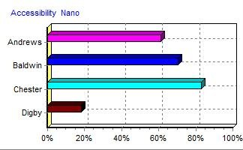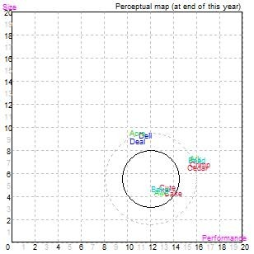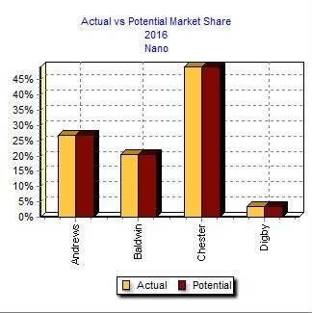Round: 3
Efren Escoto
December 31, 2016

Nano Statistics
Total Industry Unit Demand | 5,412
Actual Industry Unit Sales | 5,412
Segment % of Total Industry | 20.3%
Next Year's Segment Growth Rate 14.0%

Nano Customer Buying Criteria
Expectations Importance
1. Ideal Position Pfmn 12.9 Size 4.4 35%
2. Price $28.00 - 40.00 27%
- Age Ideal Age = 1.0 20%
- Reliability MTBF 18000-24000 18%

Perceptual Map for Nano Segment

Top Products in Nano Segment

COMP-XM® INQUIRER Page 7
Name | Market Share | Units Sold  to Seg | Revision Date | Stock Out | Pfmn Coord | Size Coord | List Price | MTBF | Age Dec.31 | Promo Cust. Aware- Budget ness |  | Sales Cust. Access- Dec. Cust. Budget ibility Survey
Cute | 25% | 1,368 | 11/4/2016 |  | 13.5 | 4.7 | $34.00 | 23000 | 1.24 | $1,350 | 87% | $1,000 | 83% | 62
Awe | 24% | 1,305 | 9/21/2016 |  | 12.9 | 4.3 | $36.00 | 22000 | 1.24 | $1,500 | 100% | $1,100 | 61% | 52
Cake | 22% | 1,194 | 7/2/2016 |  | 14.0 | 4.2 | $37.00 | 23000 | 1.34 | $1,350 | 87% | $900 | 83% | 48
Baker | 20% | 1,055 | 12/16/2016 |  | 12.9 | 4.6 | $30.00 | 18000 | 1.03 | $1,140 | 67% | $1,900 | 70% | 46
Ark | 2% | 127 | 10/27/2016 |  | 15.9 | 7.2 | $38.00 | 26000 | 1.23 | $1,350 | 90% | $1,100 | 61% | 0
Deal | 2% | 99 | 12/16/2015 |  | 10.9 | 8.7 | $24.00 | 18000 | 2.09 | $1,250 | 78% | $1,100 | 18% | 2
Cedar | 2% | 85 | 7/24/2016 |  | 16.1 | 6.4 | $37.00 | 25000 | 1.34 | $1,350 | 87% | $900 | 83% | 0
Dell | 2% | 82 | 12/18/2015 |  | 11.6 | 9.2 | $24.00 | 20000 | 2.10 | $1,250 | 78% | $1,100 | 18% | 1
Bead | 1% | 61 | 12/16/2016 |  | 16.0 | 7.1 | $36.00 | 20000 | 1.04 | $1,140 | 67% | $2,200 | 70% | 0
Acre | 0% | 20 | 10/7/2016 |  | 10.9 | 9.4 | $25.00 | 20000 | 1.28 | $1,200 | 83% | $1,000 | 61% | 0
Crimp | 0% | 17 | 8/23/2016 |  | 16.3 | 6.7 | $34.00 | 25000 | 1.90 | $1,350 | 87% | $1,000 | 83% | 0

Elite Market Segment Analysis
Top

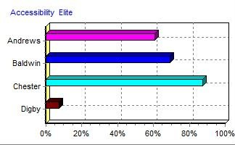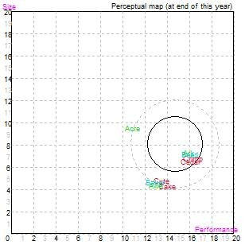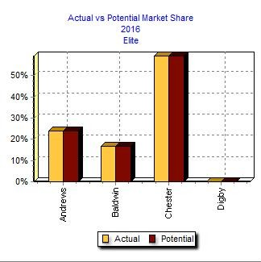Round: 3
Efren Escoto
December 31, 2016

Elite Statistics
Total Industry Unit Demand | 5,434
Actual Industry Unit Sales | 5,434
Segment % of Total Industry | 20.3%
Next Year's Segment Growth Rate 16.0%

Elite Customer Buying Criteria
Expectations Importance
1. Age Ideal Age = 0.0 34%
2. Price $30.00 - 42.00 24%
- Ideal Position Pfmn 15.8 Size 7.3 22%
- Reliability MTBF 20000-26000 20%

Perceptual Map for Elite Segment

Top Products in Elite Segment

COMP-XM® INQUIRER Page 8
Name | Market Share | Units Sold  to Seg | Revision Date | Stock Out | Pfmn Coord | Size Coord | List Price | MTBF | Age Dec.31 | Promo Cust. Aware- Budget ness |  | Sales Cust. Access- Dec. Cust. Budget ibility Survey
Cedar | 27% | 1,442 | 7/24/2016 |  | 16.1 | 6.4 | $37.00 | 25000 | 1.34 | $1,350 | 87% | $900 | 87% | 48
Crimp | 25% | 1,334 | 8/23/2016 |  | 16.3 | 6.7 | $34.00 | 25000 | 1.90 | $1,350 | 87% | $1,000 | 87% | 47
Ark | 23% | 1,248 | 10/27/2016 |  | 15.9 | 7.2 | $38.00 | 26000 | 1.23 | $1,350 | 90% | $1,100 | 61% | 48
Bead | 14% | 775 | 12/16/2016 |  | 16.0 | 7.1 | $36.00 | 20000 | 1.04 | $1,140 | 67% | $2,200 | 69% | 30
Cute | 7% | 392 | 11/4/2016 |  | 13.5 | 4.7 | $34.00 | 23000 | 1.24 | $1,350 | 87% | $1,000 | 87% | 8
Baker | 2% | 127 | 12/16/2016 |  | 12.9 | 4.6 | $30.00 | 18000 | 1.03 | $1,140 | 67% | $1,900 | 69% | 1
Cake | 1% | 55 | 7/2/2016 |  | 14.0 | 4.2 | $37.00 | 23000 | 1.34 | $1,350 | 87% | $900 | 87% | 1
Awe | 1% | 55 | 9/21/2016 |  | 12.9 | 4.3 | $36.00 | 22000 | 1.24 | $1,500 | 100% | $1,100 | 61% | 0
Acre | 0% | 6 | 10/7/2016 |  | 10.9 | 9.4 | $25.00 | 20000 | 1.28 | $1,200 | 83% | $1,000 | 61% | 0

Market Share Report
Top

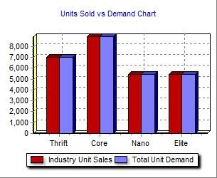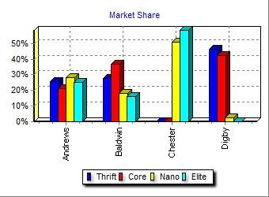Round: 3
Efren Escoto
December 31, 2016

Actual M  Thrift  Industry Unit  Sales 6,985 | arket Share in Units  Core Nano Elite  8,898 5,412 5,434 |  |  | Total  26,729 | Potential Mark  Thrift Core  Units  Demanded 6,985 8,898 |  | et Share in Units  Nano Elite  5,412 5,434 |  | Total  26,729
% of Market 26.1% | 33.3% | 20.3% | 20.3% | 100.0% | % of Market 26.1% | 33.3% | 20.3% | 20.3% | 100.0%
Ark |  | 2.4% | 23.0% | 5.2% | Ark |  | 2.4% | 23.0% | 5.2%
Able 20.7% | 2.3% |  |  | 6.2% | Able 22.0% | 2.6% |  |  | 6.6%
Acre 1.2% | 16.9% | 0.4% | 0.1% | 6.0% | Acre 1.2% | 16.8% | 0.4% | 0.1% | 6.0%
Awe |  | 24.1% | 1.0% | 5.1% | Awe |  | 24.1% | 1.0% | 5.1%
Total 21.9% | 19.1% | 26.8% | 24.1% | 22.4% | Total 23.2% | 19.4% | 26.8% | 24.1% | 22.9%
Buzz 13.6% | 0.3% |  |  | 3.6% | Buzz 13.2% | 0.3% |  |  | 3.5%
Brat 10.3% | 12.7% |  |  | 6.9% | Brat 10.1% | 12.6% |  |  | 6.8%
Baker |  | 19.5% | 2.3% | 4.4% | Baker |  | 19.5% | 2.3% | 4.4%
Bead |  | 1.1% | 14.3% | 3.1% | Bead |  | 1.1% | 14.3% | 3.1%
Bid 2.7% | 15.5% |  |  | 5.9% | Bid 2.7% | 15.4% |  |  | 5.8%
Bold 0.4% | 11.5% |  |  | 3.9% | Bold 0.4% | 11.6% |  |  | 4.0%
Total 27.0% | 39.9% | 20.6% | 16.6% | 27.9% | Total 26.4% | 39.9% | 20.6% | 16.6% | 27.7%
Cute | 0.0% | 25.3% | 7.2% | 6.6% | Cute |  | 25.3% | 7.2% | 6.6%
Crimp |  | 0.3% | 24.6% | 5.0% | Crimp |  | 0.3% | 24.5% | 5.1%
Cake |  | 22.1% | 1.0% | 4.7% | Cake |  | 22.1% | 1.0% | 4.7%
Cedar |  | 1.6% | 26.5% | 5.7% | Cedar |  | 1.6% | 26.5% | 5.7%
Total | 0.0% | 49.2% | 59.3% | 22.0% | Total | 0.0% | 49.2% | 59.3% | 22.0%
Dug 25.6% | 2.0% |  |  | 7.3% | Dug 25.3% | 2.0% |  |  | 7.3%
Drat 25.5% | 3.0% |  |  | 7.7% | Drat 25.1% | 3.0% |  |  | 7.6%
Deal | 16.8% | 1.8% |  | 6.0% | Deal | 16.7% | 1.8% |  | 5.9%
Dell | 19.0% | 1.5% |  | 6.6% | Dell | 18.9% | 1.5% |  | 6.6%
Total 51.1% | 40.9% | 3.3% |  | 27.6% | Total 50.3% | 40.7% | 3.3% |  | 27.4%
COMP-XM® INQUIRER |  |  |  |  |  |  |  |  | Page 9

Top
Efren Escoto
Perceptual Map December Round: 3
Perceptual Map for All Segments
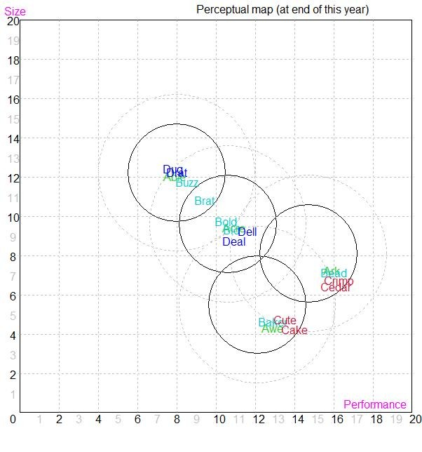

 | Andrews |  |  | Baldwin |  |  | Chester
Name | Pfmn Size | Revised | Name | Pfmn Size | Revised | Name | Pfmn Size | Revised
Ark | 15.9 7.2 | 10/27/2016 | Buzz | 8.5 11.7 | 12/19/2016 | Cute | 13.5 4.7 | 11/4/2016
Able | 7.9 12.0 | 12/1/2016 | Brat | 9.4 10.8 | 12/7/2014 | Crimp | 16.3 6.7 | 8/23/2016
Acre | 10.9 9.4 | 10/7/2016 | Baker | 12.9 4.6 | 12/16/2016 | Cake | 14.0 4.2 | 7/2/2016
Awe | 12.9 4.3 | 9/21/2016 | Bead | 16.0 7.1 | 12/16/2016 | Cedar | 16.1 6.4 | 7/24/2016
 |  |  | Bid | 10.8 9.3 | 12/24/2016
 |  |  | Bold | 10.5 9.7 | 2/10/2016
Digby
Name Pfmn Size Revised
Dug 7.8 12.4 6/10/2017
Drat 8.0 12.2 6/10/2017
Deal 10.9 8.7 12/16/2015
Dell 11.6 9.2 12/18/2015
COMP-XM® INQUIRER Page 10

HR/TQM Report
Top

Round: 3
December 31, 2016

HUMAN RESOURCES SUMMARY
Efren Escoto

Needed Complement | Andrews  522 | Baldwin  590 | Chester  612 | Digby 431
Complement | 522 | 590 | 612 | 431
1st Shift Complement | 396 | 415 | 395 | 275
2nd Shift Complement | 126 | 175 | 218 | 156
Overtime% | 0.0% | 0.0% | 0.0% | 0.0%
Turnover Rate | 7.0% | 6.2% | 10.0% | 8.0%
New Employees | 37 | 137 | 61 | 35
Separated Employees | 107 | 0 | 49 | 0
Recruiting Spend | $4,000 | $5,000 | $0 | $2,500
Training Hours | 80 | 80 | 0 | 40
Productivity Index | 109.4% | 125.6% | 100.0% | 116.4%
Recruiting Cost | $183 | $825 | $61 | $123
Separation Cost | $535 | $0 | $247 | $0
Training Cost | $835 | $944 | $0 | $345
Total HR Admin Cost | $1,553 | $1,769 | $309 | $468
Labor Contract Next Year
Wages | $29.56 | $29.56 | $29.56 | $29.56
Benefits | 2,500 | 2,500 | 2,500 | 2,500
Profit Sharing | 2.0% | 2.0% | 2.0% | 2.0%
Annual Raise | 5.0% | 5.0% | 5.0% | 5.0%
Starting Negotiation Position
Wages
Benefits
Profit Sharing
Annual Raise
Ceiling Negotiation Position
Wages
Benefits
Profit Sharing
Annual Raise
Adjusted Labor Demands
Wages
Benefits
Profit Sharing
Annual Raise
Strike Days
 |  | TQM SUMMARY
Process Mgt Budgets Last Year | Andrews | Baldwin | Chester | Digby
CPI Systems | $1,500 | $1,500 | $0 | $1,250
Vendor/JIT | $2,000 | $1,500 | $0 | $1,250
Quality Initiative Training | $1,000 | $0 | $1,250 | $0
Channel Support Systems | $1,250 | $0 | $1,250 | $1,500
Concurrent Engineering | $500 | $0 | $1,250 | $0
UNEP Green Programs | $500 | $1,500 | $0 | $0
TQM Budgets Last Year  Benchmarking | $300 | $1,500 | $0 | $0
Quality Function Deployment Effort | $500 | $0 | $0 | $0
CCE/6 Sigma Training | $1,600 | $0 | $1,250 | $750
GEMI TQEM Sustainability Initiatives | $800 | $0 | $1,250 | $750
Total Expenditures | $9,950 | $6,000 | $6,250 | $5,500
Cumulative Impacts  Material Cost Reduction | 11.22% | 1.41% | 6.43% | 6.03%
Labor Cost Reduction | 12.44% | 0.05% | 13.93% | 1.78%
Reduction R&D Cycle Time | 8.91% | 0.00% | 39.79% | 0.00%
Reduction Admin Costs | 47.70% | 43.11% | 0.00% | 16.23%
Demand Increase | 7.52% | 0.45% | 9.37% | 5.47%
COMP-XM® INQUIRER |  |  |  |  | Page 11

PRINT
Annual Report

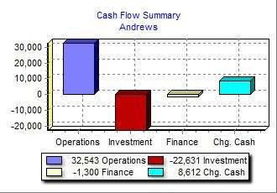Top
Annual Report Andrews C59559

Balance Sheet

Round: 3
Dec
. 31, 2016

your company stocked out. Unmet demand would, of
DEFINITIONS: Common Size: The common size column simply represents each item as a percentage of total assets for that year. Cash: Your end-of-year cash position.  Accounts Receivable: Reflects the lag between delivery | ASSETS  Cash | $26,062 |  | 2016  Common  Size 15.8% | 2015  $17,450
and payment of your products. Inventories: The current | Accounts Receivable | $14,436 |  | 8.8% | $13,196
value of your inventory across all products. A zero indicates | Inventory | $11,674 |  | 7.1% | $13,487
course, fall to your competitors. Plant & Equipment: The | Total Current Assets |  | $52,172 | 31.7% | $44,133
current value of your plant. Accum Deprec: The total  accumulated depreciation from your plant. Accts Payable: | Plant & Equipment | $180,868 |  | 109.9% | $162,696
What the company currently owes suppliers for materials and services. Current Debt: The debt the company is | Accumulated Depreciation | ($68,442) |  | -41.6% | ($60,952)
obligated to pay during the next year of operations. It | Total Fixed Assets |  | $112,426 | 68.3% | $101,744
includes emergency loans used to keep your company
solvent should you run out of cash during the year. Long
Term Debt: The company's long term debt is in the form of Total Assets |  |  | $164,597 | 100.0% | $145,876
bonds, and this represents the total value of your bonds.
Common Stock: The amount of capital invested by LIABILITIES & OWNERS' EQUITY
shareholders in the company. Retained Earnings: The  profits that the company chose to keep instead of paying to Accounts Payable |  | $7,950 |  | 4.8% | $7,940
shareholders as dividends. Current Debt |  | $0 |  | 0.0% | $11,300
Long Term Debt |  | $50,909 |  | 30.9% | $40,909
Total Liabilities |  |  | $58,859 | 35.8% | $60,149
Common Stock |  | $12,081 |  | 7.3% | $12,081
Retained Earnings |  | $93,657 |  | 56.9% | $73,647
Total Equity |  |  | $105,738 | 64.2% | $85,728
Total Liab. & O. Equity |  |  | $164,597 | 100.0% | $145,876

Cash Flow Statement
The Cash Flow Statement examines what happened in the Cash Account during the Cash Flows from Operating Activities: 2016 2015
year. Cash injections appear as positive numbers and cash withdrawals as negative numbers. The Cash Flow Statement is an excellent tool for diagnosing emergency loans. When negative cash flows exceed positives, you are forced to seek emergency funding. For example, if sales are bad and you find yourself carrying an abundance of excess inventory, the report would show the increase in inventory as a huge negative cash flow. Too much unexpected inventory could outstrip your inflows, exhaust your starting cash and force you to beg for money to keep your company afloat.
Net Income (Loss)  Depreciation | $20,010  $12,058 | $9,586  $10,846
Extraordinary gains/losses/writeoffs | ($109) | ($965)
Accounts Payable | $11 | ($31)
Inventory | $1,813 | $5,097
Accounts Receivable | ($1,240) | ($1,087)
Net cash from operations  Cash Flows from Investing Activities:  Plant Improvements  Cash Flows from Financing Activities:  Dividends Paid  Sales of Common Stock Purchase of Common Stock Cash from long term debt Retirement of long term debt  Change in current debt (net)  Net cash from financing activities Net change in cash position Closing cash position | $32,543 | $23,447
 | ($22,631) | ($29,448)
 | $0 | $0
 | $0 | $0
 | $0 | $0
 | $10,000 | $13,000
 | $0 | ($11,300)
 | ($11,300) | $11,300
 | ($1,300) | $13,000
 | $8,612 | $6,999
 | $26,062 | $17,450

Annual Report Page 1

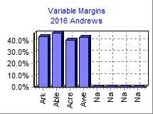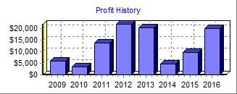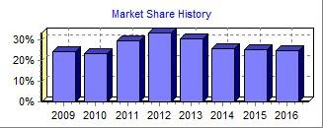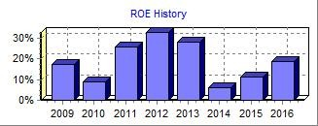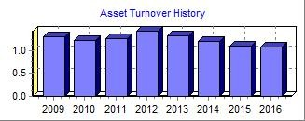Top
Annual Report Andrews C59559
2016 Income Statement

Round: 3
Dec
. 31, 2016

(Product Name:) Ark Able Acre Awe Na Na
Sales $52,275 $34,087 $40,329 $48,941 $0 $0

Variable Costs:
Direct Labor $10,994 $6,250 $7,882 $10,349 $0 $0 Direct Material $18,534 $11,886 $15,476 $17,169 $0 $0 Inventory Carry $58 $88 $676 $579 $0 $0 Total Variable $29,585 $18,224 $24,034 $28,097 $0 $0
2016
Common

Contribution Margin $22,690 $15,863 $16,295 $20,843 $0 $0

Period Costs:
Total  $175,632 | Size 100.0%
$35,475 | 20.2%
$63,065 | 35.9%
$1,401 | 0.8%
$99,940 | 56.9%
$75,692 | 43.1%

Na  $0 | Na  $0
$0 | $0
$0 | $0
$0 | $0
$0 | $0
$0 | $0

Depreciation $1,950 $3,901 $3,751 $2,456 $0 $0 $0 $0 $12,058 6.9% SG&A: R&D $836 $933 $780 $736 $0 $0 $0 $0 $3,285 1.9%
Promotions $1,350 $1,400 $1,200 $1,500 $0 $0 $0 $0 $5,450 3.1% Sales $1,100 $2,000 $1,000 $1,100 $0 $0 $0 $0 $5,200 3.0%
Admin $654 $426 $504 $612 $0 $0 $0 $0 $2,196 1.3% Total Period $5,889 $8,661 $7,235 $6,404 $0 $0 $0 $0 $28,188 16.0%

Net Margin $16,801 $7,203 $9,061 $14,439 $0 $0 $0 $0 $47,504 27.0%

Definitions: Sales: Unit sales times list price. Direct Labor: Labor costs incurred to produce the product that was sold. Inventory Carry Cost: the cost to carry unsold goods in inventory. Depreciation: Calculated on straight-line 15-year depreciation of plant value. R&D Costs: R&D department expenditures for each product. Admin: Administration overhead is estimated at 1.5% of sales. Promotions: The promotion budget for each product. Sales: The sales force budget for each product. Other: Charges not included in other categories such as Fees, Write Offs, and TQM. The fees include money paid to investment bankers and brokerage firms to issue new stocks or bonds plus consulting fees your instructor might assess. Write-offs include the loss you might experience when you sell capacity or liquidate inventory as the result of eliminating a production line. If the amount appears as a negative amount, then you actually made money on the liquidation of capacity or inventory. EBIT: Earnings Before Interest and Taxes. Short Term Interest: Interest expense based on last year's current debt, including short term debt, long term notes that have become due, and emergency loans. Long Term Interest: Interest paid on outstanding bonds. Taxes: Income tax based upon a 35% tax rate. Profit Sharing: Profits shared with employees under the labor contract. Net Profit: EBIT minus interest, taxes, and profit sharing.

Other $10,341 5.9%
EBIT $37,162 21.2%
Short Term Interest $0 0.0%
LongTerm Interest $5,749 3.3%
Taxes $10,995 6.3%
Profit Sharing $408 0.2%
Net Profit $20,010 11.4%

Annual Report Page 2
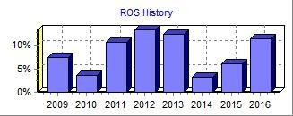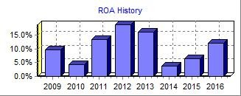PRINT
Annual Report

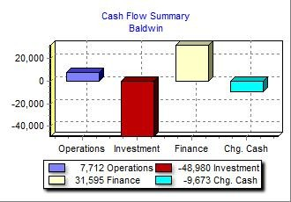Top
Annual Report Baldwin C59559

Balance Sheet

Round: 3
Dec
. 31, 2016

your company stocked out. Unmet demand would, of
DEFINITIONS: Common Size: The common size column simply represents each item as a percentage of total assets for that year. Cash: Your end-of-year cash position.  Accounts Receivable: Reflects the lag between delivery | ASSETS  Cash | $25,970 |  | 2016  Common  Size 10.9% | 2015  $35,643
and payment of your products. Inventories: The current | Accounts Receivable | $14,241 |  | 6.0% | $11,565
value of your inventory across all products. A zero indicates | Inventory | $18,354 |  | 7.7% | $8,324
course, fall to your competitors. Plant & Equipment: The | Total Current Assets |  | $58,565 | 24.6% | $55,532
current value of your plant. Accum Deprec: The total  accumulated depreciation from your plant. Accts Payable: | Plant & Equipment | $267,740 |  | 112.5% | $218,760
What the company currently owes suppliers for materials and services. Current Debt: The debt the company is | Accumulated Depreciation | ($88,249) |  | -37.1% | ($70,400)
obligated to pay during the next year of operations. It | Total Fixed Assets |  | $179,491 | 75.4% | $148,360
includes emergency loans used to keep your company
solvent should you run out of cash during the year. Long
Term Debt: The company's long term debt is in the form of Total Assets |  |  | $238,055 | 100.0% | $203,892
bonds, and this represents the total value of your bonds.
Common Stock: The amount of capital invested by LIABILITIES & OWNERS' EQUITY
shareholders in the company. Retained Earnings: The  profits that the company chose to keep instead of paying to Accounts Payable |  | $9,651 |  | 4.1% | $7,257
shareholders as dividends. Current Debt |  | $26,832 |  | 11.3% | $33,255
Long Term Debt |  | $102,406 |  | 43.0% | $82,760
Total Liabilities |  |  | $138,889 | 58.3% | $123,272
Common Stock |  | $55,651 |  | 23.4% | $37,278
Retained Earnings |  | $43,516 |  | 18.3% | $43,342
Total Equity |  |  | $99,167 | 41.7% | $80,620
Total Liab. & O. Equity |  |  | $238,055 | 100.0% | $203,892

Cash Flow Statement
The Cash Flow Statement examines what happened in the Cash Account during the Cash Flows from Operating Activities: 2016 2015
year. Cash injections appear as positive numbers and cash withdrawals as negative numbers. The Cash Flow Statement is an excellent tool for diagnosing emergency loans. When negative cash flows exceed positives, you are forced to seek emergency funding. For example, if sales are bad and you find yourself carrying an abundance of excess inventory, the report would show the increase in inventory as a huge negative cash flow. Too much unexpected inventory could outstrip your inflows, exhaust your starting cash and force you to beg for money to keep your company afloat.
Net Income (Loss)  Depreciation | $174  $17,849 | $797  $13,224
Extraordinary gains/losses/writeoffs | $0 | $0
Accounts Payable | $2,394 | $864
Inventory | ($10,029) | $2,948
Accounts Receivable | ($2,676) | ($1,947)
Net cash from operations  Cash Flows from Investing Activities:  Plant Improvements  Cash Flows from Financing Activities:  Dividends Paid  Sales of Common Stock Purchase of Common Stock Cash from long term debt Retirement of long term debt  Change in current debt (net)  Net cash from financing activities Net change in cash position Closing cash position | $7,712 | $15,885
 | ($48,980) | ($53,460)
 | $0 | $0
 | $18,373 | $18,534
 | $0 | $0
 | $19,646 | $34,903
 | $0 | ($11,300)
 | ($6,424) | $11,545
 | $31,595 | $53,682
 | ($9,673) | $16,108
 | $25,970 | $35,643

Annual Report Page 1

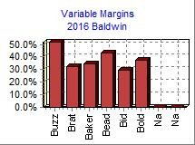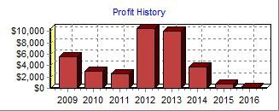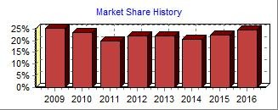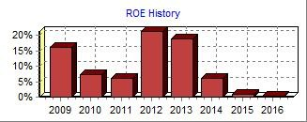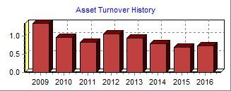Top
Annual Report Baldwin C59559
2016 Income Statement

Round: 3
Dec
. 31, 2016

(Product Name:) Buzz Brat Baker Bead Bid Bold
Sales $16,500 $35,116 $35,467 $30,122 $32,894 $23,167

Variable Costs:
Direct Labor $1,790 $7,617 $8,084 $5,388 $8,878 $4,678 Direct Material $5,804 $15,560 $14,674 $11,103 $14,033 $9,782 Inventory Carry $357 $474 $507 $659 $205 $0 Total Variable $7,951 $23,650 $23,265 $17,150 $23,115 $14,460
2016
Common

Contribution Margin $8,549 $11,466 $12,202 $12,972 $9,778 $8,707

Period Costs:
Total  $173,268 | Size 100.0%
$36,434 | 21.0%
$70,956 | 41.0%
$2,202 | 1.3%
$109,592 | 63.2%
$63,675 | 36.7%

Na  $0 | Na  $0
$0 | $0
$0 | $0
$0 | $0
$0 | $0
$0 | $0

Depreciation $3,833 $4,600 $2,153 $2,153 $2,635 $2,475 $0 $0 $17,849 10.3% SG&A: R&D $983 $0 $973 $973 $995 $114 $0 $0 $4,039 2.3% Promotions $1,140 $1,140 $1,140 $1,140 $1,140 $1,140 $0 $0 $6,840 3.9% Sales $1,000 $1,000 $1,900 $2,200 $900 $900 $0 $0 $7,900 4.6%
Admin $234 $498 $503 $427 $467 $329 $0 $0 $2,459 1.4% Total Period $7,190 $7,238 $6,670 $6,894 $6,137 $4,957 $0 $0 $39,087 22.6%

Net Margin $1,359 $4,228 $5,532 $6,078 $3,642 $3,750 $0 $0 $24,589 14.2%

Definitions: Sales: Unit sales times list price. Direct Labor: Labor costs incurred to produce the product that was sold. Inventory Carry Cost: the cost to carry unsold goods in inventory. Depreciation: Calculated on straight-line 15-year depreciation of plant value. R&D Costs: R&D department expenditures for each product. Admin: Administration overhead is estimated at 1.5% of sales. Promotions: The promotion budget for each product. Sales: The sales force budget for each product. Other: Charges not included in other categories such as Fees, Write Offs, and TQM. The fees include money paid to investment bankers and brokerage firms to issue new stocks or bonds plus consulting fees your instructor might assess. Write-offs include the loss you might experience when you sell capacity or liquidate inventory as the result of eliminating a production line. If the amount appears as a negative amount, then you actually made money on the liquidation of capacity or inventory. EBIT: Earnings Before Interest and Taxes. Short Term Interest: Interest expense based on last year's current debt, including short term debt, long term notes that have become due, and emergency loans. Long Term Interest: Interest paid on outstanding bonds. Taxes: Income tax based upon a 35% tax rate. Profit Sharing: Profits shared with employees under the labor contract. Net Profit: EBIT minus interest, taxes, and profit sharing.

Other $7,901 4.6%
EBIT $16,688 9.6%
Short Term Interest $3,327 1.9%
LongTerm Interest $13,087 7.6% Taxes $96 0.1%
Profit Sharing $4 0.0%
Net Profit $174 0.1%

Annual Report Page 2
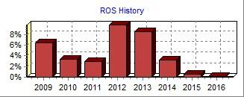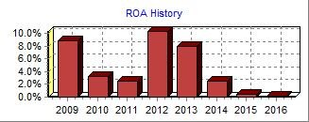PRINT
Annual Report

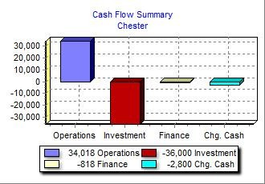Top
Annual Report Chester C59559

Balance Sheet

Round: 3
Dec
. 31, 2016

your company stocked out. Unmet demand would, of
DEFINITIONS: Common Size: The common size column simply represents each item as a percentage of total assets for that year. Cash: Your end-of-year cash position.  Accounts Receivable: Reflects the lag between delivery | ASSETS  Cash | $29,787 |  | 2016  Common  Size 17.8% | 2015  $32,587
and payment of your products. Inventories: The current | Accounts Receivable | $17,140 |  | 10.2% | $14,554
value of your inventory across all products. A zero indicates | Inventory | $21,368 |  | 12.8% | $20,657
course, fall to your competitors. Plant & Equipment: The | Total Current Assets |  | $68,295 | 40.8% | $67,798
current value of your plant. Accum Deprec: The total  accumulated depreciation from your plant. Accts Payable: | Plant & Equipment | $159,260 |  | 95.1% | $123,260
What the company currently owes suppliers for materials and services. Current Debt: The debt the company is | Accumulated Depreciation | ($60,121) |  | -35.9% | ($49,504)
obligated to pay during the next year of operations. It | Total Fixed Assets |  | $99,139 | 59.2% | $73,756
includes emergency loans used to keep your company
solvent should you run out of cash during the year. Long
Term Debt: The company's long term debt is in the form of Total Assets |  |  | $167,434 | 100.0% | $141,555
bonds, and this represents the total value of your bonds.
Common Stock: The amount of capital invested by LIABILITIES & OWNERS' EQUITY
shareholders in the company. Retained Earnings: The  profits that the company chose to keep instead of paying to Accounts Payable |  | $10,468 |  | 6.3% | $10,159
shareholders as dividends. Current Debt |  | $20,522 |  | 12.3% | $30,661
Long Term Debt |  | $39,055 |  | 23.3% | $28,150
Total Liabilities |  |  | $70,045 | 41.8% | $68,970
Common Stock |  | $10,915 |  | 6.5% | $11,159
Retained Earnings |  | $86,474 |  | 51.6% | $61,425
Total Equity |  |  | $97,389 | 58.2% | $72,584
Total Liab. & O. Equity |  |  | $167,434 | 100.0% | $141,555

Cash Flow Statement
The Cash Flow Statement examines what happened in the Cash Account during the Cash Flows from Operating Activities: 2016 2015
year. Cash injections appear as positive numbers and cash withdrawals as negative numbers. The Cash Flow Statement is an excellent tool for diagnosing emergency loans. When negative cash flows exceed positives, you are forced to seek emergency funding. For example, if sales are bad and you find yourself carrying an abundance of excess inventory, the report would show the increase in inventory as a huge negative cash flow. Too much unexpected inventory could outstrip your inflows, exhaust your starting cash and force you to beg for money to keep your company afloat.
Net Income (Loss)  Depreciation | $26,389  $10,617 | $16,170  $8,217
Extraordinary gains/losses/writeoffs | $0 | $0
Accounts Payable | $309 | $2,121
Inventory | ($711) | ($8,546)
Accounts Receivable | ($2,586) | ($1,881)
Net cash from operations  Cash Flows from Investing Activities:  Plant Improvements  Cash Flows from Financing Activities:  Dividends Paid  Sales of Common Stock Purchase of Common Stock Cash from long term debt Retirement of long term debt  Change in current debt (net)  Net cash from financing activities Net change in cash position Closing cash position | $34,018 | $16,081
 | ($36,000) | ($29,300)
 | $0 | $0
 | $0 | $2,360
 | ($1,584) | $0
 | $10,904 | $18,600
 | $0 | ($11,300)
 | ($10,138) | $16,689
 | ($818) | $26,349
 | ($2,800) | $13,130
 | $29,787 | $32,587

Annual Report Page 1

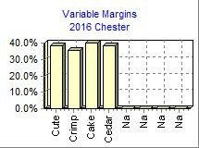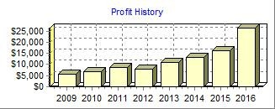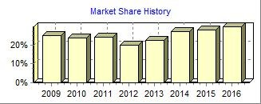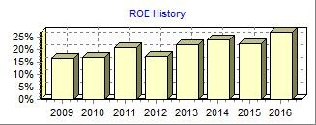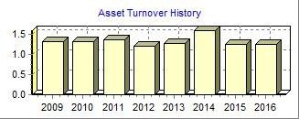Top
Annual Report Chester C59559
2016 Income Statement

Round: 3
Dec
. 31, 2016

(Product Name:) Cute Crimp Cake Cedar Na Na
Sales $59,926 $45,927 $46,192 $56,496 $0 $0

Variable Costs:
Direct Labor $13,971 $9,467 $9,107 $11,328 $0 $0 Direct Material $22,937 $19,736 $17,703 $22,399 $0 $0 Inventory Carry $108 $445 $879 $1,132 $0 $0 Total Variable $37,017 $29,648 $27,690 $34,859 $0 $0
2016
Common

Contribution Margin $22,909 $16,280 $18,502 $21,637 $0 $0

Period Costs:
Total  $208,541 | Size 100.0%
$43,873 | 21.0%
$82,776 | 39.7%
$2,564 | 1.2%
$129,213 | 62.0%
$79,328 | 38.0%

Na  $0 | Na  $0
$0 | $0
$0 | $0
$0 | $0
$0 | $0
$0 | $0

Depreciation $2,911 $1,927 $2,720 $3,060 $0 $0 $0 $0 $10,617 5.1% SG&A: R&D $858 $655 $510 $571 $0 $0 $0 $0 $2,595 1.2%
Promotions $1,350 $1,350 $1,350 $1,350 $0 $0 $0 $0 $5,400 2.6% Sales $1,000 $1,000 $900 $900 $0 $0 $0 $0 $3,800 1.8% Admin $508 $389 $392 $479 $0 $0 $0 $0 $1,768 0.8% Total Period $6,627 $5,322 $5,872 $6,360 $0 $0 $0 $0 $24,180 11.6%

Net Margin $16,282 $10,958 $12,630 $15,277 $0 $0 $0 $0 $55,147 26.4%

Definitions: Sales: Unit sales times list price. Direct Labor: Labor costs incurred to produce the product that was sold. Inventory Carry Cost: the cost to carry unsold goods in inventory. Depreciation: Calculated on straight-line 15-year depreciation of plant value. R&D Costs: R&D department expenditures for each product. Admin: Administration overhead is estimated at 1.5% of sales. Promotions: The promotion budget for each product. Sales: The sales force budget for each product. Other: Charges not included in other categories such as Fees, Write Offs, and TQM. The fees include money paid to investment bankers and brokerage firms to issue new stocks or bonds plus consulting fees your instructor might assess. Write-offs include the loss you might experience when you sell capacity or liquidate inventory as the result of eliminating a production line. If the amount appears as a negative amount, then you actually made money on the liquidation of capacity or inventory. EBIT: Earnings Before Interest and Taxes. Short Term Interest: Interest expense based on last year's current debt, including short term debt, long term notes that have become due, and emergency loans. Long Term Interest: Interest paid on outstanding bonds. Taxes: Income tax based upon a 35% tax rate. Profit Sharing: Profits shared with employees under the labor contract. Net Profit: EBIT minus interest, taxes, and profit sharing.

Other $6,819 3.3%
EBIT $48,328 23.2%
Short Term Interest $2,299 1.1%
LongTerm Interest $4,603 2.2%
Taxes $14,499 7.0%
Profit Sharing $539 0.3%
Net Profit $26,389 12.7%

Annual Report Page 2
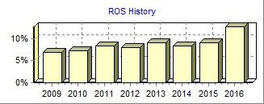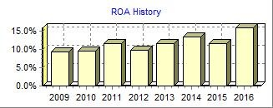PRINT
Annual Report

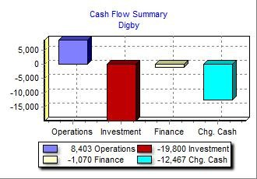Top
Annual Report Digby C59559

Balance Sheet

Round: 3
Dec
. 31, 2016

your company stocked out. Unmet demand would, of
DEFINITIONS: Common Size: The common size column simply represents each item as a percentage of total assets for that year. Cash: Your end-of-year cash position.  Accounts Receivable: Reflects the lag between delivery | ASSETS  Cash | $38,303 |  | 2016  Common  Size 18.6% | 2015  $50,770
and payment of your products. Inventories: The current | Accounts Receivable | $11,932 |  | 5.8% | $12,389
value of your inventory across all products. A zero indicates | Inventory | $14,088 |  | 6.8% | $4,059
course, fall to your competitors. Plant & Equipment: The | Total Current Assets |  | $64,323 | 31.2% | $67,218
current value of your plant. Accum Deprec: The total  accumulated depreciation from your plant. Accts Payable: | Plant & Equipment | $235,300 |  | 114.0% | $215,500
What the company currently owes suppliers for materials and services. Current Debt: The debt the company is | Accumulated Depreciation | ($93,158) |  | -45.1% | ($77,471)
obligated to pay during the next year of operations. It | Total Fixed Assets |  | $142,142 | 68.8% | $138,029
includes emergency loans used to keep your company
solvent should you run out of cash during the year. Long
Term Debt: The company's long term debt is in the form of Total Assets |  |  | $206,465 | 100.0% | $205,247
bonds, and this represents the total value of your bonds.
Common Stock: The amount of capital invested by LIABILITIES & OWNERS' EQUITY
shareholders in the company. Retained Earnings: The  profits that the company chose to keep instead of paying to Accounts Payable |  | $8,296 |  | 4.0% | $7,622
shareholders as dividends. Current Debt |  | $29,290 |  | 14.2% | $41,485
Long Term Debt |  | $87,986 |  | 42.6% | $85,529
Total Liabilities |  |  | $125,572 | 60.8% | $134,636
Common Stock |  | $45,786 |  | 22.2% | $37,118
Retained Earnings |  | $35,107 |  | 17.0% | $33,493
Total Equity |  |  | $80,893 | 39.2% | $70,611
Total Liab. & O. Equity |  |  | $206,465 | 100.0% | $205,247

Cash Flow Statement
The Cash Flow Statement examines what happened in the Cash Account during the Cash Flows from Operating Activities: 2016 2015
year. Cash injections appear as positive numbers and cash withdrawals as negative numbers. The Cash Flow Statement is an excellent tool for diagnosing emergency loans. When negative cash flows exceed positives, you are forced to seek emergency funding. For example, if sales are bad and you find yourself carrying an abundance of excess inventory, the report would show the increase in inventory as a huge negative cash flow. Too much unexpected inventory could outstrip your inflows, exhaust your starting cash and force you to beg for money to keep your company afloat.
Net Income (Loss)  Depreciation | $1,614  $15,687 | ($1,221)  $14,367
Extraordinary gains/losses/writeoffs | $0 | $0
Accounts Payable | $674 | ($1,204)
Inventory | ($10,029) | $8,042
Accounts Receivable | $457 | $95
Net cash from operations  Cash Flows from Investing Activities:  Plant Improvements  Cash Flows from Financing Activities:  Dividends Paid  Sales of Common Stock Purchase of Common Stock Cash from long term debt Retirement of long term debt  Change in current debt (net)  Net cash from financing activities Net change in cash position Closing cash position | $8,403 | $20,078
 | ($19,800) | ($37,940)
 | $0 | $0
 | $8,668 | $9,609
 | $0 | $0
 | $2,456 | $28,650
 | $0 | ($11,300)
 | ($12,194) | $16,208
 | ($1,070) | $43,167
 | ($12,467) | $25,305
 | $38,303 | $50,770

Annual Report Page 1

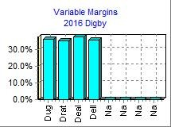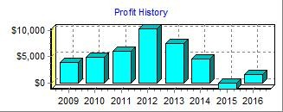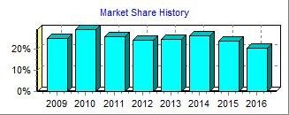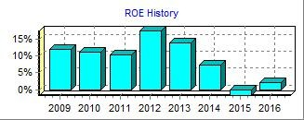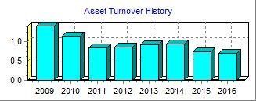Top
Annual Report Digby C59559
2016 Income Statement

Round: 3
Dec
. 31, 2016

(Product Name:) Dug Drat Deal Dell Na Na
Sales $31,429 $32,844 $38,281 $42,619 $0 $0

Variable Costs:
Direct Labor $5,880 $6,089 $7,322 $8,011 $0 $0 Direct Material $13,806 $14,751 $16,057 $18,992 $0 $0 Inventory Carry $317 $394 $490 $489 $0 $0 Total Variable $20,003 $21,234 $23,869 $27,492 $0 $0
2016
Common

Contribution Margin $11,427 $11,609 $14,412 $15,127 $0 $0

Period Costs:
Total  $145,174 | Size 100.0%
$27,302 | 18.8%
$63,606 | 43.8%
$1,691 | 1.2%
$92,598 | 63.8%
$52,576 | 36.2%

Na  $0 | Na  $0
$0 | $0
$0 | $0
$0 | $0
$0 | $0
$0 | $0

Depreciation $4,447 $4,907 $2,913 $3,420 $0 $0 $0 $0 $15,687 10.8% SG&A: R&D $1,000 $1,000 $0 $0 $0 $0 $0 $0 $2,000 1.4%
Promotions $1,250 $1,250 $1,250 $1,250 $0 $0 $0 $0 $5,000 3.4% Sales $1,400 $1,400 $1,100 $1,100 $0 $0 $0 $0 $5,000 3.4%
Admin $286 $298 $348 $387 $0 $0 $0 $0 $1,319 0.9% Total Period $8,382 $8,855 $5,611 $6,157 $0 $0 $0 $0 $29,006 20.0%

Net Margin $3,044 $2,754 $8,801 $8,970 $0 $0 $0 $0 $23,570 16.2%

Definitions: Sales: Unit sales times list price. Direct Labor: Labor costs incurred to produce the product that was sold. Inventory Carry Cost: the cost to carry unsold goods in inventory. Depreciation: Calculated on straight-line 15-year depreciation of plant value. R&D Costs: R&D department expenditures for each product. Admin: Administration overhead is estimated at 1.5% of sales. Promotions: The promotion budget for each product. Sales: The sales force budget for each product. Other: Charges not included in other categories such as Fees, Write Offs, and TQM. The fees include money paid to investment bankers and brokerage firms to issue new stocks or bonds plus consulting fees your instructor might assess. Write-offs include the loss you might experience when you sell capacity or liquidate inventory as the result of eliminating a production line. If the amount appears as a negative amount, then you actually made money on the liquidation of capacity or inventory. EBIT: Earnings Before Interest and Taxes. Short Term Interest: Interest expense based on last year's current debt, including short term debt, long term notes that have become due, and emergency loans. Long Term Interest: Interest paid on outstanding bonds. Taxes: Income tax based upon a 35% tax rate. Profit Sharing: Profits shared with employees under the labor contract. Net Profit: EBIT minus interest, taxes, and profit sharing.

Other $6,056 4.2%
EBIT $17,514 12.1%
Short Term Interest $3,749 2.6%
LongTerm Interest $11,230 7.7%
Taxes $887 0.6%
Profit Sharing $33 0.0%
Net Profit $1,614 1.1%

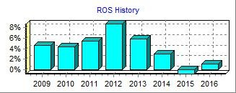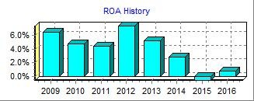

Annual Report Page 2

