Page 1 Front Page  Page 2 Stocks & Bonds  Page 3 Financial Summary  Page 4 Production Analysis | Page 5 Thrift Segment Analysis  Page 6 Core Segment Analysis  Page 7 Nano Segment Analysis  Page 8 Elite Segment Analysis | Page 9 Market Share Page 10 Perceptual Map Page 11 HR/TQM Report

Annual Report Andrews | Annual Report Baldwin | Annual Report Chester | Annual Report Digby

PRINT

Top
"

Round: 2
Dec. 31, 2015

Student: Efren Escoto

EsEcfroeton

Andrews
Efren Escoto

Baldwin Chester

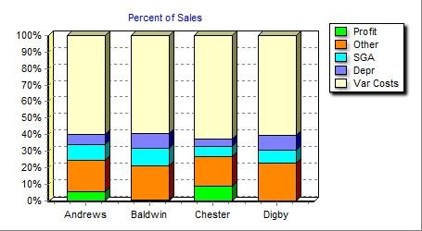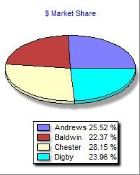

Digby

Selected Financial Statistics

 | Andrews | Baldwin | Chester | Digby
ROS | 6.0% | 0.6% | 9.1% | -0.8%
Asset Turnover | 1.10 | 0.69 | 1.25 | 0.73
ROA | 6.6% | 0.4% | 11.4% | -0.6%
Leverage (Assets/Equity) | 1.7 | 2.5 | 1.9 | 2.9
ROE | 11.2% | 1.0% | 22.3% | -1.7%
Emergency Loan | $0 | $0 | $0 | $0
Sales | $160,547,759 | $140,706,366 | $177,076,547 | $150,730,295
EBIT | $20,702,998 | $15,517,792 | $31,740,664 | $13,980,967
Profits | $9,586,140 | $796,755 | $16,169,854 | ($1,220,875)
Cumulative Profit | $14,326,212 | $4,529,356 | $29,192,092 | $3,361,271
SG&A / Sales | 10.2% | 12.1% | 6.9% | 9.1%
Contrib. Margin % | 35.6% | 34.4% | 33.6% | 32.8%

COMP-XM® INQUIRER Page 1

Stocks & Bonds Efren Escoto

Round: 2

December 31 , 2015

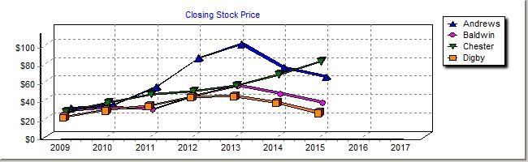

Stock Market Summary

Company | Close | Change | Shares | MarketCap ($M) | Book Value | EPS | Dividend | Yield | P/E
Andrews | $60.44 | ($9.85) | 2,050,942 | $124 | $41.80 | $4.67 | $0.00 | 0.0% | 12.9
Baldwin | $34.33 | ($9.79) | 2,675,670 | $92 | $30.13 | $0.30 | $0.00 | 0.0% | 114.9
Chester | $80.51 | $13.92 | 1,915,875 | $154 | $37.89 | $8.44 | $0.00 | 0.0% | 9.5
Digby | $26.71 | ($11.09) | 2,882,967 | $77 | $24.49 | ($0.42) | $0.00 | 0.0% | -63.2

Bond Market Summary

Company | Series# | Face | Yield | Close$ | S&P
Andrews | 11.2S2020 | $8,837,000 | 11.4% | 97.83 | BBB
 | 11.9S2021 | $7,072,000 | 11.9% | 100.41 | BBB
 | 10.9S2024 | $12,000,000 | 11.5% | 95.17 | BBB
 | 11.0S2025 | $13,000,000 | 11.5% | 95.44 | BBB
Baldwin | 11.2S2020 | $8,632,724 | 12.3% | 91.03 | CC
 | 12.4S2021 | $5,825,802 | 13.1% | 94.53 | CC
 | 12.0S2023 | $15,610,279 | 13.1% | 91.59 | CC
 | 12.6S2024 | $17,788,546 | 13.4% | 94.02 | CC
 | 13.1S2025 | $34,902,738 | 13.6% | 96.32 | CC
Chester | 11.1S2022 | $2,509,600 | 11.9% | 93.28 | B
 | 11.2S2023 | $5,662,814 | 12.0% | 93.19 | B
 | 11.5S2024 | $1,377,976 | 12.2% | 94.27 | B
 | 11.6S2025 | $18,600,072 | 12.3% | 94.49 | B
Digby | 11.3S2020 | $10,417,600 | 12.5% | 90.09 | C
 | 12.5S2021 | $14,665,611 | 13.4% | 93.42 | C
 | 12.5S2022 | $7,963,435 | 13.5% | 92.75 | C
 | 12.5S2023 | $9,569,958 | 13.6% | 92.17 | C
 | 12.9S2024  13.4S2025 | $14,262,838  $28,649,980 | 13.8%  14.0% | 93.62  95.86 | C C
Next Year's Prime Rate 8.50%
COMP-XM® INQUIRER Page 2

Financial Summary |  | Efren Escoto |  | Round: 2  December 31, 2015
Cash Flow Statement Survey | Andrews | Baldwin | Chester | Digby
Cash flows from operating activities
Net Income (Loss) | $9,586 | $797 | $16,170 | ($1,221)
Adjustment for non-cash items:
Depreciation | $10,846 | $13,224 | $8,217 | $14,367
Extraordinary gains/losses/writeoffs | ($965) | $0 | $0 | $0
Changes in current assets and liabilities:
Accounts payable | ($31) | $864 | $2,121 | ($1,204)
Inventory | $5,097 | $2,948 | ($8,546) | $8,042
Accounts receivable | ($1,087) | ($1,947) | ($1,881) | $95
Net cash from operations | $23,447 | $15,885 | $16,081 | $20,078
Cash flows from investing activities
Plant improvements (net) | ($29,448) | ($53,460) | ($29,300) | ($37,940)
Cash flows from financing activities
Dividends paid | $0 | $0 | $0 | $0
Sales of common stock | $0 | $18,534 | $2,360 | $9,609
Purchase of common stock | $0 | $0 | $0 | $0
Cash from long term debt issued | $13,000 | $34,903 | $18,600 | $28,650
Early retirement of long term debt | $0 | $0 | $0 | $0
Retirement of current debt | $0 | ($21,710) | ($13,971) | ($25,277)
Cash from current debt borrowing | $0 | $21,955 | $19,361 | $30,185
Cash from emergency loan | $0 | $0 | $0 | $0
Net cash from financing activities | $13,000 | $53,682 | $26,349 | $43,167
Net change in cash position | $6,999 | $16,108 | $13,130 | $25,305
Balance Sheet Survey | Andrews | Baldwin | Chester | Digby
Cash | $17,450 | $35,643 | $32,587 | $50,770
Accounts Receivable | $13,196 | $11,565 | $14,554 | $12,389
Inventory | $13,487 | $8,324 | $20,657 | $4,059
Total Current Assets | $44,133 | $55,532 | $67,799 | $67,218
Plant and equipment | $162,696 | $218,760 | $123,260 | $215,500
Accumulated Depreciation | ($60,952) | ($70,400) | ($49,504) | ($77,471)
Total Fixed Assets | $101,744 | $148,360 | $73,756 | $138,029
Total Assets | $145,876 | $203,892 | $141,555 | $205,247
Accounts Payable | $7,940 | $7,257 | $10,159 | $7,622
Current Debt | $11,300 | $33,255 | $30,661 | $41,485
Long Term Debt | $40,909 | $82,760 | $28,150 | $85,529
Total Liabilities | $60,149 | $123,272 | $68,970 | $134,636
Common Stock | $12,081 | $37,278 | $11,159 | $37,118
Retained Earnings | $73,647 | $43,342 | $61,425 | $33,493
Total Equity | $85,728 | $80,620 | $72,584 | $70,610
Total Liabilities & Owners' Equity | $145,876 | $203,892 | $141,555 | $205,247
Income Statement Survey | Andrews | Baldwin | Chester | Digby
Sales | $160,548 | $140,706 | $177,077 | $150,730
Variable Costs (Labor, Material, Carry) | $103,314 | $92,239 | $117,533 | $101,267
Depreciation | $10,846 | $13,224 | $8,217 | $14,367
SGA (R&D, Promo, Sales, Admin) | $16,350 | $17,054 | $12,288 | $13,703
Other (Fees, Writeoffs, TQM, Bonuses) | $9,335 | $2,672 | $7,298 | $7,413
EBIT | $20,703 | $15,518 | $31,741 | $13,981
Interest (Short term, Long term) | $5,654 | $14,267 | $6,356 | $15,859
Taxes | $5,267 | $438 | $8,885 | ($657)
Profit Sharing | $196 | $16 | $330 | $0
Net Profit | $9,586 | $797 | $16,170 | ($1,221)
COMP-XM® INQUIRER | Page 3

Production Analysis Efren Escoto

Round: 2
December 31, 2015

Production Information

Unit

2nd Shift
&

Auto
mation Capacity

Primary
Name | Segment | Sold | tory | Revision Date | Dec.31 | MTBF | Coord | Coord | Price | Cost | Cost | Marg. | time | Round | Round | Utiliz.
Ark | Elite | 1,059 | 0 | 8/30/2015 | 1.3 | 26000 | 14.7 | 7.9 | $40.00 | $14.72 | $10.13 | 38% | 50% | 5.5 | 914 | 148%
Able | Thrift | 1,356 | 0 | 11/19/2015 | 2.1 | 20000 | 7.3 | 12.6 | $21.00 | $7.91 | $5.38 | 34% | 0% | 8.5 | 930 | 92%
Acre | Core | 1,666 | 604 | 12/3/2015 | 1.3 | 20000 | 10.2 | 9.9 | $26.50 | $10.25 | $5.60 | 35% | 9% | 7.6 | 1,800 | 108%
Awe | Nano | 1,248 | 150 | 11/18/2015 | 1.2 | 22000 | 12.2 | 5.3 | $36.50 | $13.66 | $10.01 | 35% | 44% | 5.5 | 1,228 | 142%
Buzz | Thrift | 1,335 | 113 | 12/19/2016 | 3.5 | 14000 | 7.0 | 13.2 | $18.00 | $6.26 | $2.33 | 50% | 0% | 9.5 | 1,250 | 91%
Brat | Core | 2,091 | 34 | 12/7/2014 | 2.1 | 16000 | 9.4 | 10.8 | $20.00 | $9.01 | $5.18 | 27% | 30% | 8.0 | 1,500 | 129%
Baker | Nano | 1,022 | 164 | 12/17/2015 | 1.0 | 18000 | 12.1 | 5.7 | $30.00 | $13.17 | $6.50 | 35% | 31% | 6.0 | 850 | 130%
Bead | Elite | 841 | 175 | 12/18/2015 | 1.0 | 20000 | 14.9 | 7.9 | $34.00 | $14.05 | $7.37 | 37% | 13% | 6.0 | 850 | 111%
Bid | Core | 743 | 0 | 4/1/2015 | 0.8 | 16000 | 10.0 | 10.2 | $21.00 | $9.54 | $5.78 | 26% | 100% | 7.0 | 1,040 | 149%
Bold |  | 0 | 0 | 2/10/2016 | 0.0 | 0 | 0.0 | 0.0 | $0.00 | $0.00 | $0.00 | 0% | 0% | 7.0 | 600 | 0%
Cute | Nano | 1,561 | 23 | 12/3/2015 | 1.3 | 23000 | 12.0 | 6.2 | $32.00 | $13.96 | $9.33 | 30% | 100% | 6.0 | 900 | 198%
Crimp | Elite | 880 | 235 | 1/4/2015 | 2.4 | 25000 | 15.2 | 7.7 | $35.00 | $15.32 | $8.73 | 28% | 50% | 6.5 | 850 | 149%
Cake | Nano | 1,256 | 302 | 9/19/2015 | 1.2 | 23000 | 13.1 | 5.0 | $37.00 | $14.96 | $8.13 | 36% | 59% | 6.0 | 1,000 | 157%
Cedar | Elite | 1,279 | 320 | 8/17/2015 | 1.2 | 25000 | 15.0 | 7.2 | $39.00 | $15.41 | $7.97 | 38% | 47% | 6.0 | 1,150 | 146%
Dug | Thrift | 2,216 | 0 | 4/11/2015 | 2.7 | 17000 | 7.8 | 12.4 | $17.00 | $7.76 | $3.93 | 31% | 100% | 9.0 | 1,450 | 198%
Drat | Thrift | 2,310 | 0 | 4/11/2015 | 2.6 | 17000 | 8.0 | 12.2 | $17.00 | $7.94 | $3.81 | 30% | 72% | 9.0 | 1,600 | 170%
Deal | Core | 1,390 | 141 | 12/16/2015 | 1.1 | 18000 | 10.9 | 8.7 | $25.00 | $11.07 | $4.49 | 37% | 29% | 8.0 | 1,050 | 127%
Dell | Core | 1,561 | 113 | 12/18/2015 | 1.1 | 20000 | 11.6 | 9.2 | $25.00 | $11.75 | $4.33 | 34% | 16% | 8.0 | 1,250 | 115%

Units
Inven
Age
Pfmn
Size
Material
Labor
Contr.
Over-
Next
Next
Plant

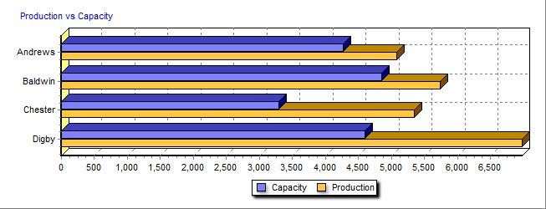

COMP-XM® INQUIRER Page 4

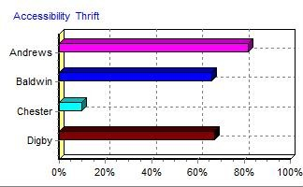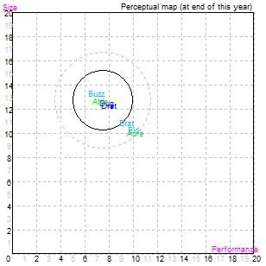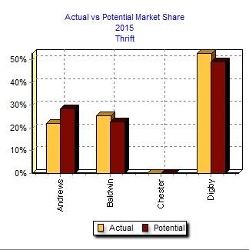Top

Thrift Market Segment Analysis Efren Escoto

Round: 2
December 31, 2015

Thrift Statistics
Total Industry Unit Demand | 6,293
Actual Industry Unit Sales | 6,293
Segment % of Total Industry | 26.4%
Next Year's Segment Growth Rate 11.0%

Thrift Customer Buying Criteria
 |  | Expectations | Importance
1. | Price | $14.00 - 26.00 | 55%
2. | Reliability | MTBF 14000-20000 | 20%
3. | Ideal Position | Pfmn 7.5 Size 12.7 | 15%
4. | Age | Ideal Age = 3.0 | 10%
Perceptual Map for Thrift Segment

Top Products in Thrift Segment

Name | Market Share | Units Sold  to Seg | Revision Date | Stock Out | Pfmn Coord | Size Coord | List Price | MTBF | Age Dec.31 | Promo Cust. Aware- Budget ness |  | Sales Cust. Access- Dec. Cust. Budget ibility Survey
Drat | 26% | 1,664 | 4/11/2015 | YES | 8.0 | 12.2 | $17.00 | 17000 | 2.64 | $1,200 | 74% | $1,100 | 67% | 42
Dug | 26% | 1,650 | 4/11/2015 | YES | 7.8 | 12.4 | $17.00 | 17000 | 2.74 | $1,200 | 73% | $1,100 | 67% | 44
Buzz | 18% | 1,142 | 12/19/2016 |  | 7.0 | 13.2 | $18.00 | 14000 | 3.48 | $1,050 | 61% | $1,000 | 66% | 26
Able | 18% | 1,133 | 11/19/2015 | YES | 7.3 | 12.6 | $21.00 | 20000 | 2.09 | $1,400 | 91% | $2,000 | 82% | 44
Brat | 7% | 428 | 12/7/2014 |  | 9.4 | 10.8 | $20.00 | 16000 | 2.11 | $1,050 | 61% | $1,000 | 66% | 14
Acre | 4% | 249 | 12/3/2015 |  | 10.2 | 9.9 | $26.50 | 20000 | 1.35 | $1,200 | 82% | $1,000 | 82% | 1
Bid | 0% | 28 | 4/1/2015 | YES | 10.0 | 10.2 | $21.00 | 16000 | 0.75 | $1,050 | 48% | $900 | 66% | 3
COMP-XM® INQUIRER Page 5

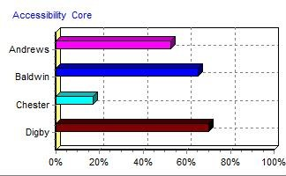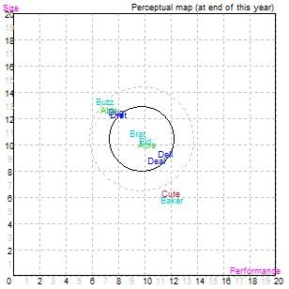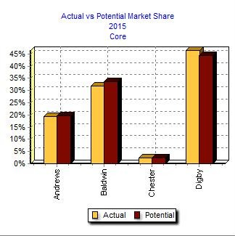Top

Core Market Segment Analysis Efren Escoto

Round: 2
December 31, 2015

Core Statistics
Total Industry Unit Demand | 8,089
Actual Industry Unit Sales | 8,089
Segment % of Total Industry | 34.0%
Next Year's Segment Growth Rate 10.0%

Core Customer Buying Criteria
 |  | Expectations | Importance
1. | Price | $20.00 - 32.00 | 46%
2. | Age | Ideal Age = 2.0 | 20%
3. | Reliability | MTBF 16000-22000 | 18%
4. | Ideal Position | Pfmn 10.2 Size 10.0 | 16%
Perceptual Map for Core Segment

Top Products in Core Segment

Name | Market Share | Units Sold  to Seg | Revision Date | Stock Out | Pfmn Coord | Size Coord | List Price | MTBF | Age Dec.31 | Promo Cust. Aware- Budget ness |  | Sales Cust. Access- Dec. Cust. Budget ibility Survey
Brat | 21% | 1,663 | 12/7/2014 |  | 9.4 | 10.8 | $20.00 | 16000 | 2.11 | $1,050 | 61% | $1,000 | 65% | 38
Dell | 17% | 1,348 | 12/18/2015 |  | 11.6 | 9.2 | $25.00 | 20000 | 1.10 | $1,200 | 73% | $900 | 70% | 30
Acre | 17% | 1,339 | 12/3/2015 |  | 10.2 | 9.9 | $26.50 | 20000 | 1.35 | $1,200 | 82% | $1,000 | 53% | 35
Deal | 15% | 1,194 | 12/16/2015 |  | 10.9 | 8.7 | $25.00 | 18000 | 1.09 | $1,200 | 73% | $900 | 70% | 26
Bid | 9% | 715 | 4/1/2015 | YES | 10.0 | 10.2 | $21.00 | 16000 | 0.75 | $1,050 | 48% | $900 | 65% | 33
Drat | 8% | 646 | 4/11/2015 | YES | 8.0 | 12.2 | $17.00 | 17000 | 2.64 | $1,200 | 74% | $1,100 | 70% | 18
Dug | 7% | 567 | 4/11/2015 | YES | 7.8 | 12.4 | $17.00 | 17000 | 2.74 | $1,200 | 73% | $1,100 | 70% | 14
Able | 3% | 223 | 11/19/2015 | YES | 7.3 | 12.6 | $21.00 | 20000 | 2.09 | $1,400 | 91% | $2,000 | 53% | 20
Cute | 2% | 201 | 12/3/2015 |  | 12.0 | 6.2 | $32.00 | 23000 | 1.35 | $1,300 | 82% | $900 | 17% | 0
Buzz | 2% | 193 | 12/19/2016 |  | 7.0 | 13.2 | $18.00 | 14000 | 3.48 | $1,050 | 61% | $1,000 | 65% | 0
COMP-XM® INQUIRER Page 6

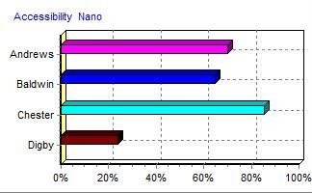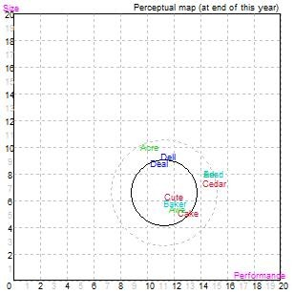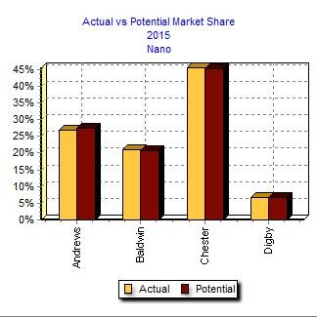Top

Nano Market Segment Analysis Efren Escoto

Round: 2
December 31, 2015

Nano Statistics
Total Industry Unit Demand | 4,747
Actual Industry Unit Sales | 4,747
Segment % of Total Industry | 19.9%
Next Year's Segment Growth Rate 14.0%

Nano Customer Buying Criteria
 |  | Expectations | Importance
1. | Ideal Position | Pfmn 12.1 Size 5.5 | 35%
2. | Price | $28.00 - 40.00 | 27%
3. | Age | Ideal Age = 1.0 | 20%
4. | Reliability | MTBF 18000-24000 | 18%
Perceptual Map for Nano Segment

Top Products in Nano Segment

Name | Market Share | Units Sold  to Seg | Revision Date | Stock Out | Pfmn Coord | Size Coord | List Price | MTBF | Age Dec.31 | Promo Cust. Aware- Budget ness |  | Sales Cust. Access- Dec. Cust. Budget ibility Survey
Cake | 23% | 1,080 | 9/19/2015 |  | 13.1 | 5.0 | $37.00 | 23000 | 1.20 | $1,300 | 82% | $800 | 85% | 45
Awe | 22% | 1,035 | 11/18/2015 |  | 12.2 | 5.3 | $36.50 | 22000 | 1.22 | $1,500 | 95% | $1,100 | 70% | 49
Cute | 20% | 939 | 12/3/2015 |  | 12.0 | 6.2 | $32.00 | 23000 | 1.35 | $1,300 | 82% | $900 | 85% | 64
Baker | 17% | 829 | 12/17/2015 |  | 12.1 | 5.7 | $30.00 | 18000 | 1.04 | $1,050 | 61% | $900 | 65% | 41
Ark | 4% | 187 | 8/30/2015 | YES | 14.7 | 7.9 | $40.00 | 26000 | 1.30 | $1,300 | 86% | $1,200 | 70% | 4
Deal | 4% | 167 | 12/16/2015 |  | 10.9 | 8.7 | $25.00 | 18000 | 1.09 | $1,200 | 73% | $900 | 24% | 8
Bead | 3% | 165 | 12/18/2015 |  | 14.9 | 7.9 | $34.00 | 20000 | 1.05 | $1,050 | 61% | $1,500 | 65% | 2
Dell | 3% | 156 | 12/18/2015 |  | 11.6 | 9.2 | $25.00 | 20000 | 1.10 | $1,200 | 73% | $900 | 24% | 9
Cedar | 3% | 139 | 8/17/2015 |  | 15.0 | 7.2 | $39.00 | 25000 | 1.24 | $1,300 | 81% | $800 | 85% | 4
Acre | 1% | 51 | 12/3/2015 |  | 10.2 | 9.9 | $26.50 | 20000 | 1.35 | $1,200 | 82% | $1,000 | 70% | 7
COMP-XM® INQUIRER Page 7

Elite Market Segment Analysis Efren Escoto

Round: 2
December 31, 2015

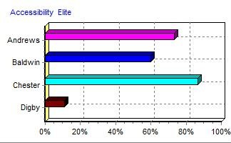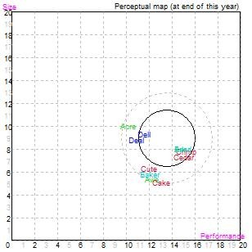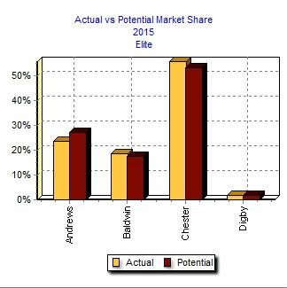

Elite Statistics
Total Industry Unit Demand | 4,684
Actual Industry Unit Sales | 4,684
Segment % of Total Industry | 19.7%
Next Year's Segment Growth Rate 16.0%

Elite Customer Buying Criteria
 |  | Expectations | Importance
1. | Age | Ideal Age = 0.0 | 34%
2. | Price | $30.00 - 42.00 | 24%
3. | Ideal Position | Pfmn 14.7 Size 8.1 | 22%
4. | Reliability | MTBF 20000-26000 | 20%
Perceptual Map for Elite Segment

Top Products in Elite Segment

Name | Market Share | Units Sold  to Seg | Revision Date | Stock Out | Pfmn Coord | Size Coord | List Price | MTBF | Age Dec.31 | Promo Cust. Aware- Budget ness |  | Sales Cust. Access- Dec. Cust. Budget ibility Survey
Cedar | 24% | 1,139 | 8/17/2015 |  | 15.0 | 7.2 | $39.00 | 25000 | 1.24 | $1,300 | 81% | $800 | 87% | 41
Crimp | 19% | 880 | 1/4/2015 |  | 15.2 | 7.7 | $35.00 | 25000 | 2.45 | $1,300 | 82% | $900 | 87% | 36
Ark | 19% | 872 | 8/30/2015 | YES | 14.7 | 7.9 | $40.00 | 26000 | 1.30 | $1,300 | 86% | $1,200 | 73% | 42
Bead | 14% | 677 | 12/18/2015 |  | 14.9 | 7.9 | $34.00 | 20000 | 1.05 | $1,050 | 61% | $1,500 | 60% | 30
Cute | 9% | 421 | 12/3/2015 |  | 12.0 | 6.2 | $32.00 | 23000 | 1.35 | $1,300 | 82% | $900 | 87% | 18
Awe | 5% | 213 | 11/18/2015 |  | 12.2 | 5.3 | $36.50 | 22000 | 1.22 | $1,500 | 95% | $1,100 | 73% | 2
Baker | 4% | 194 | 12/17/2015 |  | 12.1 | 5.7 | $30.00 | 18000 | 1.04 | $1,050 | 61% | $900 | 60% | 4
Cake | 4% | 176 | 9/19/2015 |  | 13.1 | 5.0 | $37.00 | 23000 | 1.20 | $1,300 | 82% | $800 | 87% | 1
Dell | 1% | 57 | 12/18/2015 |  | 11.6 | 9.2 | $25.00 | 20000 | 1.10 | $1,200 | 73% | $900 | 11% | 3
Deal | 1% | 29 | 12/16/2015 |  | 10.9 | 8.7 | $25.00 | 18000 | 1.09 | $1,200 | 73% | $900 | 11% | 1
Acre | 1% | 27 | 12/3/2015 |  | 10.2 | 9.9 | $26.50 | 20000 | 1.35 | $1,200 | 82% | $1,000 | 73% | 3
COMP-XM® INQUIRER Page 8

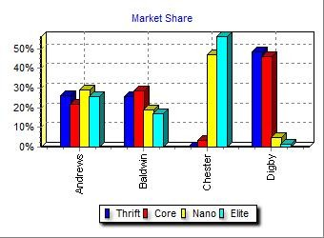
Market Share Report |  |  |  |  |  |  | Efren Escoto | Round: 2  December 31, 2015
 | 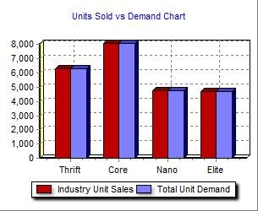
 |  | Actual Market Share in Units |  |  |  |  | Potential Market Share in Units
 |  | Thrift Core Nano Elite | Total |  |  |  | Thrift Core Nano Elite | Total
Industry Unit |  |  |  |  |  | Units
Sales |  | 6,293 8,089 4,747 4,684 | 23,814 |  |  | Demanded | 6,293 8,089 4,747 4,684 | 23,814
% of Market |  | 26.4% 34.0% 19.9% 19.7% | 100.0% |  |  | % of Market | 26.4% 34.0% 19.9% 19.7% | 100.0%
Ark |  | 3.9% 18.6% | 4.5% |  |  | Ark | 4.7% 22.3% | 5.3%
Able |  | 18.0% 2.8% | 5.7% |  |  | Able | 24.8% 3.8% | 7.8%
Acre |  | 4.0% 16.6% 1.1% 0.6% | 7.0% |  |  | Acre | 3.6% 15.8% 1.1% 0.5% | 6.6%
Awe |  | 21.8% 4.5% | 5.2% |  |  | Awe | 21.6% 4.3% | 5.2%
Total |  | 22.0% 19.3% 26.8% 23.7% | 22.4% |  |  | Total | 28.4% 19.6% 27.3% 27.2% | 25.0%
Buzz |  | 18.1% 2.4% | 5.6% |  |  | Buzz | 16.1% 2.3% | 5.1%
Brat |  | 6.8% 20.6% | 8.8% |  |  | Brat | 5.8% 19.7% | 8.2%
Baker |  | 17.4% 4.1% | 4.3% |  |  | Baker | 17.3% 3.9% | 4.2%
Bead |  | 3.5% 14.4% | 3.5% |  |  | Bead | 3.4% 13.8% | 3.4%
Bid |  | 0.4% 8.8% | 3.1% |  |  | Bid | 0.6% 11.5% | 4.1%
Total |  | 25.4% 31.8% 20.9% 18.6% | 25.3% |  |  | Total | 22.6% 33.5% 20.7% 17.7% | 25.0%
Cute |  | 2.5% 19.8% 9.0% | 6.5% |  |  | Cute | 2.4% 19.8% 8.7% | 6.5%
Crimp |  | 18.8% | 3.7% |  |  | Crimp | 17.9% | 3.5%
Cake |  | 22.7% 3.8% | 5.3% |  |  | Cake | 22.5% 3.6% | 5.2%
Cedar |  | 2.9% 24.3% | 5.4% |  |  | Cedar | 2.9% 23.1% | 5.1%
Total |  | 2.5% 45.5% 55.9% | 20.9% |  |  | Total | 2.4% 45.2% 53.3% | 20.3%
Dug |  | 26.2% 7.0% | 9.3% |  |  | Dug | 24.8% 6.8% | 8.9%
Drat |  | 26.4% 8.0% | 9.7% |  |  | Drat | 24.2% 7.7% | 9.0%
Deal |  | 14.8% 3.5% 0.6% | 5.8% |  |  | Deal | 14.1% 3.5% 0.6% | 5.6%
Dell |  | 16.7% 3.3% 1.2% | 6.6% |  |  | Dell | 15.9% 3.3% 1.2% | 6.3%
Total |  | 52.7% 46.4% 6.8% 1.8% | 31.4% |  |  | Total | 49.0% 44.5% 6.7% 1.8% | 29.7%
COMP-XM® INQUIRER Page 9

Perceptual Map Efren Escoto

Round: 2
December 31, 2015

Perceptual Map for All Segments

Andrews

Name Pfmn Size Revised
Ark 14.7 7.9 8/30/2015
Able 7.3 12.6 11/19/2015
Acre 10.2 9.9 12/3/2015
Awe 12.2 5.3 11/18/2015

Digby

Name Pfmn Size Revised
Dug 7.8 12.4 4/11/2015
Drat 8.0 12.2 4/11/2015
Deal 10.9 8.7 12/16/2015
Dell 11.6 9.2 12/18/2015

Baldwin

Name Pfmn Size Revised
Buzz 7.0 13.2 12/19/2016
Brat 9.4 10.8 12/7/2014
Baker 12.1 5.7 12/17/2015
Bead 14.9 7.9 12/18/2015
Bid 10.0 10.2 4/1/2015

Chester

Name Pfmn Size Revised
Cute 12.0 6.2 12/3/2015
Crimp 15.2 7.7 1/4/2015
Cake 13.1 5.0 9/19/2015
Cedar 15.0 7.2 8/17/2015

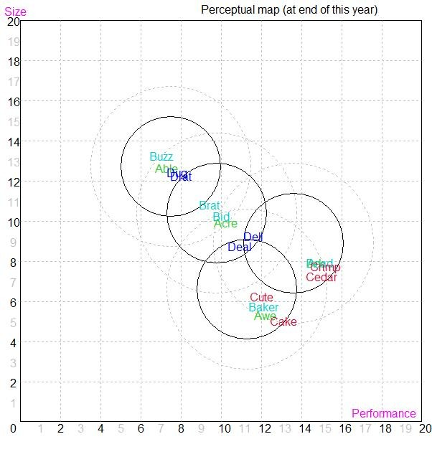

COMP-XM® INQUIRER Page 10

HR/TQM Report |  |  |  |  | Efren Escoto December Round: 2
 | HUMAN RESOURCES SUMMARY
Needed Complement |  | Andrews | Baldwin | Chester | Digby
 |  | 629 | 489 | 662 | 430
Complement |  | 629 | 489 | 662 | 430
1st Shift Complement |  | 496 | 383 | 403 | 288
2nd Shift Complement |  | 133 | 106 | 259 | 142
Overtime% |  | 0.0% | 0.0% | 0.0% | 0.0%
Turnover Rate |  | 7.0% | 6.3% | 10.0% | 8.0%
New Employees |  | 44 | 89 | 145 | 34
Separated Employees |  | 69 | 0 | 0 | 182
Recruiting Spend |  | $150 | $5,000 | $0 | $2,500
Training Hours |  | 80 | 80 | 0 | 40
Productivity Index |  | 104.6% | 124.2% | 100.0% | 113.9%
Recruiting Cost |  | $51 | $537 | $145 | $121
Separation Cost |  | $345 | $0 | $0 | $912
Training Cost |  | $1,006 | $782 | $0 | $344
Total HR Admin Cost |  | $1,402 | $1,319 | $145 | $1,377
Labor Contract Next Year
Wages |  | $28.15 | $28.15 | $28.15 | $28.15
Benefits |  | 2,500 | 2,500 | 2,500 | 2,500
Profit Sharing |  | 2.0% | 2.0% | 2.0% | 2.0%
Annual Raise |  | 5.0% | 5.0% | 5.0% | 5.0%
Starting Negotiation Position
Wages
Benefits
Profit Sharing
Annual Raise
Ceiling Negotiation Position
Wages
Benefits
Profit Sharing
Annual Raise
Adjusted Labor Demands
Wages
Benefits
Profit Sharing
Annual Raise
Strike Days
TQM SUMMARY
Process Mgt Budgets Last Year |  | Andrews | Baldwin | Chester | Digby
CPI Systems |  | $1,200 | $0 | $0 | $1,250
Vendor/JIT |  | $2,000 | $0 | $0 | $1,250
Quality Initiative Training |  | $800 | $0 | $1,250 | $0
Channel Support Systems |  | $500 | $0 | $1,250 | $1,500
Concurrent Engineering |  | $300 | $0 | $1,250 | $0
UNEP Green Programs |  | $1,000 | $0 | $0 | $0
TQM Budgets Last Year
Benchmarking |  | $100 | $0 | $0 | $0
Quality Function Deployment Effort |  | $1,800 | $0 | $0 | $0
CCE/6 Sigma Training |  | $1,800 | $0 | $1,250 | $750
GEMI TQEM Sustainability Initiatives |  | $150 | $0 | $1,250 | $750
Total Expenditures |  | $9,650 | $0 | $6,250 | $5,500
Cumulative Impacts
Material Cost Reduction |  | 6.51% | 0.00% | 2.92% | 1.40%
Labor Cost Reduction |  | 5.12% | 0.00% | 11.25% | 0.33%
Reduction R&D Cycle Time |  | 4.06% | 0.00% | 32.13% | 0.00%
Reduction Admin Costs |  | 24.11% | 0.00% | 0.00% | 3.25%
Demand Increase |  | 2.04% | 0.00% | 4.56% | 1.16%
COMP-XM® INQUIRER |  | Page 11

PRINT
Annual Report

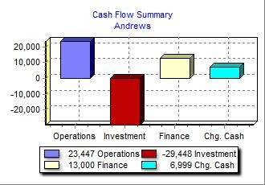Top
Annual Report Andrews C59559

Balance Sheet
DEFINITIONS: Common Size: The common size column simply represents each item as a percentage of total assets for that year. Cash: Your end-of-year cash position. Accounts Receivable: Reflects the lag between delivery | ASSETS  Cash | $17,450 |  | 2015  Common  Size 12.0% | 2014  $10,451
and payment of your products. Inventories: The current | Accounts Receivable | $13,196 |  | 9.0% | $12,109
value of your inventory across all products. A zero indicates | Inventory | $13,487 |  | 9.2% | $18,584
course, fall to your competitors. Plant & Equipment: The | Total Current Assets |  | $44,133 | 30.3% | $41,144
current value of your plant. Accum Deprec: The total  accumulated depreciation from your plant. Accts Payable: | Plant & Equipment | $162,696 |  | 111.5% | $135,628
What the company currently owes suppliers for materials and services. Current Debt: The debt the company is | Accumulated Depreciation | ($60,952) |  | -41.8% | ($53,451)
obligated to pay during the next year of operations. It includes emergency loans used to keep your company | Total Fixed Assets |  | $101,744 | 69.7% | $82,177
solvent should you run out of cash during the year. Long  Term Debt: The company's long term debt is in the form of | Total Assets |  | $145,876 | 100.0% | $123,321
Common Stock: The amount of capital invested by | LIABILITIES & OWNERS' EQUITY
shareholders in the company. Retained Earnings: The  profits that the company chose to keep instead of paying to | Accounts Payable | $7,940 |  | 5.4% | $7,970
shareholders as dividends. | Current Debt | $11,300 |  | 7.7% | $0
 | Long Term Debt | $40,909 |  | 28.0% | $39,209
 | Total Liabilities |  | $60,149 | 41.2% | $47,179
 | Common Stock | $12,081 |  | 8.3% | $12,081
 | Retained Earnings | $73,647 |  | 50.5% | $64,060
 | Total Equity |  | $85,728 | 58.8% | $76,141
 | Total Liab. & O. Equity |  | $145,876 | 100.0% | $123,321

Round: 2
Dec
. 31, 2015

your company stocked out. Unmet demand would, of

bonds, and this represents the total value of your bonds.

Cash Flow Statement

The Cash Flow Statement examines what happened in the Cash Account during the Cash Flows from Operating Activities: 2015 2014

year. Cash injections appear as positive numbers and cash withdrawals as negative numbers. The Cash Flow Statement is an excellent tool for diagnosing emergency loans. When negative cash flows exceed positives, you are forced to seek emergency funding. For example, if sales are bad and you find yourself carrying an abundance of excess inventory, the report would show the increase in inventory as a huge negative cash flow. Too much unexpected inventory could outstrip your inflows, exhaust your starting cash and
Net Income (Loss) $9,586 $4,740
Depreciation $10,846 $9,042
Extraordinary gains/losses/writeoffs ($965) $0
Accounts Payable ($31) ($1,546)
Inventory $5,097 $6,948
Accounts Receivable ($1,087) $1,347
Net cash from operations $23,447 $20,531

Cash Flows from Investing Activities:
Plant Improvements ($29,448) ($38,804)

Cash Flows from Financing Activities:
Dividends Paid $0 $0
Sales of Common Stock $0 $0
Purchase of Common Stock $0 $0
Cash from long term debt $13,000 $12,000
Retirement of long term debt ($11,300) $0
Change in current debt (net) $11,300 ($15,717)
Net cash from financing activities $13,000 ($3,717)
Net change in cash position $6,999 ($21,990)
Closing cash position $17,450 $10,451

Annual Report Page 1

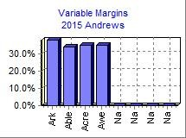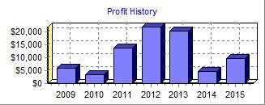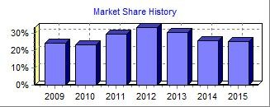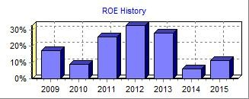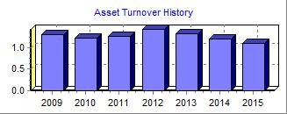Top
Annual Report Andrews C59559
2015 Income Statement

Round: 2
Dec
. 31, 2015

(Product Name:) Ark Able Acre Awe Na Na
Sales $42,379 $28,472 $44,159 $45,538 $0 $0

Variable Costs:
Direct Labor $10,730 $8,244 $10,678 $12,510 $0 $0 Direct Material $15,509 $10,532 $16,819 $16,674 $0 $0 Inventory Carry $0 $0 $1,197 $422 $0 $0 Total Variable $26,239 $18,776 $28,693 $29,606 $0 $0
2015
Common

Contribution Margin $16,140 $9,696 $15,466 $15,932 $0 $0

Period Costs:
Total  $160,548 | Size 100.0%
$42,162 | 26.3%
$59,533 | 37.1%
$1,618 | 1.0%
$103,314 | 64.4%
$57,234 | 35.6%

Na  $0 | Na  $0
$0 | $0
$0 | $0
$0 | $0
$0 | $0
$0 | $0

Depreciation $1,706 $2,480 $4,368 $2,292 $0 $0 $0 $0 $10,846 6.8% SG&A: R&D $672 $895 $935 $893 $0 $0 $0 $0 $3,395 2.1%
Promotions $1,300 $1,400 $1,200 $1,500 $0 $0 $0 $0 $5,400 3.4% Sales $1,200 $2,000 $1,000 $1,100 $0 $0 $0 $0 $5,300 3.3%
Admin $595 $400 $620 $640 $0 $0 $0 $0 $2,255 1.4% Total Period $5,474 $7,175 $8,123 $6,425 $0 $0 $0 $0 $27,196 16.9%

Net Margin $10,667 $2,521 $7,343 $9,507 $0 $0 $0 $0 $30,038 18.7%

Definitions: Sales: Unit sales times list price. Direct Labor: Labor costs incurred to produce the product that was sold. Inventory Carry Cost: the cost to carry unsold goods in inventory. Depreciation: Calculated on straight-line 15-year depreciation of plant value. R&D Costs: R&D department expenditures for each product. Admin: Administration overhead is estimated at 1.5% of sales. Promotions: The promotion budget for each product. Sales: The sales force budget for each product. Other: Charges not included in other categories such as Fees, Write Offs, and TQM. The fees include money paid to investment bankers and brokerage firms to issue new stocks or bonds plus consulting fees your instructor might assess. Write-offs include the loss you might experience when you sell capacity or liquidate inventory as the result of eliminating a production line. If the amount appears as a negative amount, then you actually made money on the liquidation of capacity or inventory. EBIT: Earnings Before Interest and Taxes. Short Term Interest: Interest expense based on last year's current debt, including short term debt, long term notes that have become due, and emergency loans. Long Term Interest: Interest paid on outstanding bonds. Taxes: Income tax based upon a 35% tax rate. Profit Sharing: Profits shared with employees under the labor contract. Net Profit: EBIT minus interest, taxes, and profit sharing.

Other $9,335 5.8%
EBIT $20,703 12.9%
Short Term Interest $1,085 0.7%
LongTerm Interest $4,569 2.8%
Taxes $5,267 3.3%
Profit Sharing $196 0.1%
Net Profit $9,586 6.0%

Annual Report Page 2
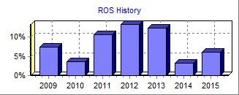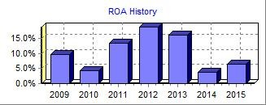PRINT
Annual Report

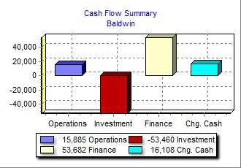Top
Annual Report Baldwin C59559

Balance Sheet
DEFINITIONS: Common Size: The common size column simply represents each item as a percentage of total assets for that year. Cash: Your end-of-year cash position. Accounts Receivable: Reflects the lag between delivery | ASSETS  Cash | $35,643 |  | 2015  Common  Size 17.5% | 2014  $19,535
and payment of your products. Inventories: The current | Accounts Receivable | $11,565 |  | 5.7% | $9,617
value of your inventory across all products. A zero indicates | Inventory | $8,324 |  | 4.1% | $11,272
course, fall to your competitors. Plant & Equipment: The | Total Current Assets |  | $55,532 | 27.2% | $40,424
current value of your plant. Accum Deprec: The total  accumulated depreciation from your plant. Accts Payable: | Plant & Equipment | $218,760 |  | 107.3% | $165,300
What the company currently owes suppliers for materials and services. Current Debt: The debt the company is | Accumulated Depreciation | ($70,400) |  | -34.5% | ($57,176)
obligated to pay during the next year of operations. It includes emergency loans used to keep your company | Total Fixed Assets |  | $148,360 | 72.8% | $108,124
solvent should you run out of cash during the year. Long  Term Debt: The company's long term debt is in the form of | Total Assets |  | $203,892 | 100.0% | $148,549
Common Stock: The amount of capital invested by | LIABILITIES & OWNERS' EQUITY
shareholders in the company. Retained Earnings: The  profits that the company chose to keep instead of paying to | Accounts Payable | $7,257 |  | 3.6% | $6,393
shareholders as dividends. | Current Debt | $33,255 |  | 16.3% | $21,710
 | Long Term Debt | $82,760 |  | 40.6% | $59,157
 | Total Liabilities |  | $123,272 | 60.5% | $87,260
 | Common Stock | $37,278 |  | 18.3% | $18,743
 | Retained Earnings | $43,342 |  | 21.3% | $42,545
 | Total Equity |  | $80,620 | 39.5% | $61,288
 | Total Liab. & O. Equity |  | $203,892 | 100.0% | $148,549

Round: 2
Dec
. 31, 2015

your company stocked out. Unmet demand would, of

bonds, and this represents the total value of your bonds.

Cash Flow Statement

The Cash Flow Statement examines what happened in the Cash Account during the Cash Flows from Operating Activities: 2015 2014

year. Cash injections appear as positive numbers and cash withdrawals as negative numbers. The Cash Flow Statement is an excellent tool for diagnosing emergency loans. When negative cash flows exceed positives, you are forced to seek emergency funding. For example, if sales are bad and you find yourself carrying an abundance of excess inventory, the report would show the increase in inventory as a huge negative cash flow. Too much unexpected inventory could outstrip your inflows, exhaust your starting cash and
Net Income (Loss) $797 $3,733
Depreciation $13,224 $9,887
Extraordinary gains/losses/writeoffs $0 $0
Accounts Payable $864 $596
Inventory $2,948 ($3,891)
Accounts Receivable ($1,947) $132
Net cash from operations $15,885 $10,456

Cash Flows from Investing Activities:
Plant Improvements ($53,460) ($40,900)

Cash Flows from Financing Activities:
Dividends Paid $0 $0
Sales of Common Stock $18,534 $4,365 Purchase of Common Stock $0 $0
Cash from long term debt $34,903 $17,789
Retirement of long term debt ($11,300) $0
Change in current debt (net) $11,545 ($3,812)
Net cash from financing activities $53,682 $18,341
Net change in cash position $16,108 ($12,103)
Closing cash position $35,643 $19,535

Annual Report Page 1

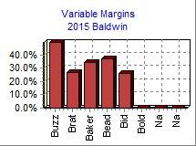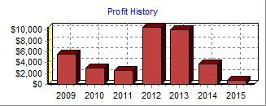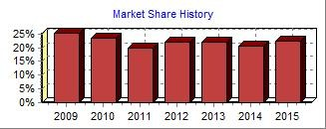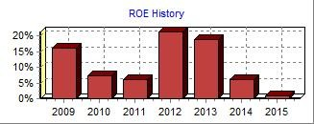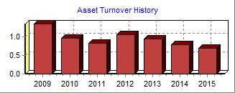Top
Annual Report Baldwin C59559
2015 Income Statement

Round: 2
Dec
. 31, 2015

(Product Name:) Buzz Brat Baker Bead Bid Bold
Sales $24,021 $41,814 $30,671 $28,604 $15,596 $0

Variable Costs:
Direct Labor $3,226 $10,918 $6,591 $6,158 $4,293 $0 Direct Material $8,780 $19,508 $13,065 $11,420 $7,281 $0 Inventory Carry $122 $60 $379 $438 $0 $0 Total Variable $12,128 $30,486 $20,035 $18,017 $11,574 $0
2015
Common

Contribution Margin $11,893 $11,329 $10,636 $10,587 $4,022 $0

Period Costs:
Total  $140,706 | Size 100.0%
$31,186 | 22.2%
$60,054 | 42.7%
$999 | 0.7%
$92,239 | 65.6%
$48,467 | 34.4%

Na  $0 | Na  $0
$0 | $0
$0 | $0
$0 | $0
$0 | $0
$0 | $0

Depreciation $3,667 $3,800 $1,700 $1,700 $2,357 $0 $0 $0 $13,224 9.4% SG&A: R&D $1,000 $0 $973 $977 $250 $1,000 $0 $0 $4,200 3.0%
Promotions $1,050 $1,050 $1,050 $1,050 $1,050 $0 $0 $0 $5,250 3.7% Sales $1,000 $1,000 $900 $1,500 $900 $0 $0 $0 $5,300 3.8%
Admin $393 $685 $502 $468 $255 $0 $0 $0 $2,304 1.6% Total Period $7,110 $6,535 $5,125 $5,695 $4,813 $1,000 $0 $0 $30,278 21.5%

Net Margin $4,783 $4,794 $5,511 $4,892 ($791) ($1,000) $0 $0 $18,190 12.9%

Definitions: Sales: Unit sales times list price. Direct Labor: Labor costs incurred to produce the product that was sold. Inventory Carry Cost: the cost to carry unsold goods in inventory. Depreciation: Calculated on straight-line 15-year depreciation of plant value. R&D Costs: R&D department expenditures for each product. Admin: Administration overhead is estimated at 1.5% of sales. Promotions: The promotion budget for each product. Sales: The sales force budget for each product. Other: Charges not included in other categories such as Fees, Write Offs, and TQM. The fees include money paid to investment bankers and brokerage firms to issue new stocks or bonds plus consulting fees your instructor might assess. Write-offs include the loss you might experience when you sell capacity or liquidate inventory as the result of eliminating a production line. If the amount appears as a negative amount, then you actually made money on the liquidation of capacity or inventory. EBIT: Earnings Before Interest and Taxes. Short Term Interest: Interest expense based on last year's current debt, including short term debt, long term notes that have become due, and emergency loans. Long Term Interest: Interest paid on outstanding bonds. Taxes: Income tax based upon a 35% tax rate. Profit Sharing: Profits shared with employees under the labor contract. Net Profit: EBIT minus interest, taxes, and profit sharing.

Other $2,672 1.9%
EBIT $15,518 11.0%
Short Term Interest $3,891 2.8%
LongTerm Interest $10,376 7.4%
Taxes $438 0.3%
Profit Sharing $16 0.0%
Net Profit $797 0.6%

Annual Report Page 2
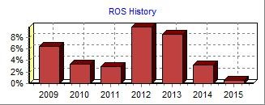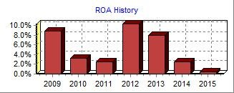PRINT
Annual Report

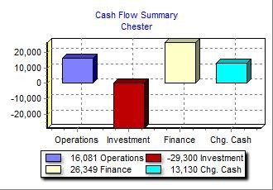Top
Annual Report Chester C59559

Balance Sheet
DEFINITIONS: Common Size: The common size column simply represents each item as a percentage of total assets for that year. Cash: Your end-of-year cash position. Accounts Receivable: Reflects the lag between delivery | ASSETS  Cash | $32,587 |  | 2015  Common  Size 23.0% | 2014  $19,458
and payment of your products. Inventories: The current | Accounts Receivable | $14,554 |  | 10.3% | $12,673
value of your inventory across all products. A zero indicates | Inventory | $20,657 |  | 14.6% | $12,111
course, fall to your competitors. Plant & Equipment: The | Total Current Assets |  | $67,798 | 47.9% | $44,242
current value of your plant. Accum Deprec: The total  accumulated depreciation from your plant. Accts Payable: | Plant & Equipment | $123,260 |  | 87.1% | $93,960
What the company currently owes suppliers for materials and services. Current Debt: The debt the company is | Accumulated Depreciation | ($49,504) |  | -35.0% | ($41,287)
obligated to pay during the next year of operations. It includes emergency loans used to keep your company | Total Fixed Assets |  | $73,756 | 52.1% | $52,673
solvent should you run out of cash during the year. Long  Term Debt: The company's long term debt is in the form of | Total Assets |  | $141,555 | 100.0% | $96,915
Common Stock: The amount of capital invested by | LIABILITIES & OWNERS' EQUITY
shareholders in the company. Retained Earnings: The  profits that the company chose to keep instead of paying to | Accounts Payable | $10,159 |  | 7.2% | $8,038
shareholders as dividends. | Current Debt | $30,661 |  | 21.7% | $13,971
 | Long Term Debt | $28,150 |  | 19.9% | $20,850
 | Total Liabilities |  | $68,970 | 48.7% | $42,859
 | Common Stock | $11,159 |  | 7.9% | $8,799
 | Retained Earnings | $61,425 |  | 43.4% | $45,256
 | Total Equity |  | $72,584 | 51.3% | $54,055
 | Total Liab. & O. Equity |  | $141,555 | 100.0% | $96,915

Round: 2
Dec
. 31, 2015

your company stocked out. Unmet demand would, of

bonds, and this represents the total value of your bonds.

Cash Flow Statement

The Cash Flow Statement examines what happened in the Cash Account during the Cash Flows from Operating Activities: 2015 2014

year. Cash injections appear as positive numbers and cash withdrawals as negative numbers. The Cash Flow Statement is an excellent tool for diagnosing emergency loans. When negative cash flows exceed positives, you are forced to seek emergency funding. For example, if sales are bad and you find yourself carrying an abundance of excess inventory, the report would show the increase in inventory as a huge negative cash flow. Too much unexpected inventory could outstrip your inflows, exhaust your starting cash and
Net Income (Loss) $16,170 $13,022
Depreciation $8,217 $6,264
Extraordinary gains/losses/writeoffs $0 $0 Accounts Payable $2,121 $1,437
Inventory ($8,546) $4,720
Accounts Receivable ($1,881) ($2,832)
Net cash from operations $16,081 $22,611

Cash Flows from Investing Activities:
Plant Improvements ($29,300) ($9,580)

Cash Flows from Financing Activities:
Dividends Paid $0 ($6,494)
Sales of Common Stock $2,360 $0
Purchase of Common Stock $0 ($1,609)
Cash from long term debt $18,600 $1,378
Retirement of long term debt ($11,300) $0
Change in current debt (net) $16,689 ($4,473)
Net cash from financing activities $26,349 ($11,198)
Net change in cash position $13,130 $1,833
Closing cash position $32,587 $19,458

Annual Report Page 1

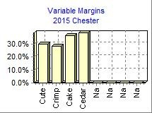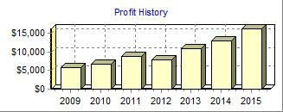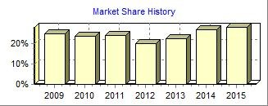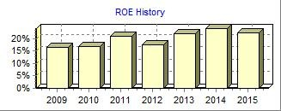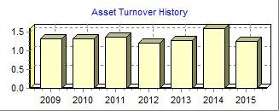Top
Annual Report Chester C59559
2015 Income Statement

Round: 2
Dec
. 31, 2015

(Product Name:) Cute Crimp Cake Cedar Na Na
Sales $49,950 $30,795 $46,457 $49,875 $0 $0

Variable Costs:
Direct Labor $14,571 $7,680 $10,285 $10,226 $0 $0 Direct Material $20,404 $13,769 $18,500 $19,618 $0 $0 Inventory Carry $63 $688 $832 $897 $0 $0 Total Variable $35,038 $22,137 $29,617 $30,741 $0 $0
2015
Common

Contribution Margin $14,912 $8,658 $16,840 $19,134 $0 $0

Period Costs:
Total  $177,077 | Size 100.0%
$42,763 | 24.1%
$72,291 | 40.8%
$2,479 | 1.4%
$117,533 | 66.4%
$59,544 | 33.6%

Na  $0 | Na  $0
$0 | $0
$0 | $0
$0 | $0
$0 | $0
$0 | $0

Depreciation $2,104 $1,813 $2,000 $2,300 $0 $0 $0 $0 $8,217 4.6% SG&A: R&D $934 $9 $727 $634 $0 $0 $0 $0 $2,304 1.3%
Promotions $1,300 $1,300 $1,300 $1,300 $0 $0 $0 $0 $5,200 2.9% Sales $900 $900 $800 $800 $0 $0 $0 $0 $3,400 1.9% Admin $390 $241 $363 $390 $0 $0 $0 $0 $1,384 0.8% Total Period $5,629 $4,263 $5,190 $5,423 $0 $0 $0 $0 $20,505 11.6%

Net Margin $9,283 $4,395 $11,650 $13,711 $0 $0 $0 $0 $39,039 22.0%

Definitions: Sales: Unit sales times list price. Direct Labor: Labor costs incurred to produce the product that was sold. Inventory Carry Cost: the cost to carry unsold goods in inventory. Depreciation: Calculated on straight-line 15-year depreciation of plant value. R&D Costs: R&D department expenditures for each product. Admin: Administration overhead is estimated at 1.5% of sales. Promotions: The promotion budget for each product. Sales: The sales force budget for each product. Other: Charges not included in other categories such as Fees, Write Offs, and TQM. The fees include money paid to investment bankers and brokerage firms to issue new stocks or bonds plus consulting fees your instructor might assess. Write-offs include the loss you might experience when you sell capacity or liquidate inventory as the result of eliminating a production line. If the amount appears as a negative amount, then you actually made money on the liquidation of capacity or inventory. EBIT: Earnings Before Interest and Taxes. Short Term Interest: Interest expense based on last year's current debt, including short term debt, long term notes that have become due, and emergency loans. Long Term Interest: Interest paid on outstanding bonds. Taxes: Income tax based upon a 35% tax rate. Profit Sharing: Profits shared with employees under the labor contract. Net Profit: EBIT minus interest, taxes, and profit sharing.

Other $7,298 4.1%
EBIT $31,741 17.9%
Short Term Interest $3,127 1.8%
LongTerm Interest $3,229 1.8%
Taxes $8,885 5.0%
Profit Sharing $330 0.2%
Net Profit $16,170 9.1%

Annual Report Page 2
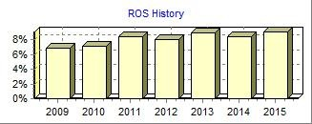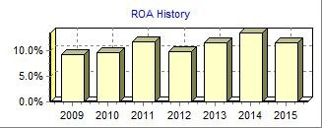PRINT
Annual Report

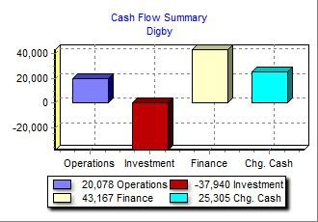Top
Annual Report Digby C59559

Balance Sheet
DEFINITIONS: Common Size: The common size column simply represents each item as a percentage of total assets for that year. Cash: Your end-of-year cash position. Accounts Receivable: Reflects the lag between delivery | ASSETS  Cash | $50,770 |  | 2015  Common  Size 24.7% | 2014  $25,465
and payment of your products. Inventories: The current | Accounts Receivable | $12,389 |  | 6.0% | $12,483
value of your inventory across all products. A zero indicates | Inventory | $4,059 |  | 2.0% | $12,101
course, fall to your competitors. Plant & Equipment: The | Total Current Assets |  | $67,218 | 32.7% | $50,049
current value of your plant. Accum Deprec: The total  accumulated depreciation from your plant. Accts Payable: | Plant & Equipment | $215,500 |  | 105.0% | $177,560
What the company currently owes suppliers for materials and services. Current Debt: The debt the company is | Accumulated Depreciation | ($77,471) |  | -37.7% | ($63,104)
obligated to pay during the next year of operations. It includes emergency loans used to keep your company | Total Fixed Assets |  | $138,029 | 67.3% | $114,456
solvent should you run out of cash during the year. Long  Term Debt: The company's long term debt is in the form of | Total Assets |  | $205,247 | 100.0% | $164,505
Common Stock: The amount of capital invested by | LIABILITIES & OWNERS' EQUITY
shareholders in the company. Retained Earnings: The  profits that the company chose to keep instead of paying to | Accounts Payable | $7,622 |  | 3.7% | $8,826
shareholders as dividends. | Current Debt | $41,485 |  | 20.2% | $25,277
 | Long Term Debt | $85,529 |  | 41.7% | $68,179
 | Total Liabilities |  | $134,636 | 65.6% | $102,282
 | Common Stock | $37,118 |  | 18.1% | $27,509
 | Retained Earnings | $33,493 |  | 16.3% | $34,713
 | Total Equity |  | $70,611 | 34.4% | $62,222
 | Total Liab. & O. Equity |  | $205,247 | 100.0% | $164,505

Round: 2
Dec
. 31, 2015

your company stocked out. Unmet demand would, of

bonds, and this represents the total value of your bonds.

Cash Flow Statement

The Cash Flow Statement examines what happened in the Cash Account during the Cash Flows from Operating Activities: 2015 2014

year. Cash injections appear as positive numbers and cash withdrawals as negative numbers. The Cash Flow Statement is an excellent tool for diagnosing emergency loans. When negative cash flows exceed positives, you are forced to seek emergency funding. For example, if sales are bad and you find yourself carrying an abundance of excess inventory, the report would show the increase in inventory as a huge negative cash flow. Too much unexpected inventory could outstrip your inflows, exhaust your starting cash and
Net Income (Loss) ($1,221) $4,582
Depreciation $14,367 $11,837
Extraordinary gains/losses/writeoffs $0 $0 Accounts Payable ($1,204) $1,628
Inventory $8,042 ($2,107)
Accounts Receivable $95 ($1,636)
Net cash from operations $20,078 $14,304

Cash Flows from Investing Activities:
Plant Improvements ($37,940) ($34,660)

Cash Flows from Financing Activities:
Dividends Paid $0 $0
Sales of Common Stock $9,609 $2,840
Purchase of Common Stock $0 $0
Cash from long term debt $28,650 $14,263
Retirement of long term debt ($11,300) $0
Change in current debt (net) $16,208 ($4,005)
Net cash from financing activities $43,167 $13,098
Net change in cash position $25,305 ($7,259)
Closing cash position $50,770 $25,465

Annual Report Page 1

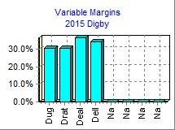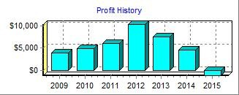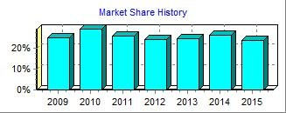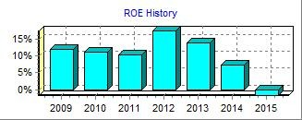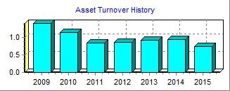Top
Annual Report Digby C59559
2015 Income Statement

Round: 2
Dec
. 31, 2015

(Product Name:) Dug Drat Deal Dell Na Na
Sales $37,677 $39,268 $34,752 $39,032 $0 $0

Variable Costs:
Direct Labor $8,795 $8,909 $6,705 $7,435 $0 $0 Direct Material $17,304 $18,460 $15,112 $18,059 $0 $0 Inventory Carry $0 $0 $265 $222 $0 $0 Total Variable $26,099 $27,370 $22,083 $25,716 $0 $0
2015
Common

Contribution Margin $11,578 $11,899 $12,670 $13,316 $0 $0

Period Costs:
Total  $150,730 | Size 100.0%
$31,844 | 21.1%
$68,936 | 45.7%
$487 | 0.3%
$101,267 | 67.2%
$49,463 | 32.8%

Na  $0 | Na  $0
$0 | $0
$0 | $0
$0 | $0
$0 | $0
$0 | $0

Depreciation $4,060 $4,480 $2,660 $3,167 $0 $0 $0 $0 $14,367 9.5% SG&A: R&D $279 $279 $970 $976 $0 $0 $0 $0 $2,505 1.7%
Promotions $1,200 $1,200 $1,200 $1,200 $0 $0 $0 $0 $4,800 3.2% Sales $1,100 $1,100 $900 $900 $0 $0 $0 $0 $4,000 2.7% Admin $599 $625 $553 $621 $0 $0 $0 $0 $2,398 1.6% Total Period $7,238 $7,684 $6,283 $6,864 $0 $0 $0 $0 $28,069 18.6%

Net Margin $4,340 $4,215 $6,387 $6,452 $0 $0 $0 $0 $21,394 14.2%

Definitions: Sales: Unit sales times list price. Direct Labor: Labor costs incurred to produce the product that was sold. Inventory Carry Cost: the cost to carry unsold goods in inventory. Depreciation: Calculated on straight-line 15-year depreciation of plant value. R&D Costs: R&D department expenditures for each product. Admin: Administration overhead is estimated at 1.5% of sales. Promotions: The promotion budget for each product. Sales: The sales force budget for each product. Other: Charges not included in other categories such as Fees, Write Offs, and TQM. The fees include money paid to investment bankers and brokerage firms to issue new stocks or bonds plus consulting fees your instructor might assess. Write-offs include the loss you might experience when you sell capacity or liquidate inventory as the result of eliminating a production line. If the amount appears as a negative amount, then you actually made money on the liquidation of capacity or inventory. EBIT: Earnings Before Interest and Taxes. Short Term Interest: Interest expense based on last year's current debt, including short term debt, long term notes that have become due, and emergency loans. Long Term Interest: Interest paid on outstanding bonds. Taxes: Income tax based upon a 35% tax rate. Profit Sharing: Profits shared with employees under the labor contract. Net Profit: EBIT minus interest, taxes, and profit sharing.

Other $7,413 4.9%
EBIT $13,981 9.3%
Short Term Interest $4,978 3.3%
LongTerm Interest $10,881 7.2%
Taxes ($657) -0.4%
Profit Sharing $0 0.0%
Net Profit ($1,221) -0.8%

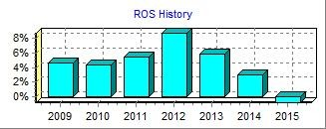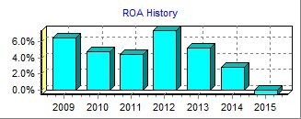
Annual Report Page 2

