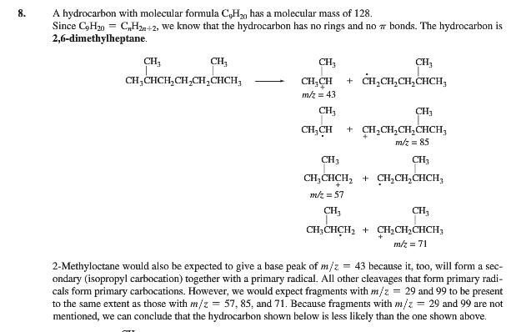
Why does not
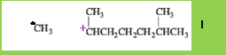
Form. Why is it worse to get a primary radical when a secondary cation is stable versus
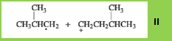
Is it so that 1 unstable (a) and 1 stable (b) forms less than 2 components that has stability between (a) and (b)?Could one come up with a general explanation for that situation as two unstable fragments as in II forms more readily than one more stable and one less stable relatively to II as in I?
I know that the primary radical is unstable but the secondary cation is more stable than other products. Could one explain this by rate laws or rate constants mathematically? And in general explain which radicals and cations that are formed for normal alkanes?

