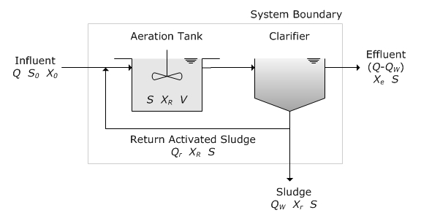
A town in Virginia has a population of 50,000 people. The average flow for each person is 100 gpd. If the design were to use a detention time of 6 hours, and a recirculation rate of 0.5, WAS concentration of 9,000 mg/l, an F/M Ratio of 0.4, and a reactor loading rate of 30 lbs of BOD / 1000 cu.ft. Assume the BOD concentration is 0.25 lbs/c/day and the sedimentation basin has a removal rate of 40% BOD reduction.

Question #1: BOD Load to the AST Tank

Question #2: Volume of the AST Tank in cubic feet

Question #3: Recirculation Flow Rate in MGD

Question #4 Sludge Age in hours

