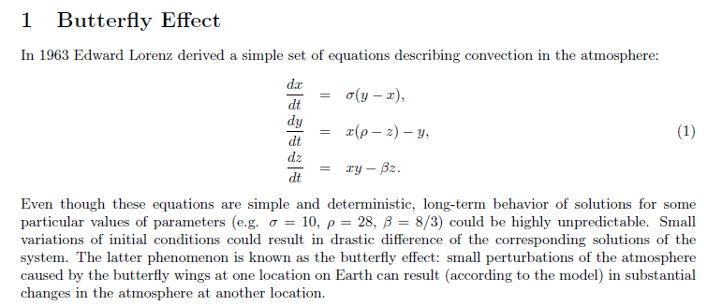
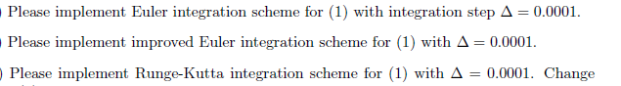
PROBLEM 1
PROBLEM 2
PROBLEM 3
PROBLEM 4

