Purpose
The following Investment Policy Statement is a tool that Boston Holdings, LLC will utilize to manage the investing activities of Investor A. Boston Holdings, LLC will recommend stocks, bonds, and other assets suitable towards Investor A’s long term retirement goals. In doing so, it will be Investor A’s responsibility to evaluate said portfolio on a yearly basis to ensure that activities are within reason to the investment strategies suggested by Boston Holdings, LLC.
Asset Allocation
For asset allocation, roughly 10% is kept as cash to meet any financial emergencies that may occur. The remaining 90% is allocated into small cap ETFs, mid cap ETF’s, S&P 500 Index ETFs, and inverse ETF’s. Overall, the portfolio strategy is aggressive based on Investor A’s individual needs for long term gains. The plan is to invest greater than 10 years so there is a comfort level with the high level of risk involved.
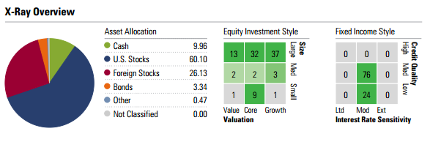
Initially, allocation appears geared toward large-cap companies with a high dosage of investments in technology. Depending on fluctuations in the market place, Boston Holdings, LLC will suggest diversifying the portfolio further by increasing investments in small and mid-cap companies.
