a) The gravitational potential energy $U(r)$ of a mass $m$ due to a mass density $ρ(r)$ satisfies $∇^{2}U$ = 4$π$ $Gmρ$, where G is the gravitational constant. If the earth is considered to be a uniform sphere of mass M, radius R, show that the gravitational potential energy of a mass m inside the earth a distance $r$ from the center is

$U\left(r\right)=\frac{mg}{2R}(r^{2}-3R^{2}$)

where $g$ = $GM/R^{2}$ = 9.81 $m/s^{2}.$

b) A tunnel is to be constructed through the earth, along which a frictionless train will run between cities at A and B. The track is described by the curve $r(ϕ)$ (polar coordinates).
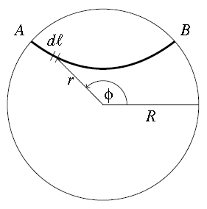

Use energy conservation to derive an expression for the speed $v$ of a train which starts at rest at $A$ as it passes through segment $dl$ of the curve at $r(ϕ)$, and hence show that the journey time is
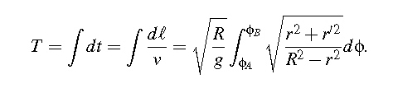

where $r' = dr/dϕ.$

c) The tunnel is to be constructed so as to minimize the journey time. Taking care to note the nature of the integrand, write down an Euler-Lagrange equation for the extremal curve $r(ϕ)$ [not asked to solve this].
Let $a$ be the minimum distance of the tunnel from the center of the earth, where $dr/dϕ$ = 0. Use this to obtain an expression for $dr/dϕ$ in terms of $r, R,$ and $a.$

d) Noting$dϕ$ = $dr/(dr$/$dϕ$), reexpress $T$ as an integral
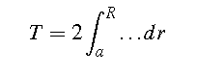

and evaluate.

e) If $R$ = 6,400 km determine the journey time in minutes through the center of the earth.

