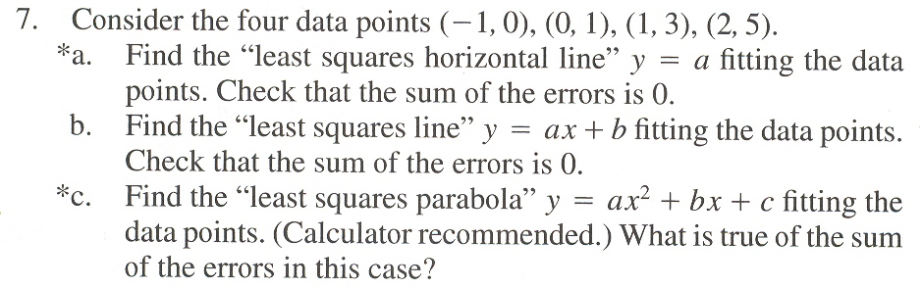

(The material is from INCONSISTENT SYSTEMS AND PROJECTION. Please solve for the part b. Thank you.)

