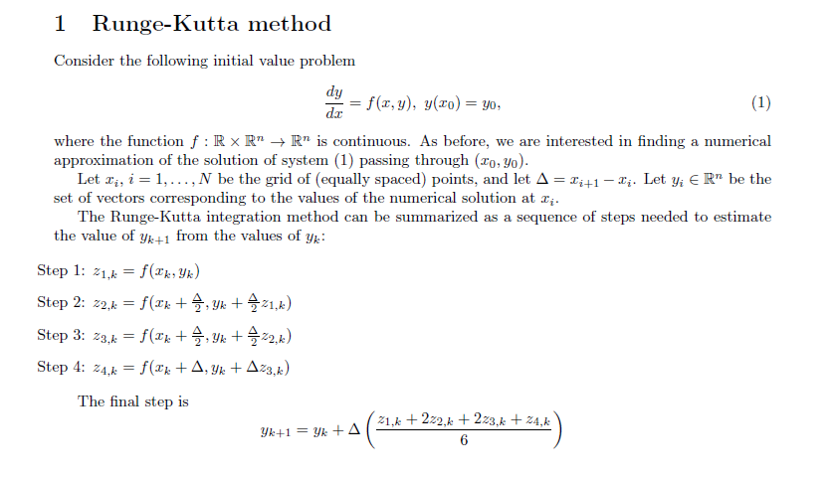
Consider the Lotka-Volterra system ，Consider the following system of differential equations
$\frac{dx}{dt}=-x\left(2-y\right), t_{0}=0, x\left(t_{0}=1\right), (2)$
$\frac{dy}{dt}=y\left(1-2x\right),t_{0}=0, y\left(t_{0}\right)=2, (3)$
Let [0; 40] be the interval of integration.
C1. Implement Runge-Kutta integration scheme with Δ = 0:005 for system (2), (3).Plot the phase curves (trajectories x(t); y(t) in the phase/state space).
C2. Run explicit Euler and improved Euler integration schemes for the same system and same Δ. Plot the phase curves.
How the results compare with the curves obtained using the Runge-Kutta method?

