Application Assignment: Southern Care Hospital
There are various options for organizing a project. Selecting the organizational structure for your project can be an important step in organizing for success. In your readings, you explored the advantages and disadvantages of various organizational structures. In this Application Assignment, you will explore the role of the project manager and select the appropriate organizational structure for the Southern Care Hospital Project.
After reading Chapter 2 of the Mantel text, carefully reread the Southern Care Hospital case study on pages 74–77 and answer the following questions:
- Describe the primary roles and responsibilities of a project manager.
- How would you recommend the project be organized? Functional Project? Pure Project? Matrix?
- What are some of the similarities and differences between the various organizational structures?
- What criteria would you use to select resources to serve on your project team?
- From the available resource pool, who would you select to be on your project team? Why?

Southern Care Hospital
Southern Care Hospital (SCH) is a large, nonprofit regional hospital located in the southeast. Several years ago it contracted with the healthcare division of a major medical equipment supplier to provide Six Sigma training to a group of its hospital employees. Since that time, numerous waves of Green Belts and Black Belts have been trained including people across all job ranks and representing most departments. Green Belt training entails two weeks of formal in-class training while Black Belt training entails the two weeks of Green Belt training plus an additional four weeks of training. Both Green Belt and Black Belt training require the completion of a Six Sigma project in addition to the in-class training.
One challenge currently facing SCH is significant levels of dissatisfaction from the medical staff regarding the three-day lead time it currently averages the nuclear medicine department to turn around the results of stress tests. In this case, “lead time” is defined as the elapsed time from when the stress test is ordered by a physician until the time when a radiologist from the nuclear medicine department signs off on the test results. Stress tests are used to determine the amount of stress the heart can endure before either an abnormal rhythm or insufficient flow of blood to the heart develops. Typically, the stress test is administered by increasing the level of difficulty as a patient walks on a treadmill or rides a stationary bike. During the stress test vital statistics are collected and monitored, including the patient's heart rate and blood pressure. Discussions with the medical staff indicate that they desire maximum lead times of a day and a half.
You have been selected to manage a Six Sigma project focusing on reducing the lead times associated with receiving the results of stress tests. Based on your past experience with similar projects, you have identified 20 major activities. SSH's steering committee has further granted you permission to select up to four team members from the available resource pool to staff the project.
Table 1 provides relevant background information on the 12 people currently available for assignment to a Six Sigma project. All resources are available to the project on a part-time basis and therefore support Six Sigma projects in addition to performing their normal job assignments. The table lists the employee name, job title, level of education, years of work experience, Six Sigma rank (i.e., Green Belt or Black Belt), the number of Six Sigma projects the employee has worked on, the average amount of savings that resulted from the Six Sigma projects the employee has worked on, the employee's hourly rate, and the percent of time the employee is available. The hourly rate represents what will be charged against your project's budget for work performed by a given employee. The percent available is based on a 40-hour work week. Therefore, the number of hours you can utilize a resource during a given week cannot exceed the available percentage times 40. To illustrate, Anna Frost can complete at most 8 hours (20% × 40 hours/week) of project work per week.
(Jr. 74-77)
Jr., Samuel J. M. Project Management in Practice, 4th Edition. John Wiley & Sons, 10/2010. VitalBook file.
The citation provided is a guideline. Please check each citation for accuracy before use.

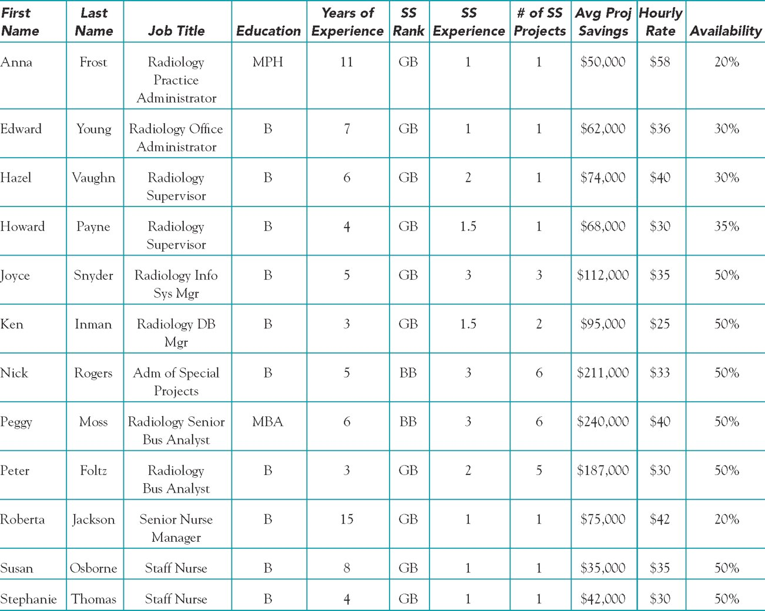
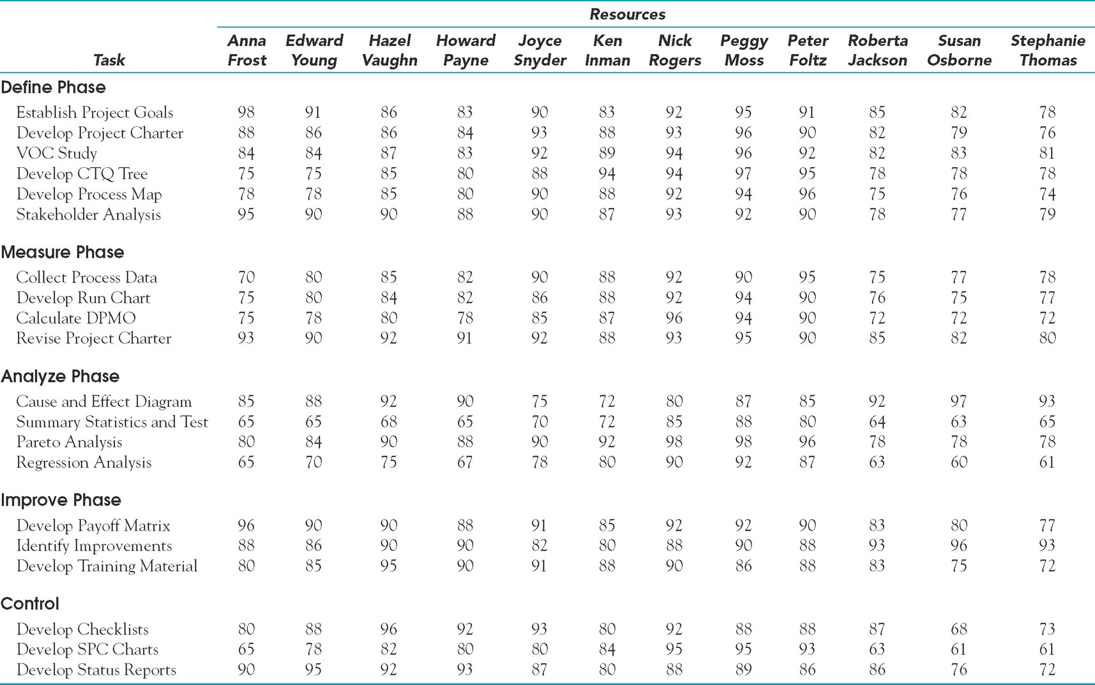

To facilitate project planning, SSH uses an advanced Six Sigma database program to track the progress and performance of all ongoing projects. Furthermore, the HR department has developed a process to estimate the proficiency of employees completing various planned tasks in future Six Sigma projects based on the historical data contained in the database. The proficiency numbers can range between zero and 100, with a zero indicating no ability to perform the task and 100 implying extensive expertise and experience performing the task. Table 2 summarizes this information for the 12 employees listed in Table 1 for the 20 project tasks initially identified. Past experience with these estimates indicates they are fairly accurate over an entire project but that employee performance typically varies ± 3 percentage points within a given week. Thus, an employee with an estimated proficiency of 90 on a particular task would be expected to perform in the 87–93 range on the task in any given week.
A final comment regarding the available resources is in order. Specifically, past experience with projects indicates that conflict occasionally arises when more than one Black Belt is assigned to the same task. When such conflict does arise, it tends to negatively impact both the time required to complete tasks that the Black Belts are jointly assigned to as well as the overall quality of the work performed.
QUESTIONS
1. Explain how you would execute your roles as project manager of this project.
2. As the project manager, how would you manage trade-offs?
3. How would you recommend this project be organized? Functional project? Pure project? Matrix? Why?
4. What criteria would you use in selecting resources to serve on your project team?
5. From the available resource pool, who would you select to be on your project team? Why?
(Jr. 77)
Jr., Samuel J. M. Project Management in Practice, 4th Edition. John Wiley & Sons, 10/2010. VitalBook file.
The citation provided is a guideline. Please check each citation for accuracy before use.

