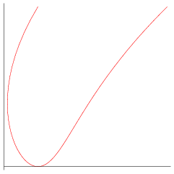1e mtach c explainations
(a) x = t⁴ – t + 3, y = t²
(b) x = t² – 3t, y = √t
(c) x = sin(2t), y = sin(t + sin(2t))
(d) x = cos(5t), y = sin(2t)
(e) x = t + sin(4t), y = t² + cos(3t)
(f) 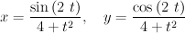
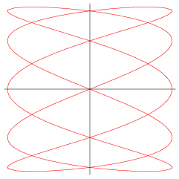1f match c explainations
(a) x = t⁴ – t + 3, y = t²
(b) x = t² – 3t, y = √t
(c) x = sin(2t), y = sin(t + sin(2t))
(d) x = cos(5t), y = sin(2t)
(e) x = t + sin(4t), y = t² + cos(3t)
(f)

