I have chosen the Montessori Method

Review the major curriculum models and approaches discussed in the chapters this week (e.g. Montessori, Reggio Emilia, Creative Curriculum, etc.). Which model/approach most closely matches your own teaching philosophy? Explain why. Then, suppose that you have started a new teaching position and the curriculum you have been asked to use differs significantly from your teaching philosophy. Explain how you will address this difference. Your initial discussion post should be at least 200 words in length.

Montessori Method
While Maria Montessori is a major historical influence on early childhood education, the methods that today bear her name go beyond the work she accomplished in her lifetime; they represent her ideas in action.

Figure 2.4: Curriculum Time Line
The emergence of well-known early childhood curricular models and approaches is interconnected with research, developmental theories, and accumulated practical knowledge about how children learn.
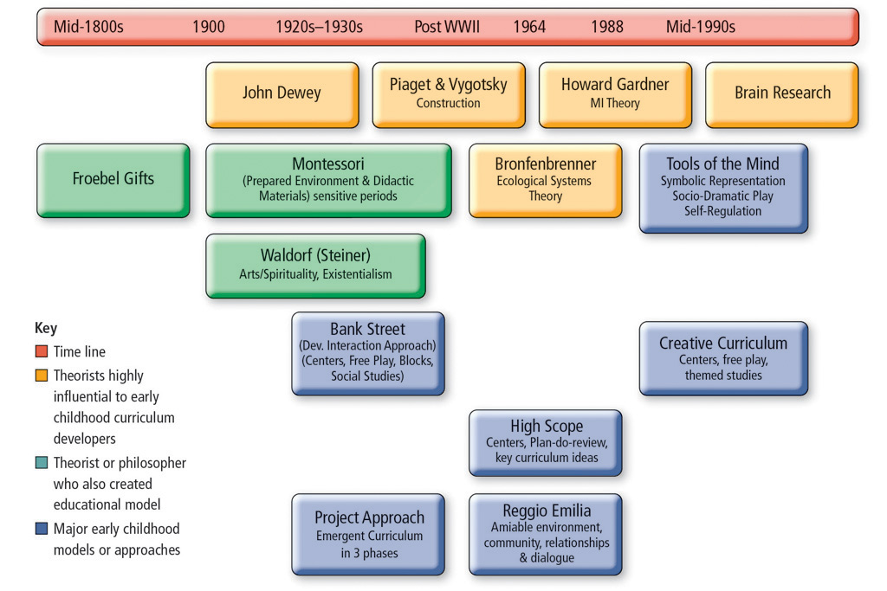

Basic Philosophy and Principles
The books Maria Montessori wrote, including The Absorbent Mind (1949) and The Montessori Method (1909), describe the philosophical and pedagogical principles of her method as well as the expected characteristics and responsibilities of teachers and children that underlie its execution. Among these are the principles of the absorbent mind; the concept of the prepared environment; and the use of child-sized, didactic materials and practical activities designed for a specific purpose.

The Absorbent Mind
The principle of the absorbent mind refers primarily to the notion that children have an innate desire to learn. Further, they are intrinsically motivated to communicate and particularly disposed to learn through imitation and practice (Montessori, 1949). This principle has significant implications for the role of Montessori teachers, as their primary obligation is to encourage children's natural propensity to learn. They observe children carefully for sensitive periods, or windows of time when a child is developmentally and intuitively most receptive to learning particular skills and behaviors. They plan and orchestrate activities according to each child's unique but predictable learning timetable and needs. Montessori teachers see themselves as facilitators or directors of learning who maintain a low profile as they move around the classroom. They observe children's work, demonstrate lessons, and redirect behavior.

The Prepared Environment
Montessori classrooms are orderly and calm, and the environment is carefully organized and sequenced. The classroom is characterized by three primary areas: practical life, sensory materials, and academic materials for reading, writing, and mathematics. Montessori children are free to move about the classroom but must stay on their chosen tasks and use only materials that the teacher has introduced or demonstrated.

The Use of Didactic Materials and Practical Activities
© Vanessa Davies / Getty Images
The materials used in many of today's Montessori programs were inspired by the objects originally developed by Maria Montessori more than a hundred years ago. This image shows a child using the "sandpaper letters," which provide sensory reinforcement of the shape of each letter as the child traces the textured surface.
Like the Montessori environment, Montessori materials and demonstration lessons are organized and sequenced. Some resources and activities, like taking care of plants and sorting picture cards that depict the different parts of a plant, support nature study and physical education, while others, like working with puzzle maps and cards that identify different types of land forms, emphasize geography. Children actively manipulate materials to train their senses, refine their motor skills, and learn academic concepts.
Sensory materials promote discrimination skills and are typically self-correcting. For instance, knobbed cylinders made of wood with a small knob on top encourage manipulation with the thumb and forefinger. Each cylinder fits into only one corresponding hole in a wooden block, so the child knows when a correct match is made. There are several sets of cylinders intended to teach how objects vary by a particular attribute—depth, diameter, or both.
In addition to the cylinders, some of the more commonly recognized sensory materials include:
- Color tablets—Three sets of color tiles that focus on primary colors, secondary colors, and shade and tints of both
- Sound boxes—Cylinders filled with various materials for matching sounds
- Smelling jars—Small glass jars with lids that have holes through which children can smell and compare the contents
- Pink tower—Graduated set of pink wood cubes that vary by one centimeter in each dimension
- Brown stairs—Graduated set of wooden blocks that vary by height and width
Montessori believed that children learn reading through writing first. The academic materials prepare children to hold writing implements properly; learn the shapes and sounds of letters and numbers; gradually put together words, phrases, and sentences; and develop a sense for numbers and geometric forms. While children typically master the practical life and sensory materials by age 4, elementary Montessori still employs the academic materials for math and language activities. Some of the most recognizable academic materials include:
- Sandpaper letters and numerals—for tactile internalization of the shapes of numbers and letters
- Metal stencils—for tracing geometric shapes
- Geometric solids—wooden models of basic shapes
- Movable alphabet—blue vowels and red consonant letters with wooden trays for arranging letters
- Golden beads—beads grouped as singles, tens, hundreds, and one thousand that can be manipulated in various ways to teach the decimal system
Activities are practical and emphasize everyday routines for care of the person, environment, social courtesies, and movement control. Children develop physical coordination and concentration and learn to be self-directed, independent, and responsible. Lessons introduce and reinforce the left-to-right and top-to-bottom orientation children will eventually use to learn to read, write, and perform mathematical operations.
Some of the practical life activities include:
- Pouring rice from one pitcher to another
- Washing and polishing plant leaves
- Mastering different kinds of clothing fasteners
- Walking and balancing on a line
- Greeting visitors
- Dusting tables
Finally, Montessori programs often include gardening and extended periods of time set aside for outdoor activities and exploration.

