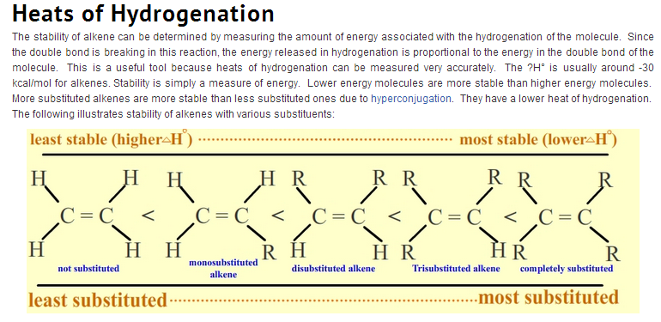
http://chemwiki.ucdavis.edu/Organic_Chemistry/Hydrocarbons/Alkenes/Reactions_of_Alkenes/Catalytic_Hydrogenation_of_Alkenes
Is it possible to determine why more substituted alkenes are more stable. Either by a mathematical formula (not dH that only gives a number for how strong the bonding is but a formula that takes proton and electron forces inte account) or by explaining how the electrons and protons align in a manner that makes it harder to break more substituted pi bonds of alkenes

