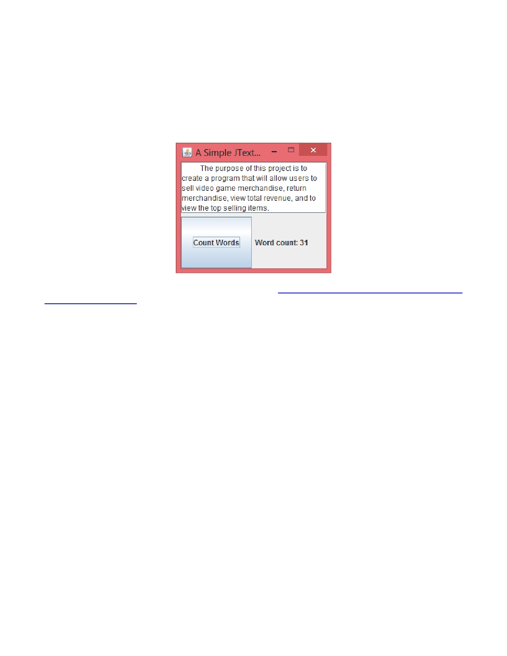
IT308 Short Assignment 6

Problem Description:

Using the GridLayout, write a simple GUI program that allows users to type in any long message and to display the number words when the button "Count Words" is pressed. Set the window frame size to 240 by 200. The gaps
between the components on the layout are 5 px. Make the frame visible and exit on close but not resizable.

Hints: You can use "\\W+" to split the text. Check the link http://stackoverflow.com/questions/9760909/split- string-with-regex-w-w-w.

Submission:
1. Submit your source codes and the corresponding program outputs.

