9.5 How Are Students Diagnosed With ASD?
The diagnosis of ASD is typically made when a child is between 2 and 4 years of age, before beginning school (Chlebowski, Green, Barton, & Fein, 2010). Often parents notice unusual behaviors or developmental patterns in their child and talk to their medical doctor. Physicians, psychiatrists, or other trained medical personnel make the diagnosis for ASD, but schools will evaluate students to determine whether they qualify for services under IDEA 2004.
Some early indicators of ASD are listed in Table 9.4.
Table 9.4: Early Indicators of ASD
Early Indicators of ASD (ages 1–3) | Later Indicators of ASD (ages 4–8)
No babbling or pointing by age 1. | Inability to make friends.
No single words by 16 months. | Impaired ability to start or sustain a conversation.
No two-word phrases by age 2. | Absence of, or impairment in, play.
No response to name. | Stereotyped or repetitive use of language.
Loss of language or social skills. | Restricted patterns of interest.
Poor eye contact. | Preoccupation with certain objects or subjects.
Excessive lining up of toys or objects. | Inflexibility with routines and rituals.
No smiling.
Source: National Institute of Neurological Disorders and Stroke, 2009.
If parents, caregivers, or teachers notice some of these characteristics on a consistent basis, the student should be referred for an initial evaluation to a professional, such as a pediatrician or family physician. Many places also have clinics specializing in the identification and treatment of students with ASD. Parents may be referred to these clinics for evaluation.
It is important to note that a medical diagnosis of ASD may differ from a school diagnosis of ASD. Although uncommon, it is possible for a school to not recognize a student as ASD if the student does not fulfill the criteria for autism under IDEA 2004 guidelines. If a student's educational performance is not affected by ASD, then a school may not be able to diagnose the student as such.
A survey or screening instrument is used to evaluate the child (Bölte et al., 2011; Chlebowski et al., 2010; Flose, Plotts, Kozeneski, & Skinner-Foster, 2011; Mayes et al., 2009). Some examples of instruments include:
- Ages and Stages Questionnaire (ASQ)
- Childhood Autism Rating Scale (CARS)
- Autism Diagnostic Observation Schedule (ADOS)
- Communication and Symbolic Behavior Scales (CSBS) (shown in Figure 9.2)
- Gilliam Autism Rating Scale (GARS)
- Parents' Evaluation of Developmental Status (PEDS)
- Modified Checklist for Autism in Toddlers (MCHAT)
- Social and Communication Disorders Checklist (SCDC)
- Social Responsiveness Scale (SRS)
- Screening Tool for Autism in Toddlers and Young Children (STAT)
A comprehensive evaluation should include information from parents, teachers (if possible), and a medical professional (Bölte et al., 2011). Others who might help with the evaluation include a psychiatrist, psychologist, speech therapist, occupational therapist, ASD specialist, or neurologist.

Figure 9.2: ASD Checklist
The Communication and Symbolic Behavior Scales (CSBS) checklist is used to assess communication skills and social skills of young students (ages 2–4) who are suspected of having ASD. If the parent answers "not yet" to many of the questions, the child should undergo a formal evaluation for ASD.
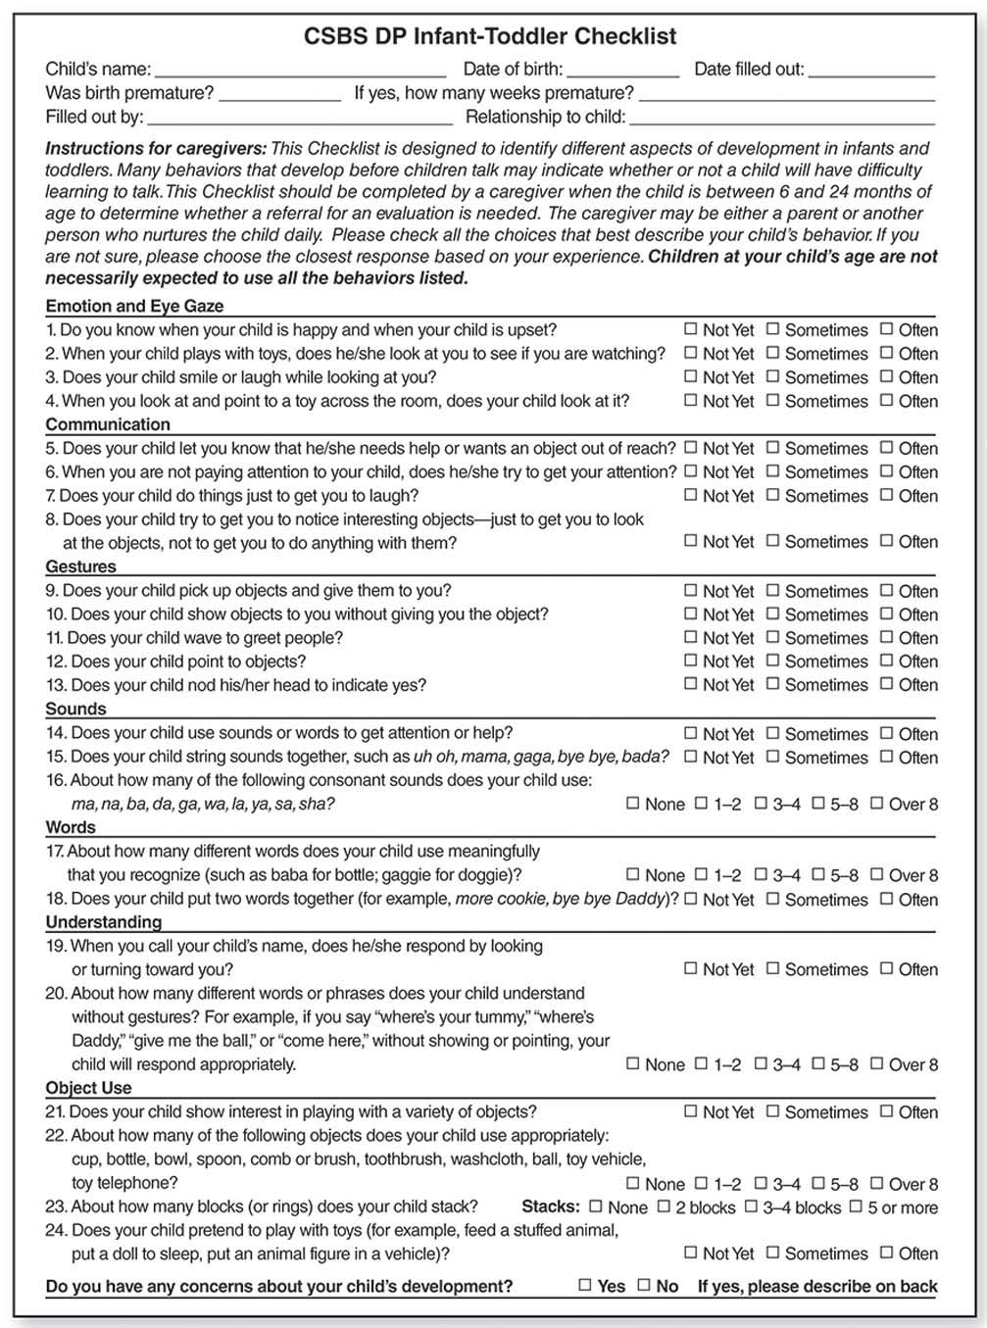
Amy M. Wetherby & Barry M. Prizant © 2002 by Paul H. Brookes Publishing Co., Inc. All rights reserved. For ordering information on all components of the CSBS DP, visit http://www.brookespublishing.com/resource-center/screening-and-assessment/csbs/csbs-dp/csbs-dp-itc/. Reprinted by permission of Paul H. Brookes Publishing Co., Inc.

