The two problems are taken from this derivation of the inclusion-exclusion principle:
http://www.proofwiki.org/wiki/Inclusion-Exclusion_Principle#Induction_Hypothesis
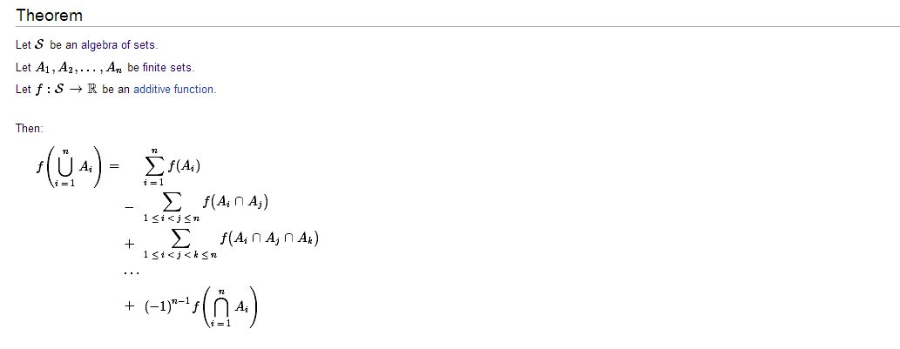
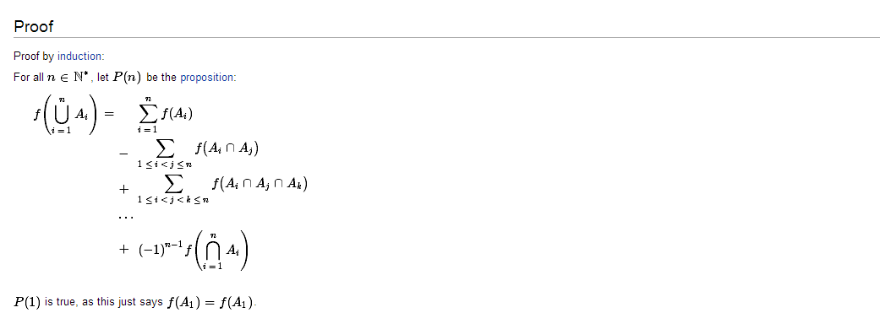
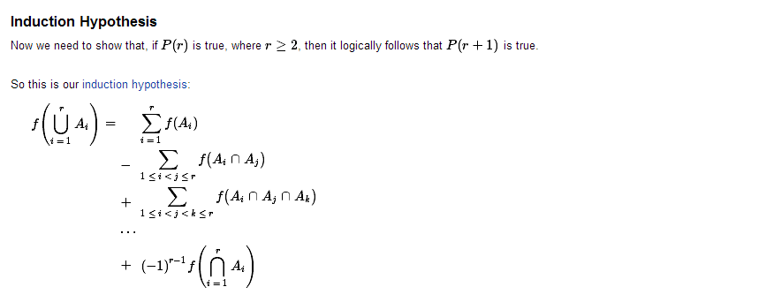
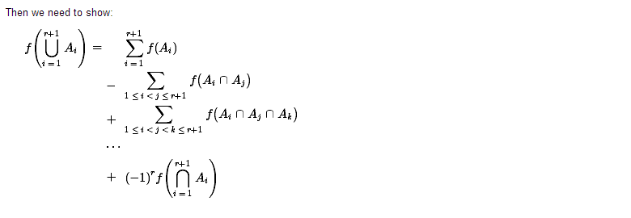
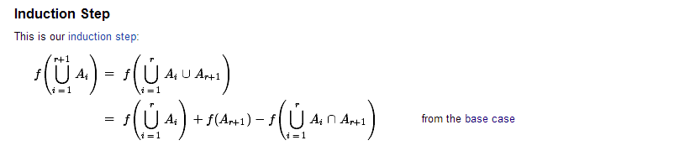
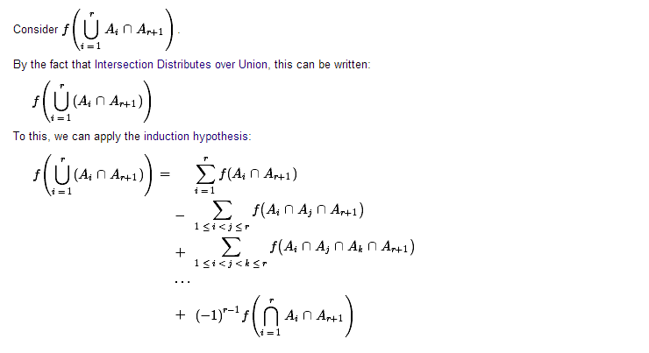
Why can they apply the induction hypothesis to the part here as well? Have they not changed the conditions by using $A_{i}∩A_{r+1}$?
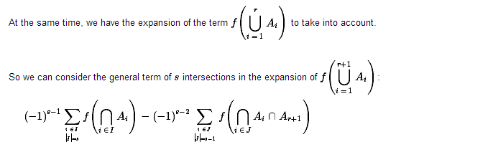
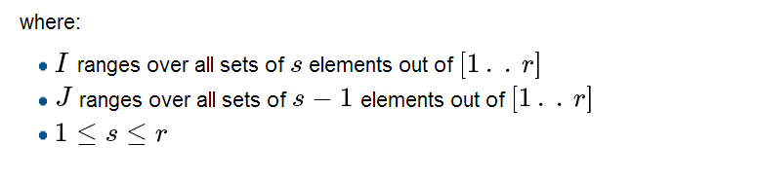
Where do we get to take into account the expansion of
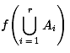
? What does it mean? And how do they end up with the part

