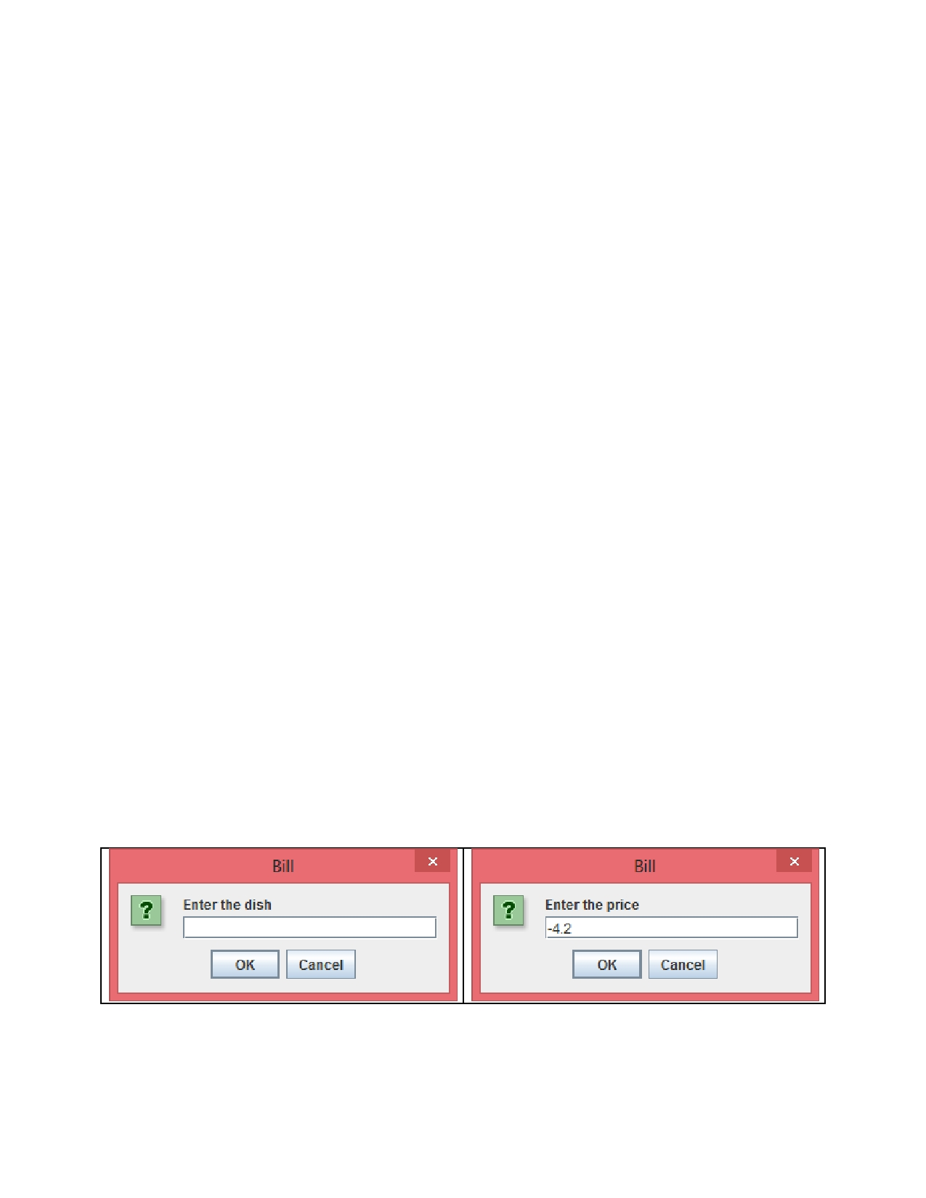
Programming Assignment #1

• All the variables have to be declared and initialized inside the method before they are used.
• All the arrays have to be declared before they are used.
• No global variables are allowed to be used in your application class.

Problem Descriptions

Write a GUI application that produces a restaurant bill. You create a bill calculator to generate window output. You should prompt the user to enter all the dishes and their prices using JOptionPane, and then display all the dishes, their prices, the total price before tax, the tax, and the total price after tax. Your output should be in a window, using a class you have derived from JFrame. Your window should include a title and appropriate icon, which you can choose. Each customer cannot order more than three dishes in each bill,
and the tax rate is 15%. You should have three classes shown as follows:

1. A Bill class to model a bill.
2. A BillFrame class to define a bill window.
3. A BillCalculator class to get a user' inputs and to generate the below outputs.

Assignment Submission

1. Submit a UML class diagram for the Bill class.
2. Submit all the three java source codes.
3. Submit the RED-STAR screenshots.

Program Sample Inputs and Outputs 1

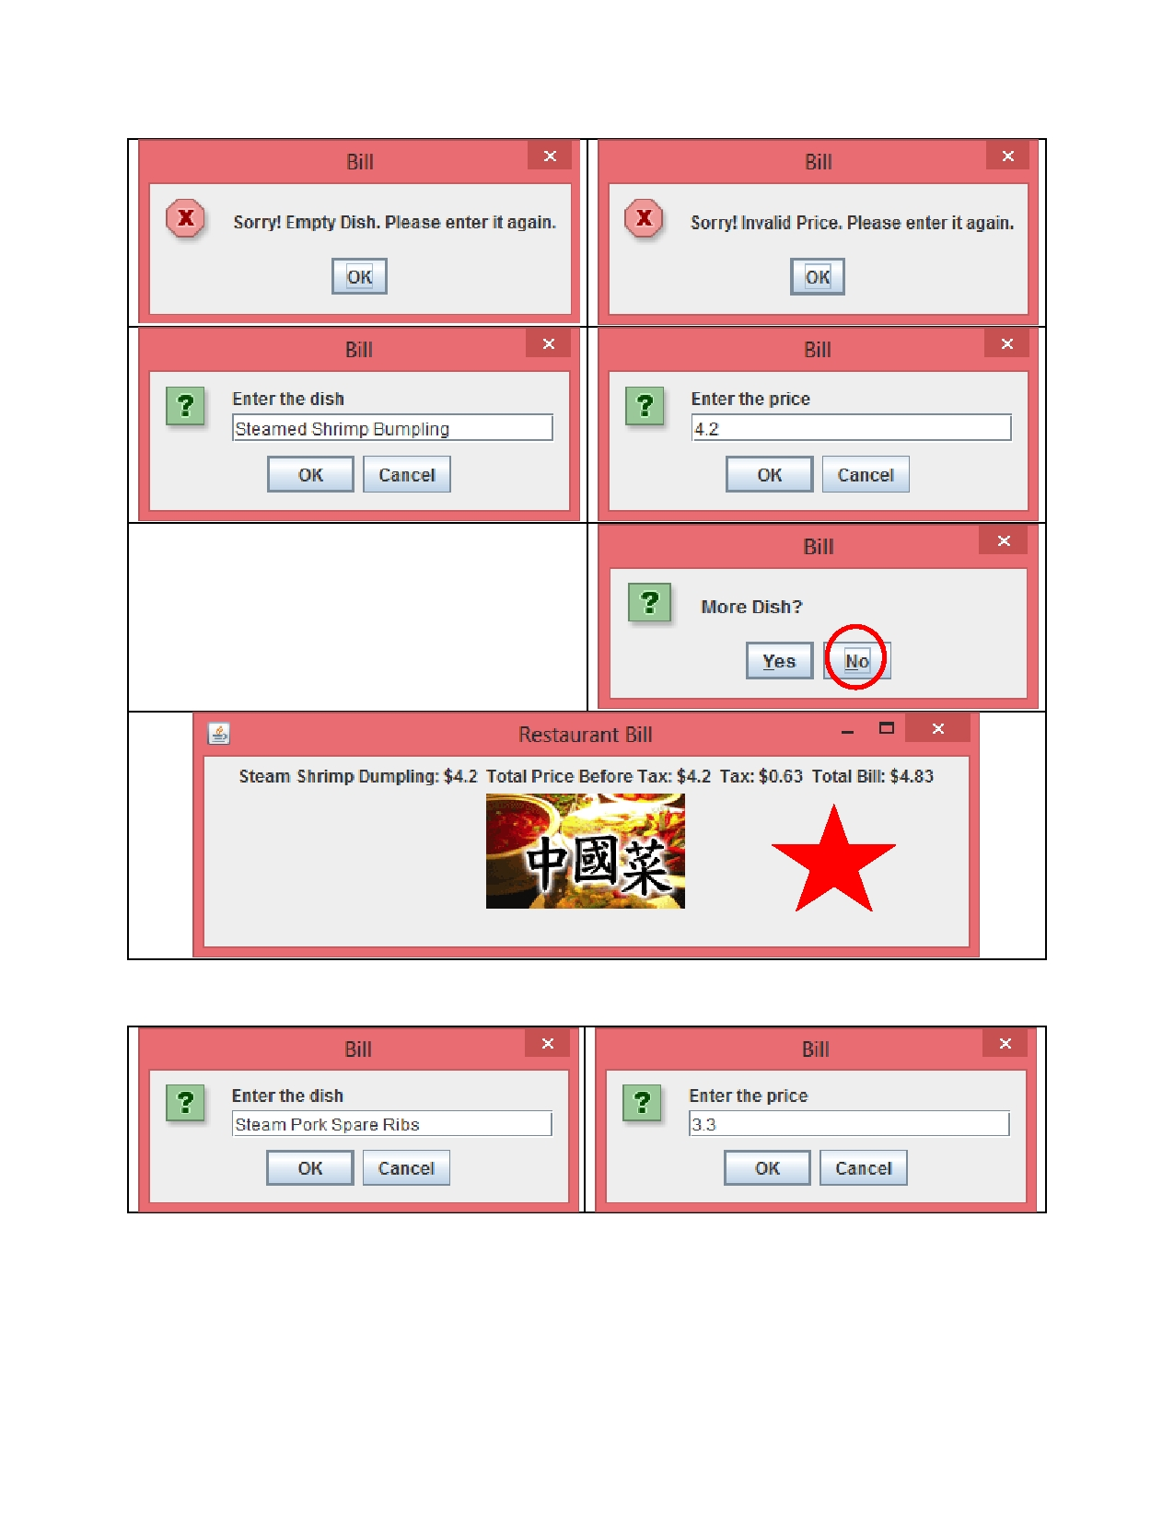
Program Sample Inputs and Outputs 2

