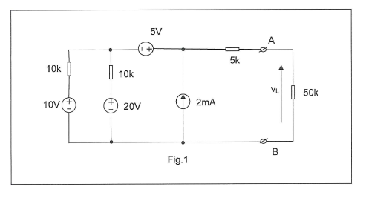

- Without the aid of software determine the Thevinin Equivalent Circuit of the above network using the ‘’ Source Equivalent ‘’ method. Hence, calculate the load voltage (VL).

- Determine VL by applying the superposition theorem

Please show workings out for each question.

