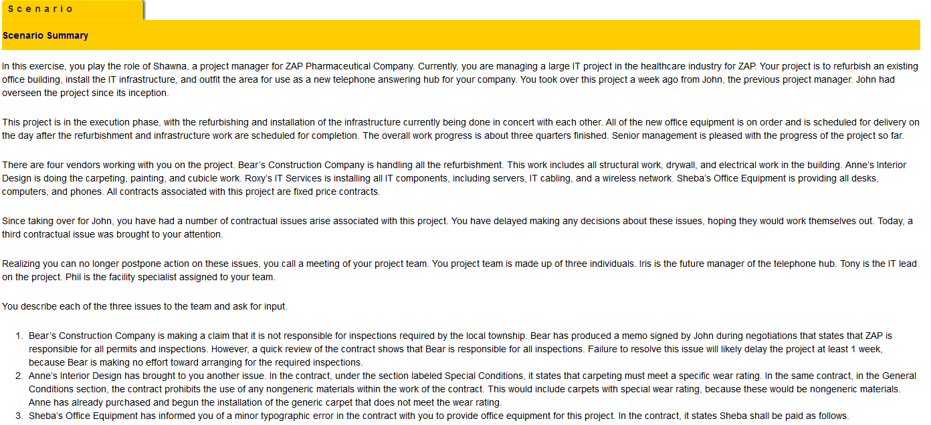

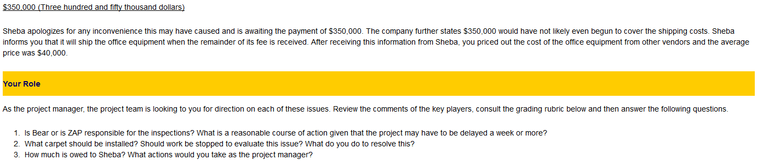

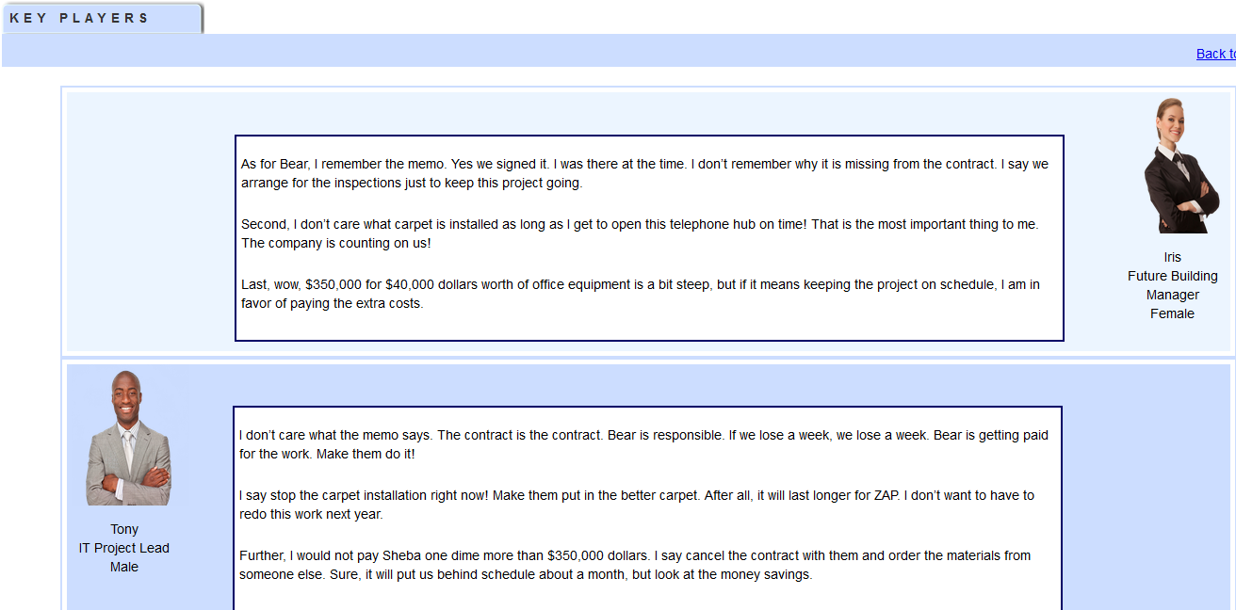
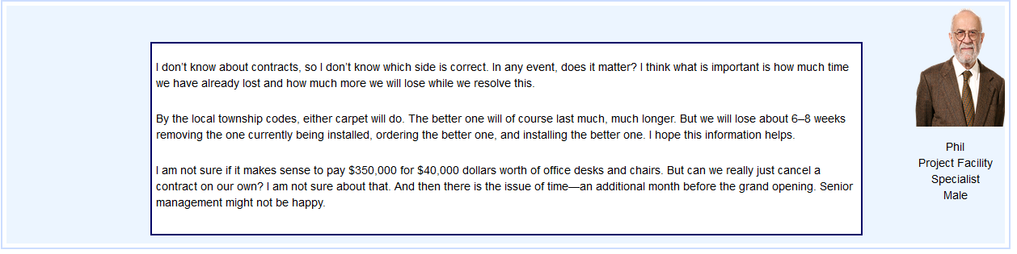

Deliverable: Turn in a three- to five-page paper outlining your complete responses to the above questions.

Again I am adding question below. It is also on top:

