Step 1: Write Section 1 of the DAA
- Provide a context of the grades.sav data set.
- Include a definition of the specified variables (predictor, outcome) and corresponding scales of measurement.
- Specify the sample size of the data set.
Step 2: Write Section 2 of the DAA
Task: Analyze the assumptions of the t test.

Case Processing Summary
 | Cases
 | Valid |  | Missing |  | Total
 | N | Percent | N | Percent | N | Percent
gender | 105 | 100.0% | 0 | 0.0% | 105 | 100.0%
gpa | 105 | 100.0% | 0 | 0.0% | 105 | 100.0%
Answer:

- 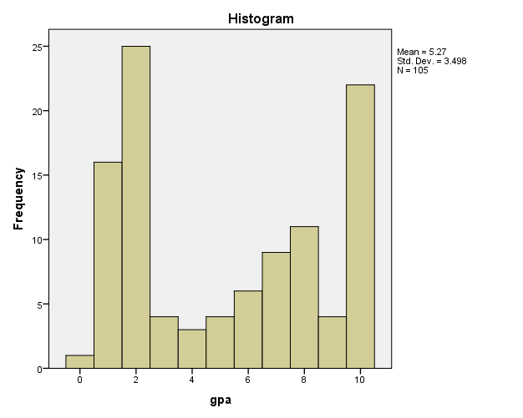
Task: Discuss your visual interpretations the SPSS histogram output for gpa.

Answer:

Tests of Normality
 | Kolmogorov-Smirnovª |  |  | Shapiro-Wilk
 | Statistic | df | Sig. | Statistic | df | Sig.
gender | .397 | 105 | .000 | .619 | 105 | .000
gpa | .225 | 105 | .000 | .854 | 105 | .000
a. Lilliefors Significance Correction

Task: Paste SPSS output for the Shapiro-Wilk test of gpa and interpret it.
Answer:

Independent Samples Test
 |  | Levene's Test for Equality of Variances |  | t-test for Equality of Means
 |  | F | Sig. | t | df | Sig. (2-tailed) | Mean Difference | Std. Error Difference | 95% Confidence Interval of the Difference
 |  |  |  |  |  |  |  |  | Lower | Upper
gender | Equal variances assumed | 10.619 | .002 | -1.271 | 103 | .207 | -.149 | .117 | -.381 | .083
 | Equal variances not assumed |  |  | -1.337 | 35.408 | .190 | -.149 | .111 | -.375 | .077
gpa | Equal variances assumed | .154 | .695 | .831 | 103 | .408 | .698 | .840 | -.968 | 2.364
 | Equal variances not assumed |  |  | .848 | 33.961 | .402 | .698 | .823 | -.974 | 2.369
Task: Report the results of the Levene test and interpret it.
Answer:

Task: Summarize whether or not the assumptions of the t test are met.
Answer:
Step 3: Write Section 3 of the DAA
- Specify a research question related to gender and gpa.
- Articulate the null hypothesis and alternative hypothesis.
- Specify the alpha level.
Step 4: Write Section 4 of the DAA
Independent Samples Test
 |  | Levene's Test for Equality of Variances |  | t-test for Equality of Means
 |  | F | Sig. | t | df | Sig. (2-tailed) | Mean Difference | Std. Error Difference | 95% Confidence Interval of the Difference
 |  |  |  |  |  |  |  |  | Lower | Upper
gender | Equal variances assumed | 10.619 | .002 | -1.271 | 103 | .207 | -.149 | .117 | -.381 | .083
 | Equal variances not assumed |  |  | -1.337 | 35.408 | .190 | -.149 | .111 | -.375 | .077
gpa | Equal variances assumed | .154 | .695 | .831 | 103 | .408 | .698 | .840 | -.968 | 2.364
 | Equal variances not assumed |  |  | .848 | 33.961 | .402 | .698 | .823 | -.974 | 2.369
  - Report the results of the SPSS output using proper APA guidelines .
  - Include:
    - t.
    - Degrees of freedom.
    - t value.
    - p value.
    - Effect size.
    - Interpretation of effect size.
    - Means and standard deviations for each group.
    - Mean difference.
    - 95% confidence interval of the difference of sample means.
- Interpret the results against the null hypothesis.
Step 5: Write Section 5 of the DAA
- Discuss the implications of this t test as it relates to the research question.
- Conclude with an analysis of the strengths and limitations of t test analysis.

