PROCESS IMPROVEMENT
Continuous improvement is one of the foundation principles of total quality that we introduced in Chapter 1. It is an important business strategy in competitive markets because
• Customer loyalty is driven by delivered value.
• Delivered value is created by business processes.
• Sustained success in competitive markets requires a business to continuously improve delivered value.
• To continuously improve value-creation ability, a business must continuously improve its value-creation processes.²⁷
The concept of continuous improvement dates back many years. One of the earliest examples in the United States was at National Cash Register Company (NCR). After a shipment of defective cash registers was returned in 1894, the company’s founder, John Patterson, discovered unpleasant and unsafe working conditions. He made many changes, including better lighting, new safety devices, ventilation, lounges, and lockers. The company offered extensive evening classes to improve employees’ education and skills, and instituted a program for soliciting suggestions from factory workers. Workers received cash prizes and other recognitions for their best ideas; by the 1940s the company was receiving an average of 3,000 suggestions each year.
Over the years, many other companies such as Lincoln Electric and Procter & Gamble developed innovative and effective improvement approaches. However, many of these focused almost exclusively on productivity and cost. Toshiba in 1946, Matsushita Electric in 1950, and Toyota in 1951 initiated some of the earliest formal continuous improvement programs. Toyota, in particular, pioneered just-in-time (JIT), which showed that companies could make products efficiently with virtually zero defects. JIT established a philosophy of improvement, which the Japanese call kaizen (pronounced kī-zen).
Kaizen²⁸
Kaizen is a Japanese word that means gradual and orderly continuous improvement. The kaizen philosophy encompasses all business activities and everyone in an organization. In this philosophy, improvement in all areas of business—cost, meeting delivery schedules, employee safety and skill development, supplier relations, new product development, or productivity—serve to enhance the quality of the firm. Thus, any activity directed toward improvement falls under the kaizen umbrella. Activities to establish traditional quality control systems, install robotics and advanced technology, institute employee suggestion systems, maintain equipment, and implement just-in-time production systems all lead to improvement.
Kaizen focuses on small, gradual, and frequent improvements over the long term with minimum financial investment, and participation by everyone in the organization.
The Kaizen Institute (http://www.kaizen-institute.com) suggests some basic tips for implementing kaizen. These suggestions include not seeking perfection; discarding conventional fixed ideas; thinking of how to do something, not why it cannot be done; not making excuses, but questioning current practices; and seeking the “wisdom of ten people rather than the knowledge of one.” By instilling kaizen into people and training them in basic quality improvement tools, workers can build this philosophy into their work and continually seek improvement in their jobs. This process-oriented approach to improvement encourages constant communication among workers and managers.
Quality Spotlight
Toyota
Kaizen is so ingrained in employees at Toyota that one manager was quoted saying “When I’m mowing the grass, I’m trying different turns to see if I can do it faster.”²⁹ An example at the Georgetown, Kentucky, plant shows the power of kaizen. A workstation used for installing visors and seat belts used to consist of eight racks of parts. The racks crowded the workstation, giving the worker ready access to all possible parts. The operator would eyeball the car coming up the line, step to the racks of visors and seat belts, and grab the right parts and run to the car. He or she would step into the slowly advancing car, bolt belts and visors in place, step back onto the factory floor, and do it again—all in 55 seconds, the unvarying time each slowly moving car spends at each workstation. The problem was, there were 12 possible combinations of sun visors and nine variations of seat belts. So just deciding which parts to snatch had become a job in itself. In every shift, 500 cars passed the racks, each car needing four specific parts: 2,000 opportunities to make an error. Even with 99 percent perfection, five cars per shift got the wrong sun visors or seat belts. So a team of assembly employees came up with a solution. Don’t make the worker pick the parts; let the worker focus on installation. Deliver a kit of presorted visors and seat belts—one kit per car, each containing exactly the right parts. The team applied the simplest technology available, a Rubbermaid caddy.
Three things are required for a successful kaizen program: operating practices, total involvement, and training.³⁰ First, operating practices expose new improvement opportunities. Practices such as just-in-time reveal waste and inefficiency as well as poor quality. Second, in kaizen, every employee strives for improvement. Top management, for example, views improvement as an inherent component of corporate strategy and provides support to improvement activities by allocating resources effectively and providing reward structures that are conducive to improvement. Middle management can implement top management’s improvement goals by establishing, upgrading, and maintaining operating standards that reflect those goals; by improving cooperation between departments; and by making employees conscious of their responsibility for improvement and developing their problem-solving skills through training. Supervisors can direct more of their attention to improvement rather than “supervision,” which, in turn, facilitates communication and offers better guidance to workers. Finally, workers can engage in improvement through suggestion systems and small group activities, self-development programs that teach practical problem-solving techniques, and enhanced job performance skills. All these improvements require significant training, both in the philosophy and in tools and techniques.
The kaizen philosophy has been widely adopted and is used by many firms in the United States and around the world. For example, at ENBI Corporation, a New York manufacturer of precision metal shafts and roller assemblies for the printer, copier, and fax machine markets, kaizen projects have resulted in a 48 percent increase in productivity, a 30 percent reduction in cycle time, and a 73 percent reduction in inventory.³¹ Kaizen has been successfully applied in the Mercedes-Benz truck factory in Brazil, resulting in reductions of 30 percent in manufacturing space, 45 percent in inventory, 70 percent in lead time, and 70 percent in set-up time over a three-year period. Sixteen employees have full-time responsibility for kaizen activities.³²
Kaizen, however, requires a significant cultural change from everyone in the organization, from top management to front-line employees. In many organizations, this is difficult to achieve. As a result, and also because of the typical business focus on short-term results and the search for the “silver bullet” solution, kaizen is not always properly implemented.³³
The kaizen philosophy is reflected in many organizations. For example, Motorola’s Commercial, Government, and Industrial Solutions Sector uses continuous improvement teams that meet regularly to proactively evaluate and improve processes. The Ritz-Carlton Hotel Company has eight mechanisms devoted solely to the improvement of process, product, and service quality:
Quality Spotlight
The Ritz-Carlton Hotel Company
• New hotel start-up improvement process: A cross-sectional team from the entire company works together to identify and correct problem areas.
• Comprehensive performance evaluation process: The work area team mechanism that empowers people who perform a job to develop the job procedures and performance standards.
• Quality network: A mechanism of peer approval through which an individual employee can advance a good idea.
• Standing problem-solving team: A standing work area team that addresses any problem it chooses.
• Quality improvement team: Special teams assembled to solve an assigned problem identified by an individual employee or leaders.
• Strategic quality planning: Annual work area teams identify their missions, primary supplier objectives and action plans, internal objectives and action plans, and progress reviews.
• Streamlining process: The annual hotel evaluation of processes, products, or services that are no longer valuable to the customer.
• Process improvement: The team mechanism for corporate leaders, managers, and employees to improve the most critical processes.
A kaizen blitz is an intense and rapid improvement process in which a team or a department throws all its resources into an improvement project over a short time period, as opposed to traditional kaizen applications, which are performed on a part-time basis.
Although kaizen is meant to be a part of daily work, many organizations are faced with quality or performance issues that require immediate attention. As a result, kaizen concepts have been incorporated into a team- and project-driven rapid improvement initiative called a kaizen blitz.
Blitz teams are generally comprised of employees from all areas involved in the process who understand it and can implement changes on the spot. Improvement is immediate, exciting, and satisfying for all those involved in the process.
Some examples of using kaizen blitz at Magnivision include the following:³⁴
Quality Spotlight
Magnivision
• The molded lens department ran two shifts per day, using 13 employees, and after 40 percent rework, yielded 1,300 pieces per day. The production line was unbalanced and work piled up between stations, which added to quality problems as the work-in-process was often damaged. After a three-day blitz, the team reduced the production to one shift of six employees and a balanced line, reducing rework to 10 percent and increasing yield to 3,500 pieces per day, saving more than $179,000.
• In Retail Services, a blitz team investigated problems that continually plagued employees, and discovered that many were related to the software system. Some of the same customer information had to be entered in multiple screens, sometimes the system took a long time to process information, and sometimes it was difficult to find specific information quickly. Neither the programmers nor the engineers were aware of these problems. By getting everyone together, some solutions were easily determined. Estimated savings were $125,000.
Improvement Opportunities
Many opportunities for improvement exist, the most obvious being reductions in manufacturing defects or service errors. One example occurred at Dell. Although it has had some of the highest quality ratings in the PC industry, CEO Michael Dell became obsessed with finding ways to reduce machine failure rates. He concluded that failures were related to the number of times a hard drive was handled during assembly, and insisted that the number of “touches” be reduced from an existing level of more than 30 per drive. Production lines were revamped and the number was reduced to fewer than 15. Soon after, the reject rate of hard drives fell by 40 percent and the overall failure rated dropped by 20 percent.³⁵
Another important business metric is cycle time. Cycle time refers to the time it takes to accomplish one cycle of a process (e.g., the time from when a customer orders a product to the time that it is delivered, or the total time needed to introduce a new product). Reductions in cycle time serve two purposes. First, they speed up work processes so that customer response is improved. Second, reductions in cycle time can only be accomplished by streamlining and simplifying processes to eliminate non-value-added steps such as rework. This approach forces improvements in quality by reducing the potential for mistakes and errors. By reducing non-value-added steps, costs are reduced as well. Thus, cycle time reductions often drive simultaneous improvements in organization, quality, cost, and productivity. Significant reductions in cycle time cannot be achieved simply by focusing on individual subprocesses; cross-functional processes must be examined all across the organization. Through these activities, the company comes to understand work at the organizational level and to engage in cooperative behaviors.
Quality Spotlight
Procter & Gamble
One example of cycle time reduction is Procter & Gamble’s over-the-counter (OTC) clinical division, which conducts clinical studies that involve testing drugs, health care products, or treatments in humans.³⁶ Such testing follows rigorous design, conduct, analysis, and summary of the data collected. P&G had at least four different ways to perform a clinical study and needed to find the best way to meet its research and development needs. They chose to focus on cycle time reduction. Their approach built on fundamental TQ principles: focusing on the customer, fact-based decisions, continual improvement, empowerment, the right leadership structure, and an understanding of work processes. An example is shown in Figure 7.4. The team found that final reports took months to prepare. Only by mapping the existing process did they fully understand the causes of long production times and the amount of rework and recycling during review and sign-off. By restructuring the activities from sequential to parallel work and identifying critical measurements to monitor the process, they were able to reduce the time to less than four weeks.
Figure 7.4: Final Report “Is” and “Should” Process Map Example
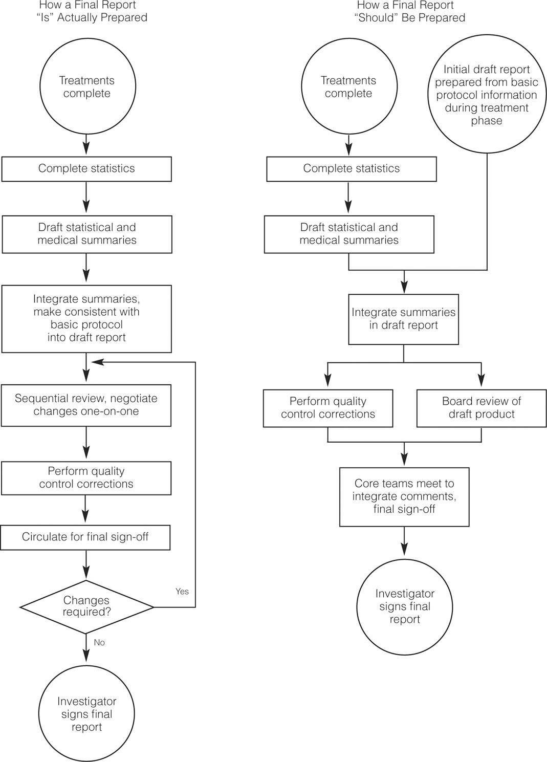
Source: Reprinted with permission from David A. McCamey, Robert W. Bogs, and Linda M. Bayuk, “More, Better, Faster From Total Quality Effort,” Quality Improvement Handbook, 2nd edition, August 1999, pp. 43–50. http://www.asq.org/quality-press/display-item/index=H1289&xvl=76BK H1289.
In addition to reducing defects, errors, and cycle times, organizations should also consider improving employee morale, satisfaction, and cooperation; improving managerial practices; improving the design of products with features that better meet customers’ needs, and that can achieve higher performance, higher reliability, and other market-driven dimensions of quality; and improving the efficiency of manufacturing systems by reducing workers’ idle time and unnecessary motions, and by eliminating unnecessary inventory, unnecessary transportation and material handling, and scrap and rework.
Improvement should be a proactive task of management and be viewed as an opportunity, not simply as a reaction to problems and competitive threats.
PROCESS IMPROVEMENT METHODOLOGIES
Successful quality and business performance improvement depends on the ability to identify and solve problems; this ability is fundamental to the Six Sigma philosophy. Many nonquantitatively inclined managers (which may include 75 or 80 percent of the population) have difficulty in grasping the concept of a systematic, fact-based, and often statistical problem-solving approach. Yet, using such an approach is vital to effectively identifying sources of problems, understanding their causes, and developing improvement solutions. “Speaking the same language” builds confidence and assures that solutions are developed objectively, rather than by intuition. Branch-Smith Printing, for example, uses a simple quality improvement process (QIP) shown in Figure 7.5 to evaluate and improve all production and delivery processes, using performance data and complaints to prioritize opportunities for process improvement.
Figure 7.5: QIP Process at Branch-Smith Printing
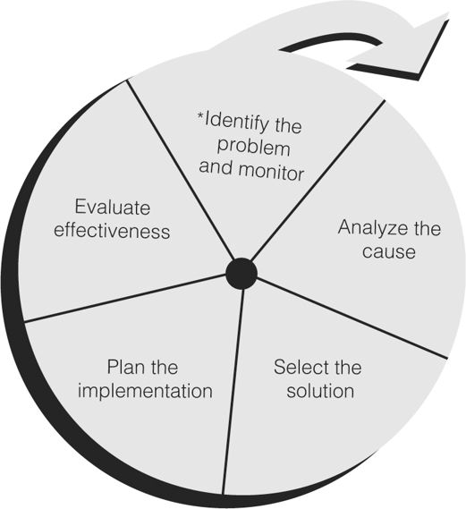
Reprinted with permission from AIM, Inc.
A structured problem-solving process provides all employees with a common language and a set of tools to communicate with each other, particularly as members of cross-functional teams.
Numerous methodologies for improvement have been proposed over the years. Although each methodology is distinctive in its own right, they share many common themes:³⁷
1. Redefining and analyzing the problem: Collect and organize information, analyze the data and underlying assumptions, and reexamine the problem for new perspectives, with the goal of achieving a workable problem definition.
2. Generating ideas: “Brainstorm” to develop potential solutions.
3. Evaluating and selecting ideas: Determine whether the ideas have merit and will achieve the problem solver’s goal.
4. Implementing ideas: Sell the solution and gain acceptance by those who must use them.
We will review some of the more prominent approaches here. We also note that they are supported by numerous analytical tools, most of which are discussed in Chapter 11.
The Deming Cycle
The Deming cycle is a simple methodology for improvement that was strongly promoted by W. Edwards Deming. It was originally called the Shewhart cycle after its original founder, Walter Shewhart, but was renamed the Deming cycle by the Japanese in 1950. The Deming cycle is composed of four stages: plan, do, study, and act (PDSA) as illustrated in Figure 7.6. (The third stage—Study—was formerly called check, and the Deming cycle was known as the PDCA cycle. Deming made the change in 1990. “Study” is more appropriate; with only a “check,” one might miss something. However, many people still use “check.”)
Figure 7.6: The Deming Cycle
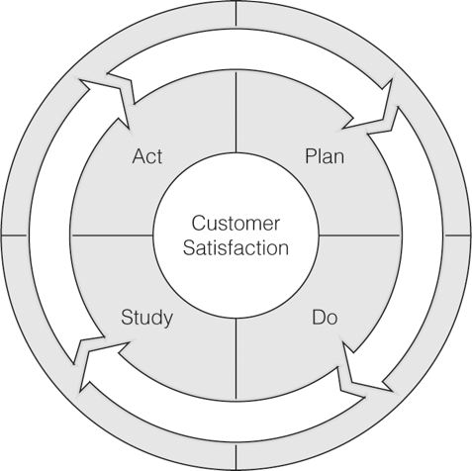
The Plan stage consists of studying the current situation and describing the process: its inputs, outputs, customers, and suppliers; understanding customer expectations; gathering data; identifying problems; testing theories of causes; and developing solutions and action plans. In the Do stage, the plan is implemented on a trial basis, for example, in a laboratory, pilot production process, or with a small group of customers, to evaluate a proposed solution and provide objective data. Data from the experiment are collected and documented.
The Study stage determines whether the trial plan is working correctly by evaluating the results, recording the learning, and determining whether any further issues or opportunities need be addressed. Often, the first solution must be modified or scrapped. New solutions are proposed and evaluated by returning to the Do stage. In the last stage, Act, the improvements become standardized and the final plan is implemented as a “current best practice” and communicated throughout the organization. This process then leads back to the Plan stage for identification of other improvement opportunities.
The Deming cycle focuses on both short-term continuous improvement and long-term organizational learning.
Table 7.5 summarizes the steps in the Deming Cycle in more detail. The fundamental premise is that improvement comes from the application of knowledge.³⁸ This knowledge may be knowledge of engineering, management, or how a process operates that can make a job easier, more accurate, faster, less costly, safer, or better meet customer needs. Three fundamental questions to consider are:
Table 7.5: Detailed Steps in the Deming Cycle
Plan
1. Define the process: its start, end, and what it does.
2. Describe the process: list the key tasks performed and sequence of steps, people involved, equipment used, environmental conditions, work methods, and materials used.
3. Describe the players: external and internal customers and suppliers, and process operators.
4. Define customer expectations: what the customer wants, when, and where, for both external and internal customers.
5. Determine what historical data are available on process performance, or what data need to be collected to better understand the process.
6. Describe the perceived problems associated with the process; for instance, failure to meet customer expectations, excessive variation, long cycle times, and so on.
7. Identify the primary causes of the problems and their impacts on process performance.
8. Develop potential changes or solutions to the process, and evaluate how these changes or solutions will address the primary causes.
9. Select the most promising solution(s).
Do
1. Conduct a pilot study or experiment to test the impact of the potential solution(s).
2. Identify measures to understand how any changes or solutions are successful in addressing the perceived problems.
Study
1. Examine the results of the pilot study or experiment.
2. Determine whether process performance has improved.
3. Identify further experimentation that may be necessary.
Act
1. Select the best change or solution.
2. Develop an implementation plan: what needs to be done, who should be involved, and when the plan should be accomplished.
3. Standardize the solution, for example, by writing new standard operating procedures.
4. Establish a process to monitor and control process performance.
Source: Adapted from Small Business Guidebook to Quality Management, office of the Secretary of Defense, Quality Management Office, Washington, DC. Copyright © 1998.
• What are we trying to accomplish?
• What changes can we make that will result in improvement?
• How will we know that a change is an improvement?
Through a process of learning, knowledge is developed. From this perspective, many organizations use the Deming cycle as the basis for their organizational performance improvement activities. For example, Mercy Health Systems, a 2007 Baldrige recipient, uses the Deming cycle as its process management framework as shown in Figure 7.7.
Figure 7.7: Mercy Health System Application of the Deming Cycle’
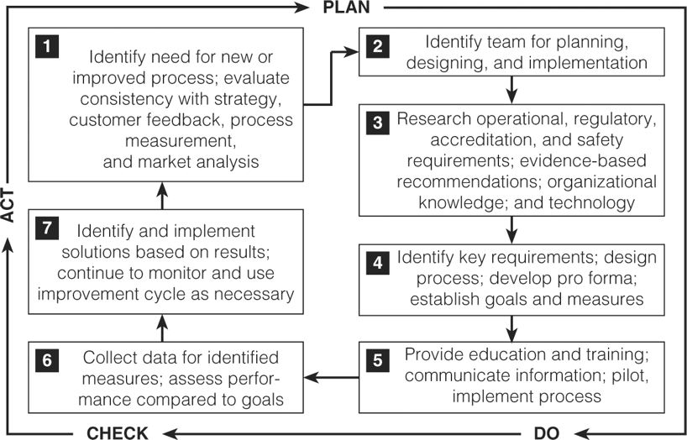
Source: Mercy Health Systems 2007 Baldrige National Quality Award application Summary. Reprinted with permission.
The following example demonstrates how the Deming cycle can be applied in practice. The co-owners of a diner decided to do something about the long lines that occurred every day in their place of business.³⁹ After discussions with their employees, several important facts came to light:
• Customers waited in line for up to 15 minutes.
• Usually, tables were available.
• Many of their customers were regulars.
• People taking orders and preparing food were getting in each other’s way.
To measure the improvement that might result from any change they made, they decided to collect data on the number of customers in line, the number of empty tables, and the time until a customer received the food ordered.
In the Plan stage, the owners wanted to test a few changes. They decided on three changes:
1. Provide a way for customers to fax their orders in ahead of time (rent a fax machine for one month).
2. Construct a preparation table in the kitchen with ample room for fax orders.
3. Devote one of their two cash registers to handling fax orders.
Both the length of the line and the number of empty tables were measured every 15 minutes during the lunch hour by one of the owners. In addition, when the 15-minute line check was done, the last person in line was noted, and the time until that person got served was measured.
In the Do phase, the owners observed the results of the three measures for three weeks. In the study phase, they detected several improvements. Time in line went down from 15 minutes to an average of 5 minutes. The line length was cut to a peak average of 12 people, and the number of empty tables decreased slightly. In the Act phase, the owners held a meeting with all employees to discuss the results. They decided to purchase a fax machine, prepare phone orders in the kitchen with the fax orders, and use both cash registers to handle walk-up and fax orders.
Creative Problem Solving
Solving quality problems often involves a high amount of creativity. Creativity is seeing things in new or novel ways. Many creativity tools are designed to help you change the context in which you view a problem or opportunity, thereby leading to fresh perspectives. The brilliant and creative mathematician John Nash, whose life was profiled in the book and movie A Beautiful Mind, was described by one of his colleagues in the following way: “Everyone else would climb a peak by looking for a path somewhere on the mountain. Nash would climb another mountain altogether and from a distant peak shine a searchlight back on the first peak.”⁴⁰
In Japanese, the word creativity has a literal translation as “dangerous opportunity.” In the Toyota production system, which has become the benchmark for world-class efficiency, a key concept is soikufu—creative thinking or inventive ideas, which means capitalizing on worker suggestions. The chairman of Toyota once observed, “One of the features of Japanese workers is that they use their brains as well as their hands. Our workers provide 1.5 million suggestions a year, and 95 percent of them are put to practical use. There is an almost tangible concern for improvement in the air at Toyota.”⁴¹
While many creative ideas seemingly come at moments of inspiration, systematic approaches can refine your thinking and help prepare for those moments. An effective problem-solving process that can easily be adapted to quality improvement stems from creative problem-solving (CPS) concepts pioneered by Osborn and refined by Parnes.⁴² This strategy consists of the following steps:
• Understanding the “mess”
• Finding facts
• Identifying specific problems
• Generating ideas
• Developing solutions
• Implementing solutions
The CPS literature provides many tools and approaches to facilitate each of these steps and develop more creative results.
Custom Methodologies
Numerous variations of the Deming Cycle and creative problem-solving process exist. In Chapter 11, we will discuss in detail the Six Sigma methodology for improvement known as DMAIC—define, measure, analyze, improve, and control. Many organizations incorporate lean tools (also discussed in Chapter 11) that focus on the elimination of waste and non-value-added activities within their process improvement approaches. For example, MESA, Inc., a Baldrige recipient, uses lean as its primary improvement approach and integrated within the framework of the Deming cycle.
Some organizations align process-improvement methodologies with their unique organizational culture. For example, some organizations embed the Deming cycle within a broader framework. An example from a health care organization is shown in Figure 7.8. The left side of the figure incorporates the essential elements of CPS. Once a solution is proposed, the Deming cycle is then used to test and evaluate the solution prior to implementation. Not every approach is appropriate for all organizations; one must be chosen or designed to fit the organization’s culture and people.
Figure 7.8: Incorporating the Deming Cycle in a Process Improvement Model
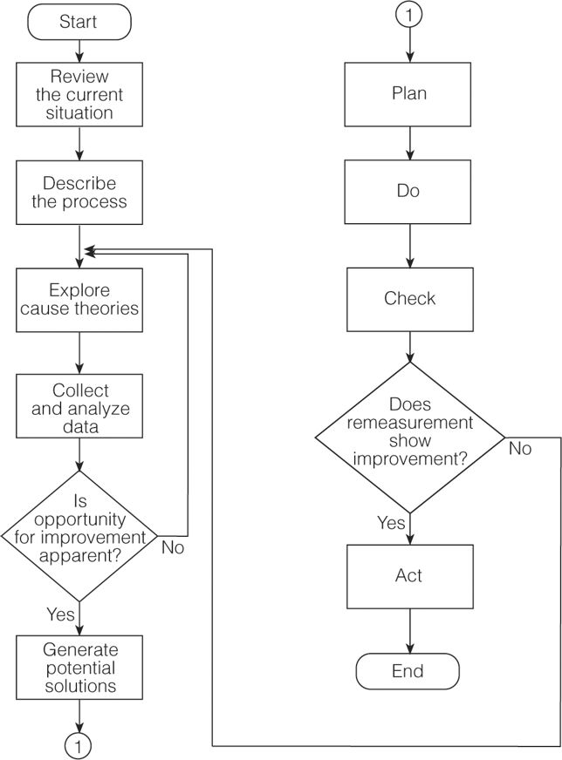
Source: Reprinted with permission of Bethesda Hospital, Inc., 619 Oak Street, Cincinnati, OH 45241.
One approach used by some hospitals and the U.S. Coast Guard, is known by the acronym FADE: focus, analyze, develop, and execute. In the Focus stage, a team selects the problem to be addressed and defines it, characterizing the current state of the process, why change is needed, what the desired result should be, and the benefits of achieving that result. In the Analyze stage, the team works to describe the process in detail, determine what data and information are needed, and develop a list of root causes for the problem. The Develop stage focuses on creating a solution and implementation plan along with documentation to explain and justify recommendations to management who must allocate the resources. Finally, in the Execute stage, the solution is implemented and a monitoring plan is established. As another example, Park Place Lexus, the first automobile dealer to receive the Baldrige Award, developed a process known as DRIVE—Define the problem, Recognize the cause, Identify the solution, Verify the actions, and Evaluate the results. Clearly this acronym has meaning for the organization and is easy for employees to remember.
How one approaches problem solving is not as critical as doing it in a systematic fashion, whether one uses the Deming cycle, CPS, or some other variation.
Recently, particularly in the context of Six Sigma, organizations have been applying an approach called TRIZ, which is a Russian acronym for the Theory of Inventive Problem Solving. TRIZ was developed by a Russian patent clerk who studied thousands of submissions, and observed patterns of innovation common to the evolution of scientific and technical advances. He recognized that these concepts could be taught and developed some 200 exercises to foster creative problem solving. TRIZ has been used by such companies as Samsung, Ford, Motorola, Procter & Gamble, 3M, Phillips, LG, and many others. It has been useful in increasing the yield of semiconductor factories, designing new motors for washing machines, and increasing the viewing angle of LCD televisions.⁴³
(Evans 326-338)
Evans, Lindsay. Managing for Quality and Performance Excellence, 8th Edition. Cengage Learning, 40179. VitalBook file.

