RAISIO GROUP AND THE BENECOL LAUNCH [A]
During 1996, Raisio Group, a 57 –year old grain-milling company based in Raisio in southwest Finland, emerged from obscurity to become the second-most-valuable public company in Finland (after Nokia) and the focus of worldwide attention. The launch of Benecol, its cholesterol-lowering margarine, at the end of 1995 had attracted the interest of food processors and supermarket groups throughout the stripped Raisio’s capability to produce the active ingredient in Benecol, stanol ester. On the Helsinki stock market, foreign demand pushed Raisio’s share price from FIM61 at the beginning of the year to FIM288 at the end (after touching FIM322 during the summer). CEO Matti Salminen commented:
1996 will go down in the Raisio Group’s history as the “Benecol year” – such was the role of this new cholesterol-reducing margarine in increasing the Group’s visibility and raising its profile in all our sectors of operations. Although we have not been able to meet even the domestic demand for Benecol margarine so far, the product is already known worldwide and great expectations are attached to it. The Benecol phenomenon quintupled the value of our shares, increasing the Group’s capitalization by billions of Finnish marks.
It was the international prospects for Benecol margarine (and potentially other food products incorporating stanol ester) that had drawn a bevy of stock analysts and portfolio managers to Raisio’s headquarters. Not only was the potential market for Benecol considered huge-the US alone was seen as having a multi-billion-dollar market potential-but also the profit opportunities also appeared excellent. In Finland, Benecol was selling at about six times the price of regular margarine. In addition to being first to market, Raisio had the ability to sustain its market leadership through its patents relating to the production and use of the active ingredient, stanol ester, and recognition of its Benecol brand name.
However, within Raisio a vigorous debate had broken out as to the best strategy for exploiting the vast commercial potential that Raisio’s innovation offered. This debate focused on two issues. The first was whether Raisio’s emphasis should be on supplying its Benecol margarine or its active ingredient, stanol ester. Despite the phenomenal success of Benecol margarine in Finland, margarine was only one of a number of potential food and drink products to which stanol ester could be added.
Several Raisio managers argued that the company could exploit its innovation more widely if it supplied stanol ester to a number of food and drink companies. A second issue concerned the means by which Raisio would exploit the international potential of its innovation. Although Raisio was a significant margarine manufacturer in Finland, it possessed few facilities and limited experience outside its home market. A number of multinational food companies and leading food retailers had approached Raisio expressing interest in icensing agreements, joint ventures, and supply agreements-for Benecol margarine, for stanol ester, and for both. Should Raisio license its intellectual property to other firms, create joint ventures with foreign companies, or keep its technology in-house and use it to build a multinational presence for itself?
HISTORY OF RAISIO
The Raisio Group began life in 1939 as Vehna Oy, a grain-milling company located in the town of Raisio. In 1950, a vegetable oil factory called Oy Kasviojy-Vaxtolje Ab was founded next to the milling plant. The two companies cooperated in introducing rapeseed cultivation to Finland. They eventually merged in 1987 to form Raisio Tehtaat Oy Ab. From cereals and vegetable oil, the company expanded into animal feeds, malt production the basis for the supply of a number of chemical products, mainly to the paper industry.
During this period Raisio developed a substantial export business. This began with malt exports to Sweden, followed by exports of margarine, pasta and other food products to the Soviet Union and subsequently to Poland. In the St. Petersburg area of Russia and in Estonia, Raisio’s Melia-branded products were market leaders allowed Raisio to expand its sales to other European countries. By 1996, 39% of Raisio’s sales were outside of Finland. Raisio’s increased international presence included margarine plants in Sweden and Poland and joint-venture plants supplying starch and other products for the paper industry in Sweden, the US, France, Germany, and Indonesia.
From its earliest days, Raisio had shown considerable entrepreneurial initiative and technical ingenuity. Its first oil-milling plant was constructed by its own employees using spare parts, scrap metal, and innovative improvisation. Raisio also maintained an active program of R & D. Benecol was the result of Raisio’s research into plant sterols Raisio’s annual report tells the story:
The cholesterol-reducing effects of plant sterols were known as early as the 1950s and ever since that time, scientists all over the world have been studying plant sterols and their properties.
In 1972, a project led by Professor Pekka Puska was launched in North Karelia. The purpose of the project, which enjoyed international prestige, was to reduce the high cardiovascular rates in the region.
In 1988, the Department of Pharmacy at the University of Helsinki started cooperation with the Helsinki and Turku Central Hospitals and the Raisio Group aimed at studying the effect of rapeseed oil on blood cholesterol levels. Professor Tatu Miettinen, who had already done extensive research on fat metabolism, suggested research on plant sterols to the Raisio Group.
The following year, R & D Manager Ingmar Wester (of Raisio’s Margarine sub-division) and his research team found a way of turning plant sterol into fatsoluble stanol ester suitable food production. A patent application was filed in 1991. This started a period of intense research aimed at producing indisputable evidence of the cholesterol-reducing effect of stanol ester. In 1993, the North Karelia project launched a long-range stanol ester study as part of its other clinical research.
The digestive tract receives cholesterol from two sources i.e., food and the tract is disposed of and the rest is absorbed by the body. Fat-soluble plant stanol was shown as efficiently preventing the absorption of cholesterol. In diet containing stanol ester, 80% of the cholesterol entering the digestive tract is disposed of and only 20% is absorbed by the body. The plant stanol itself is not absorbed, but disposed of naturally.
The findings of the North Karelia study were published in the New England Journal of Medicine in November 1995. (The article reported that, after a 14-month trial, a daily intake of 25 grams reduces total cholesterol in the bloodstream by 10% and the level of more harmful LDL cholesterol by 14%.) At the same time the first patents were issued for the production and use of stanol ester.
The first stanol ester product, Benecol margarine, was introduced on the Finnish market. The interest it aroused soon exceeded all expectations both in Finland and internationally. The registered name, Benecol, has since been confirmed as the common name for all products containing stanol ester.
Production of stanol ester began with experiemental equipment, which limited the supply. The availability of plant sterol, the raw material, was another limiting factor. All plants contain small amounts of plants processed in very large quantities. Since there had been no demand for plant sterols, no investments had been made in separation facilities.
Exhibit 1 describes the cholesterol-reducing properties of sterols and stanols. The Appendix gives information on Raisio’s main patents relating to stanol ester.
RAISIO IN 1997
A million and the beginning of 1997, the Raisio Group had annual sales of $2594 employees. The group comprised three divisions:
- Foodstuffs (47% of total sales), including the subdivisions: margarine (39% of sales), Melia Ltd (flour, pasta, breakfast cereal, muesli), oil milling, potato processing (mainly frozen French fries), malting, and Foodie Oy (rye products, pea soup, frozen pastry dough, salad dressings)
- Chemicals (34% of sales)
- Animal feeds (19% of sales).
Outside of Finland, Raisio had subsidiaries in Sweden, Estonia, Latvia, the UK, France, Spain, Germany, Belgium, Poland, Canada, the US, and Indonesia. Raisio
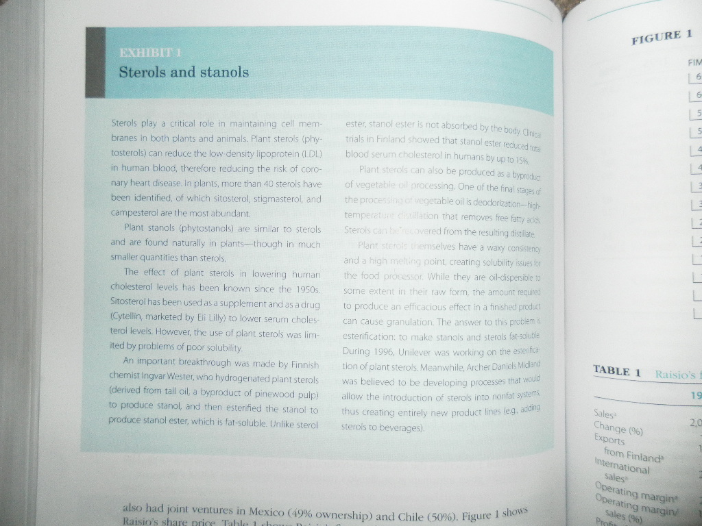
also had joint ventures in Mexico (49% ownership) and Chilie (50%). Figure 1 shows Raisio’s share price. Table 1 shows Raisio’s financial performance.
THE BENECOL LAUNCH
Raisio lauched Benecol margarine with a retail price of around FIM25 ($4.50) for a 250g tub-this compared with FIM4 for regular margarine. Despite the high price, the product flew off the shelves as quickly as it appeared and Raisio was forced to institute a system of rationing supplies to distributors. During 1996, Raisio estimated that it was only able to satisfy about two-thirds of domestic demand.
To facilitate the speedy development of the Benecol business, in March 1996 Benecol margarine was transferred from the margarine subdivision to a separate Benecol unit. The unit was headed by Jukka Kaitaranta, who reported to the deputy chief executive and heard of the Food Division, Jukka Maki. It was intended that,
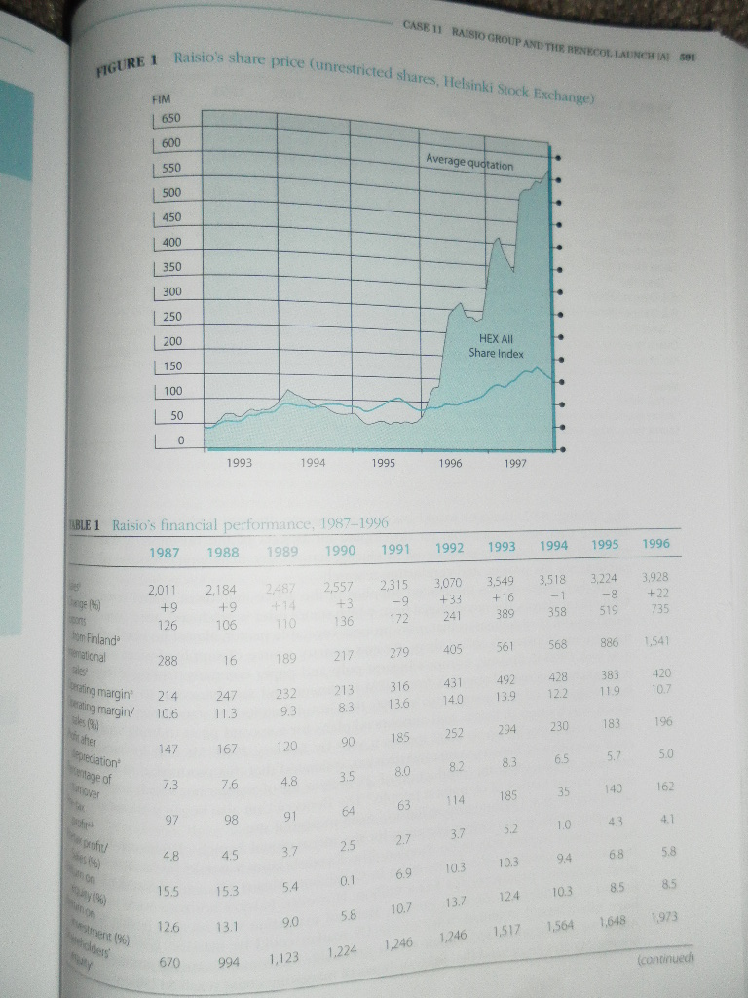
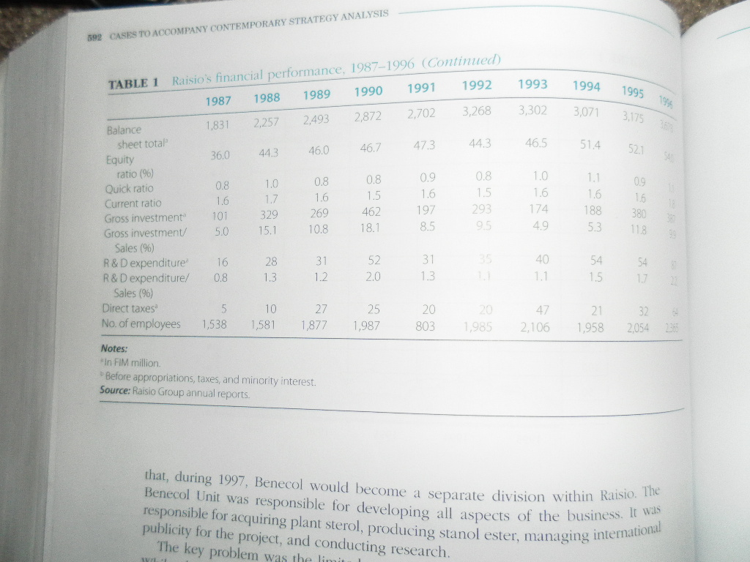
during 1997, Benecol would become a separate division within Raisio.
The key problem was the limited supplies of the active ingredient, stanol ester. While plants sterols, the raw material from which stanol ester is produced, are a common byproduct of industries that mass-process vegetable matter, almost no one had the systems in place to collect them. Raisio’s primary source of supply of plant stanols was UPM-Kymmene, Europe’s biggest pulp and paper company. During 1996, it negotiated increased supplies from UPM-Kymmene and sought access to sterols from vegetable oil processors. Also in 1996, the Group built its first stanol ester plant, which was located in Raisio, and announced plans for a second plant to bring total stanol ester capacity up to 2000 tonnes a year by January 1998. Mr. Kari Jokinen chief executive would allow the production of 25 million kg of margarine, which could supply a total market of 60 million people. The Benecol Unit also began work on a new 1500 m² R & D laboratory at Raisio’s main industrial site.
During 1996, Raisio began planning for the international launch of Benecol. Its first overseas market was to be Sweden. The Swedish launch would be facilitated by Raisio’s acquisition of a 77.5% stake in Carlshamm Mejeri AB, one of Sweden’s main margarine producers, for $44.4 million. However, Raisio’s horizons were not limited to Scandinavia, or even Europe. Benecol margarine was seen as having a huge international potential. Sales to the US market could be massive was seen as having a huge international potential. Sales to the US market could be massive, given that Americans spent some $33 billion a year on health foods and slimming products. Some estimates suggested that sales of Benecol margarine could reach $3 billion.

By January 1997, Raisio was being bombarded with requests and proposals from all over the world. Sainsbury’s, at the time Britain’s leading supermarket chain requested an own-label version of Benecol margarine. Other food processing companies were interested in purchasing licenses either for Benecol margarine or for Raisio’s stanol ester technology, or for both.
Raisio’s senior executives recognized that product formulation, marketing strategy, and distribution policies would need to be adapted to the requirements of different national markets. Moreover, there were complex national regulations relating to the health benefits. The Raisio executives were especially interested in an approach consumer products company Johnson & Johnson. McNeil was headquartered in Fort Washington, Pennsylvania and was able to field a range of relevant resources, not least Johnson & Johnson’s worldwide marketing and distribution system.
COMPETITION
In formulating a strategy for the global exploitation of Benecol, Raisio faced a number of uncertainties. One issue that especially concerned Raisio executives was the potential for Benecol to encounter competition. In 1991, Raisio had filed its first patent relating to its process for the production of stanol ester from plant sterols and for its use in reducing cholesterol as an additive to human foods. In 1996, it’s the first US patent relating to stanol ester was issued. In the same year, Raisio filed a broader patent relating to the processing and use of stanol ester (see the Appendix). However, a number of competing products were available for reducing cholesterol. In particular, the cholesterol- reducing properties of naturally available plant sterols were well known. While Raisio believed it owned the only effective means for converting plant sterols into a fat-soluble form, it thought it likely that other processes might offer head of chemicals (and soon to be appointed head of the Benecol Division as well) reckoned that Raisio had an 18-to 24-month lead over competitors.
Apart for plant setols and stanols, a growing array of cholesterol-reducing drugs was available on the market. The major category was statins, which included lovastatin (brand name Mevacor), simvastatin (brand name Zocor), pravastatin (brand name Pravachol) fluxastatin (brand name Lescol), and atorvastatin (brand name Lipitor). Statins worked through slowing down the production of cholesterol by the body and by increasing the liver’s ability to remove the LDL-cholesterol already in the blood.
In addition, there are number of natural food products that have the effect of reducing cholesterol within the blood. These include fish oil, garlic, flax seed, dietary fiber, policosanol (fatty alcohols derived from waxes of sugar cane), and guggulipid (an accident herb from India).
REGULATION
Benecol margarine falls into a wide category of products generally referred to as “nutraceuticals” or “functional foods”. These are food products or supplements that

EXHIBIT 2
COUNTRY REGULATIONS RELATING TO “FUNCTIONAL FOODS”
UNITED STATES
Under the 1990 Nutrition Labeling and Education Act (NLEA), the US Food and Drug Administration allowed health claims in the case of certain well-documented relationships, for example between calcium and osteoporosis and sodium and hypertension.
The 1997 Food and Drug Administration Modernization Act (FDAMA) allowed for two types of health claim:
- Authoritative statement health claims (e.g., relating to wholegrain foods and risk of heart disease and certain cancers, and potassium and risk of high blood pressure and stroke).
- Qualified claims restricted to dietary supplements-typically in the form of pills, capsules, tablets, or liquids, labeled as dietary supplements and not represented or marketed for consumption as a conventional food or sole item of a meal. Such claims could be based on a preponderance of scientific evidence.
In practice, this meant three possible paths for gaining approval of a food product offering stated health benefits:
- As a dietary supplement: This was the simplest path. The applicant had to file notification to the FDA 60 days prior to commercial rollout together with supporting evidence.
- As food additive: This was a more time consuming process involving much stronger evidence and a determination by an independent panel of experts assembled by the applicant and reporting to the FDA.
- As a pharmaceutical: Finally, a new food product could be approved as a drug. This process typically required several years.
CANADA
The Canadian Food and Drug Act stipulated that all products represented for the cure, treatment, mitigation, prevention, risk reduction, and correction or modification of body structure and function be regulated as a “drug” regardless of the available scientific evidence.
EUROPEAN UNION
During the 1990, the EU was in the process of harmonizing legislation among its individual member countries regarding health claims for food products. Regulation No. 258/97 concerning novel foods and novel food ingredients applied to new foods or ingredients that were primary molecular structures. EXHIBIT 2 STOPS HERE AND THE PREVIOUS PARAGRAPH BEFORE THE EXHIBIT, CONTINUES BELOW:
may have a functional or physiological effect that is beneficial. Nutraceuticals have traditionally included food supplements such as vitamin pills, herbal products, and more recently food products with additives that offer particular nutritional benefits: energy-enhancing drinks, vitamin-enriched cereals, and the like. Nutraceuticals occupy a middle ground between food and medicines. The regulations relating to them also fall between food regulations and drug regulations. They also vary greatly between countries. Japan was one of the few countries that recognized functional foods as a distinct category and, since 1991, has had a well-developed administrative system for vetting and approving health claims relating to food. Canada, on the other hand, made no distinction between functional foods and drugs in relation to functional foods. Typically, regulations required that claims regarding the beneficial medicinal claims (claims relating to the prevention or cure of a disease). The most important markets for Benecol would be the US and European Union. Here the regulations were far from clear-cut (Exhibit 2).
The Emerging Strategy
Up until 1997, Raisio had pursued a largely self-sufficient strategy for the exploitation of its stanol ester technology. It had fabricated stanol ester itself in its won plant using its own technology. Rather than selling the stanol ester to other food manufacturers for incorporation into their own products, it had followed a strategy of vertical integration. Its stanol ester was used only in its own branded margarine, Benecol, which was produced in its own factories and marketed and distributed through its own sales and distribution system.
If it was to exploit the full potential of its innovation, Raisio would need to draw upon the resources of other companies. Clearly the market for cholesterol-reducing foods was worldwide. Moreover, the potential for using stanol ester in foods was not restricted to margarine. Raisio envisaged its use in a variety of health-food products, including salad dressings, dairy products, and snack bars. If Raisio’s stanol ester technology was to exploited effectively throughout the EU, in North America, the knowledge, regulatory know-how, and distribution facilities, the provision of which was quite beyond Raisio’s ability. Time was a critical issue. Raisio patents related to its own process of producing stanol ester and incorporating it within food products. While Raisio’s technology and the patent protection it had received bought it in a few years’ lead time, it was likely that other companies would find alternative approaches to the use of plant sterols as a cholesterol-reducing food additive.
In Johnson & Johnson, Raisio had a potential partner that had the capabilities needed to introduce Benecol margarine, and other Benecol products, to the world market. Johnson & Johnson possessed global manufacturing, marketing, and distribution capabilities, together with extensive experience in the food and drug approval procedures of the US, Europe, and most other counties. It was widely considered one of the most effective health-product marketing companies in the world, with an outstanding reputation for quality and social responsibility, a global sales and distribution reach, and vast experience in guiding products through government regulations relating to foods and drugs. It viewed nutraceuticals as an important strand of its growth strategy. Its first nutraceutical was Lactaid for people unable to digest lactose. Lactaid was sold in caplets and as lactose-reduced milk and lactose-free foods. It also supplied sucralose, a low-calorie sweetener that had been approved by the US Food and Drug Administration and was sold in nearly 30 countries.
At the same time, there were voices within Raisio that saw risks in an exclusive relationship with Johnson & Johnson. If stanol ester were a potential additive to a wide range of products, would it make sense for Raisio to become identified with a single product—margarine—and would it be desirable for Raisio to link its fortunes with a single partner? An alternative approach for Raisio would be to focus on the supply of its ingredient, stanol ester. At one meeting of Raisio’s executive committee, the case of Monsanto and NutraSweet was discussed. It was noted that, following the development of NutraSweet (the branded name for aspartame), Monsanto did not forward integrate into the production of diet foods and beverages but became a supplier of NutraSweet to a wide range of different beverage suppliers and food processors.
In relation to the production and supply of stanol ester, Raisio also faced some critical strategic choices. The crucial problem in 1996 appeared to be limited capacity for producing stanol ester. Even with a new plant planned for 1997, Raisio would still be unable to supple the potential market for Benecol margarine in Finland and nearby markets. If, as anticipated, the demand for Benecol products was to be worldwide, it would need to produce stanol ester in all regions where Benecol products were manufactured and marketed. Thus, even if Raisio agreed a licensing agreement with Johnson & Johnson to produce and market Benecol products, Raisio would need to specify the terms under which stanol ester would be supplied. All Raisio’s sterol requirements were supplied by UPM-Kymmene, the pulp and paper group. Raisio had cooperated closely with UPM-Kymmene in developing the technology for separating plant sterols during wood pulp processing. To ensure access to adequate supplies of plant sterols for its stanol ester production, Raisio would need to collaborate closely with the processors of forest and agricultural products. Raisio was considering forming a joint venture with UPM-Kymmene specifically for the extraction and supply of plant sterols. Irrespective of whether the global licensing deal with Johnson & Johnson for the production and distribution of Benecol products went ahead, Raisio faced critical decisions with regard to the production of stanol ester and the supply of plant sterols. Should it keep its production of stanol ester in-house or should it license this technology also?
Appendix
Raisio’s Principal Patents Relating to Stanol Ester
US Patent No. 5,502,045 “Use of a Stanol Fatty Acid Ester for Reducing Serum Cholesterol Level”
Inventors: Tatu Miettinen, Hannu Vanhanen, Ingmar Wester.
Assignee: Raision Tehtaat Oy AB
Filed: November 22, 1993
Awarded: March 26, 1996
Abstract The invention relates to a substance which lowers cholesterol levels in serum and which is a beta-sitostanol fatty acid ester mixture, and to a method for preparing the same. The substance can be used such or added to a food.
Claims We claim:
- The method of reducing the absorption of cholesterol into the bloodstream comprising orally introducing into the body an effective amount of a substance containing a beta-sitostanol fatty acid ester prepared by the intersterification of .beta.-sitostanol fatty acid ester containing between 2 and 22 carbon atoms in the presence of an interesterification catalyst.
- The method according to claim 1, wherein the interesterification of .beta.-sitostanol is carried out in a solvent free food grade process.
- The method accordking to claim 2, wherein the interesterification occurs at a temperature of approximately 90 degree-120 degree C and a vacuum of approximately 5-15 mmHg.
- The method according to claim 3, wherein the catalyst is sodium ethylates.
- The method of claim 1, wherein the fatty acid ester comprises a mixture of fatty acid esters.
- The method according to claim 1, wherein the .beta.-sitostanol is prepared by hydrogenation of a commercial .beta.-sitosterol mixture.
- The method according to claim 1, wherein the interesterification is carried out in the presence of a stoichiometric excess of the fatty acid ester.
- The method according to claim 1, wherein an effective amount of the substance is between about 0.2 and about 20 grams per day.

Extract from “Description” Section
The present invention relates to the use of a sterol of an entirely different type for lowering the cholesterol level in serum. What is involved is fatty acid esters of alpha-saturated sterols, especially sitostanol fatty acid esters (sitostanol = 24-ethyl-5.alpha. –cholestane-3.beta.-ol), which have been ovserved to lower cholesterol levels in serum with particular efficacy. The said esters can be prepared or used as such, or they can be added to foods, especially to the fatty part of a food. The sitostanol fatty acid ester mixture is prepared by hardening a commercial .beta.-sitosterol mixture (sitosterol = 24-ethyl-5cholestene-3.beta.-ol) .beta.-sitostanol can be prepared by a prior known cholesterol hardening technique by harderning .beta.-sitosterol y means of a Pd/C catalyst in an organic solvent . . . This mixture has the approval of the FDA (Cytellin, Eli Lilly). A hardening degree of over 99% is achieved in the reaction. The catalyst used in the hardeining is removed by means of a membrane filter, and the obtained sitostanol is crystallized, washed and dried. In accordance with the invention, the .beta.-sitostanol mixture, which conatins campestanol apporx. 6%, is esterified with different fatty acids ester mixtures by a commonly known chemical interesterification technique . . . A methyl ester mixture of the fatty acids of any vegetable oil can be used in the reaction. One example is a mixture of rapeseed oil and methyl ester, but any fatty acids which contain approx. 2 to 22 carbon atoms are usable. The method according to the invention for the preparation of stanol fatty acid esters deviates advantageously from the previously patented methods in that no substances other than free stanol , a fatty acid ester or a fatty acid ester mixture, and a catalyst are used in the esterification reaction. The catalyst used may be any known interesterification catalyst, such as Na-ethylate.
US patent No. 5,958,913 “Substance for Lowering High Cholesterol Level in Serum and Methods for Preparing and Using the Same”
Inventors: Tatu Miettinen, Hannu Vanhanen, Ingmar Wester.
Assignee: Raisio Benecol Ltd.
Filed: November 5, 1996
Awarded: September 28, 1999
Abstract The invention relates to a substance which lowers LDL, cholesterol levels in serum and which is fat soluble .beta.-sitostanol fatty acid ester, and to a method for preparing and using the same. The substance can be taken orally as a food additive, food substitute or supplement. A daily consumption of the .beta.-sitostanol ester in an amount between about 0.2 and about 20 grams per day has been shown to reduce the absorption of biliary and endogenic cholesterol.
Claims What is claimed is:
- A food composition suitable for reducing blood serum cholesterol levels or reducing absorption of cholesterol from the intestines into the bloodstream, the food composition comprising a nutritional substance and a blood serum cholesterol level reducing or cholesterol absorption reducing effective amount of a sterol component comprising at least one 5.alpha.-satirated sterol fatty acid ester.
- The food composition as claimed in claim 1, wherein the sterol component comprises .beta.-sitostanol fatty acid ester.
- The food composition as claimed in claim 1, wherein the fatty acid contains about 2 to 22 carbon atoms.
- The food composition as claimed in claim 2, wherein the fatty acid contains about 2 to 22 carbon atoms.
- The food composition as claimed in claim 1, wherein the 5.alpha.-saturated sterol fatty acid ester is produced by esterifying the alpha-saturated sterol and a fatty acid ester in a solvent-free food grade process.
- The food composition as claimed in claim 2, wjereom the .beta.-sitostanol fatty acid ester is produced by esterifying .beta.-sitostanol and a fatty acid ester in a solvent-free food grade process.
- The food composition as claimed in claim 5, wherein the esterifying step is conducted in the presence of an esterification catalyst.
- The food composition as claimed in claim 6, wherein the esterifying step is conducted in the presence of an esterification catalyst.
- The food composition as claimed in claim 7, wherein the esterification catalyst comprises sodium ethylate.
- The food composition as claimed in claim 8, wherein the esterification catalyst comprises sodium ethylate.
- The food compostion as claimed in claim 5.wherein the esterifying step is conducted at a temperature of about 90-120 degree C under a vacuum of about 5-15 mmHg.
- The food composition as claimed in claim 6, wherein the esterifying step is conducted at a temperature of about 90-120 degree C under a vacuum of about 5-15 mmHg.
- The food composition as claimed in claim 5, wherein the esterifying step is conducted without the presence of additional interesterifiable lipids.
- The food composition as claimed in claim 6, wherein the esterifying step is conducted without the presence of additional interesterifiable lipids.
- The food composition as claimed in claim 1, wherein the nutritional substance comprises a member selected from the group consisting of cooking oil, margarine, butter, mayonnaise, salad dressing and shortening
- The food composition as claimed in claim 2, wherein the nutritional substance comprises a member selected from the group consisting of cooking oil, margarine, butter, mayonnaise, salad dressing and shortening.
- A method for reducing the cholesterol level in blood serum of a subject in need thereof, comprising orally administering to the subject the food composition as claimed in claim 1, wherein the sterol component is present in a blood serum cholesterol level reducing effective amount.
- A method for reducing the cholesterol level in blood serum of a subject in need thereof, comprising orally administering to the subject the food composition as claimed in claim 2, wherein the sterol component is present in a blood serum cholesterol level reducing effective amount.
- The method as claimed in claim 17, wherein about 0.2 to 20 grams per day of the sterol component are orally administered.
- The method as claimed in claim 18, wherein about 0.2 to 20 grams per day of the sterol component are orally administered.
- A method for reducing the absorption of cholesterol from the intestines into the bloodstream of a subject in need thereof, comprising orally administering to the subject the food composition as claimed in claim 1, wherein the sterol component is present in a cholesterol absorption reducing effective amount.
- A method for reducing the absorption of cholesterol from the intestines into the bloodstream of a subject in need thereof, comprising orally administering to the subject the food composition as claimed in claim 2, wherein the sterol component is present in a cholesterol absorption reducing effective amount.
- The method as claimed in claim 21, wherein about 0.2 to 20 grams per day of the sterol component are orally administered.
- The method as claimed in claim 22, wherein about 0.2 to 20 grams per day of the sterol component are orally administered.
Brief Description of the Invention - The present invention relates to a sterol of an entirely different type for lowering the cholesterol levels in blood serum. The substance comprises a fatty acid ester of alpha saturated sterols, especially sitostanol fatty acid esters, which have been observed to lower cholesterol levels in serum with particular efficacy.
The present invention includes a method of reducing the absorption of cholesterol into the bloodstream from the digestive tract by orally introducing into the body an effective amount of a fatty acid ester of a beta-sitostanol. More preferably, the invention further includes orally introducing between about 0.2 and about 20 grams per day of beta-sitostanol fatty acid ester into the body. The ester is introduced either as a food additive, a food substitute or a food supplement. When used as a food additive, the fatty acid ester of the beta-sitostanol may be added to food products such as cooking oils, margarines, butter, mayonnaise, salad dressings, shortenings, and other foods having an essential fat component.

