Data Analysis and Application with Correlations
Use this file for all assignments that require the DAA Template. Although the statistical tests will change from week to week, the basic organization and structure of the DAA remains the same. Update the title of the DAA. Remove this text and provide a brief introduction.
Data File Description
- Describe the context of the data set.
- Specify the variables used in this DAA and the scale of measurement of each variable.
- Specify sample size (N).

Testing Assumptions
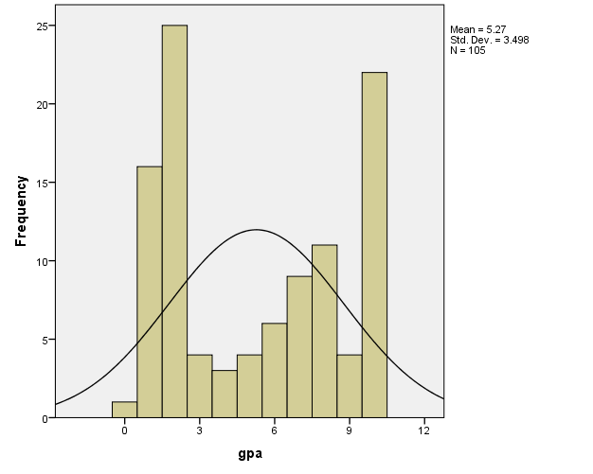

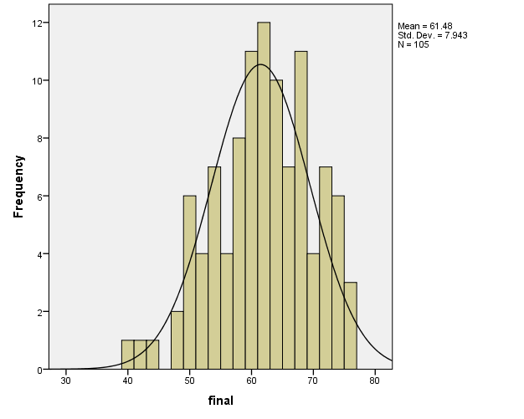

Descriptive Statistics
 | N | Mean | Std. Deviation | Skewness |  | Kurtosis
 | Statistic | Statistic | Statistic | Statistic | Std. Error | Statistic | Std. Error
gpa | 105 | 5.27 | 3.498 | .115 | .236 | -1.622 | .467
final | 105 | 61.48 | 7.943 | -.335 | .236 | -.332 | .467
Valid N (listwise) | 105

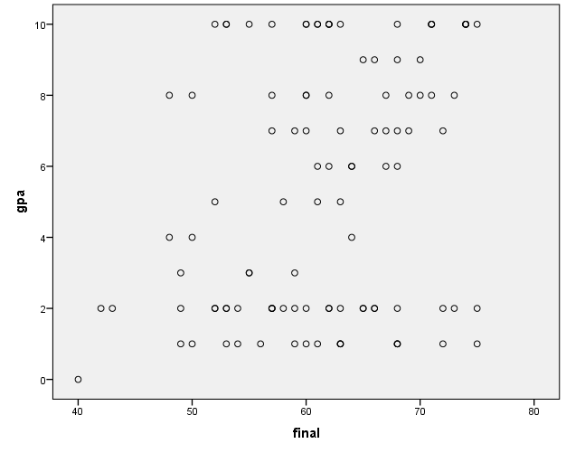

Above we can find the graphs for the GPA and Final, along with the descriptives output showing the skewness and kurtosis. Looking at the descriptives output, we can base the assumption that the values for the skewness is

- Articulate the assumptions of the statistical test.
- Paste SPSS output that tests those assumptions and interpret them.
- Summarize whether or not the assumptions are met. If assumptions are not met, discuss how to ameliorate violations of the assumptions.

Research Question, Hypotheses, and Alpha Level
- Articulate a research question relevant to the statistical test.
- Articulate the null hypothesis and alternative hypothesis.
- Specify the alpha level.

Interpretation

Correlations
 |  | gpa | final
gpa | Pearson Correlation | 1 | .295**
 | Sig. (2-tailed) |  | .002
 | N | 105 | 105
final | Pearson Correlation | .295** | 1
 | Sig. (2-tailed) | .002
 | N | 105 | 105
**. Correlation is significant at the 0.01 level (2-tailed).

- Interpret statistical results against the null hypothesis.
Conclusion
- State your conclusions.
- Analyze strengths and limitations of the statistical test.

