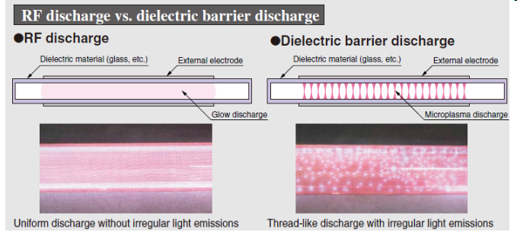
Copied from http://www.hamamatsu.com/us/en/product/category/1001/3026/L11751/index.html

