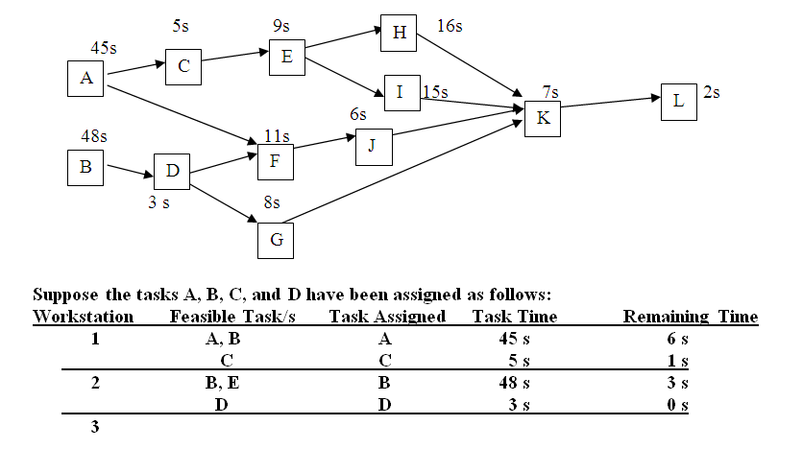
The precedence diagram and task times (in seconds) for assembling a Product X are as shown. Tasks A and C have been assigned to Workstation 1; Tasks B and D have been assigned to Workstation 2. If you were to assign tasks to work stations by using the task with most number of followers rule, the first assigned task for Workstation 3 is
A.E
B.F
C.G
D.H
E.I

2. A company is evaluating which of two alternatives should be used to produce a product that will sell for $35.00 per unit. The following cost information describes the two alternatives
 | Process A | Process B
Fixed Cost | $500,000 | $750,000
Variable Cost per Unit | $25.00 | $23.00
If total demand (volume) is 150,000 units, then the company should:

A.select Process A with a total profit of $1,300,000 to maximize profit
B.select Process B with a total profit of $750,000 to maximize profit
C.select Process A with a total profit of $1,000,000 to maximize profit
D.select Process B with a total profit of $1,050,000 to maximize profit

3. A company has a target output rate of 40 units every five (5) hours when its line is fully operational. To achieve this target the firm must have a cycle time of
A.more than 12.50 minutes
B.more than 10.00 minutes
C.7.5 minutes or less
D.8 minutes or less

