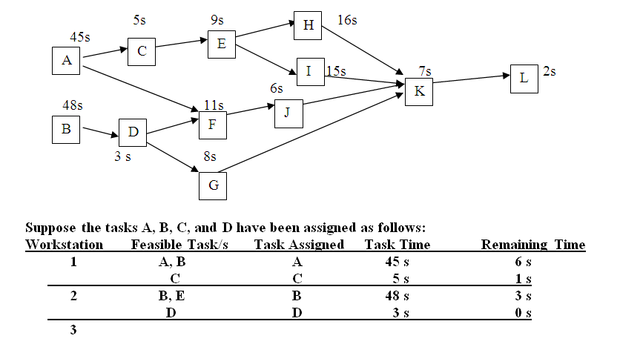
The precedence diagram and task times (in seconds) for assembling a Product X are as shown. Tasks A and C have been assigned to Workstation 1; Tasks B and D have been assigned to Workstation 2. If you were to assign tasks to work stations by using the task with longest processing time rule, the first assigned task for Workstation 3 is
A.E
B.F
C.G
D.H
E.I

2. A company is evaluating which of two alternatives should be used to produce a product that will sell for $35.00 per unit. The following cost information describes the two alternatives
 | Process A | Process B
Fixed Cost | $500,000 | $750,000
Variable Cost per Unit | $25.00 | $23.00

For what level of volume (output) would the firm prefer Process A to Process B?

A.for all volume levels greater than 75,000
B.for all volume levels greater than 97,500
C.for all volume levels greater than 117,500
D.for all volume levels greater than 125,000

3. In the breakeven analysis, the vertical intercept of the total cost function is the
A.fixed cost
B.price
C.variable cost
D.volume
E.none of the above.

