The year 2011 was another dismal one for US airlines in terms of financial performance. Despite an increase in both passenger numbers and revenues for the year, profits were down on 2010. In total, US airlines earned net profits of about $0.4 billion, representing a net margin of less than 1%. The dire financial state of the industry was underlined by AMR (the parent of American Airlines) entering Chapter 11 bankruptcy in November 2011. This ended AMR’s distinguished record of being the only one of the major legacy airlines to have avoided bankruptcy. In 2005, Delta, United, Northwest, and US Airways had all filed for bankruptcy protection.
The early months of 2012 offered little hope of improvement. Airline revenues were up by 8.2% during the first quarter of 2012 compared to the same quarter of 2011. However, as a result of higher costs, net income was down by 73.6% net margins had deteriorated from -3.2% to -5.2%.
The woes of the US Airline industry during the 21st century were typically attributed to the triple-whammy of the September 11, 201 terrorist attacks, the high price of crude oil, and the 2008 financial crash. Certainly, each of these was a powerful force in boosting costs and depressing demand. Yet the financial problems of the US airline business was little better. The IATA, the worldwide association of airlines, showed that the global airline industry had consistently failed to earn returns that covered its cost of capital (Figure 1; see also Table 1).
However, amidst the gloom, several airline executives expressed optimism about the future. At a Merrill Lynch conference on May 17, 2012, the CFO of United Continental Holdings Inc, John Rainey, observed that, compared to the past, the airline companies had become more disciplined and financially oriented. Instead of competing for market share through capacity growth, the major airlines were cutting capacity. Between the fourth quarter of 2006 and the first quarter of 2012, the major airlines would each cut capacity by between 3% and 10%. Southwest was the exception - its capacity would increase by 15%. In addition, the consolidation of the industry would reduce the number of competitors which would help support fares. Revenue generation would also be assisted by the unbundling of fares: the growing practice of charging separately for seat reservations, baggage services, and onboard refreshments. According to US Bureau of Transportation Statistics, airline yields (revenue per seat per mile) increased from 14.4 cents in the fourth quarter of 2010 to 16.8 cents a year later.
The airlines had also made progress in cost reduction. Competition from low cost carriers (LCCs) such as Southwest and JetBlue, had forced the “legacy carriers” into an endless quest for cost efficiencies and a reexamination of their business models. In particular, they had confronted the labor unions and gained substantial concessions on pay, benefits, and working practices. Chapter 11 bankruptcy had given the airlines a new flexibility in addressing some of the rigidities of their legacy systems-in particular pruning employee and retiree benefits and introducing more flexible working practices.
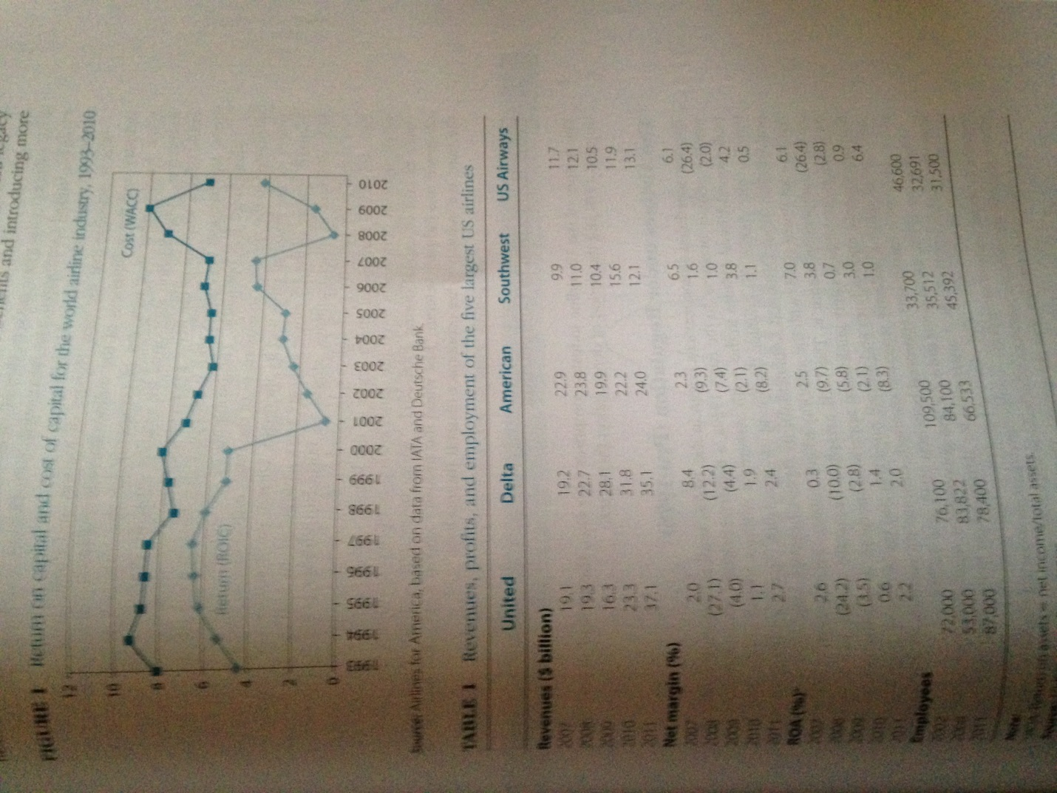
Orders for new aircraft from the US airlines also pointed toward confidence in the future. In July 2011, AMR had placed an order for 460 planes - the largest in its history – with Boeing and Airbus. In May 2012, it made a progress payment of $162 million to the plane-makers, despite its bankruptcy filing. During the early part of 2012, United Continental was negotiating Boeing and Airbus for 180 new planes, an order worth up to $15 billion.
Was it possible that the new climate of realism and financial prudence in the industry and the willingness of the airlines to reduce capacity when demand was weak would usher in a new era of prosperity for the industry? For many airline executives, consolidation supported by steadily growing demand for airline trend could offer a way out of the fierce price completion, low margins, poor labor relations, and frequent encounters with bankruptcy that had characterized the industry.
Others were less optimistic. The problems of the airline industry could not be attributed to the specific circumstances of the time; international terrorism, high FARED prices, or the financial crisis and its aftermath. Dismal profitability had been a REAR constant feature of the of the US airline industry since deregulation. And the situation is a little different in other countries: almost all European airlines were losing money Nor could poor industry performance be attributed to inept management. Do the criticism of the managerial effectiveness of the legacy carriers, the LCCs were weak financial performers. Even the much-lauded Southwest Airlines had failed its cover its cost of capital during 2008-2011. We’ve been here before, many times observed one industry veteran. Just when the industry seems to be climbing out of the mire, the industry’s dire economics reassert themselves.
FROM REGULATION TO COMPETION
The history of the US airline industry comprises two eras; the period of regulation up until 1978 and the period of deregulation.
The Airline under Regulation (Pre-1978)
The first scheduled airline services begin in the 1920s; mail rather than passengers was the primary business. In the early 1930s, a transcontinental route structure was built around United Airlines in the north, American Airlines in the north, and TWA through the middle. To counter the threat of instability from growing competition (notably from Delta and Continental), in 1998 Congress established the Civil Aeronautics Board (CAB) with the authority to administer the structure of the industry and completion within it. The CAB awarded interstate routes to the existing 23 airlines; established safety guidelines; approved mergers, acquisitions, and inter-firm agreements; and set fares and animal rates (on the basis of cost plus a reasonable rate of return). Industry structure ossified; despite more than 80 applications, not a single new carrier was approved between 1938 and 1978.
During the 1970s, the impetus grew for less government regulation and greater reliance on market forces. Political arguments for deregulation were supported by new developments in economics. The case for regulation were had been based traditionally on arguments about natural monopoly-competitive markets were impossible in industries where scale economics and network effects were important. During the early 1970s, the theory of contestable markets was developed. The main argument was that industries did not need to be competitively structured in order to result in competitive outcomes, so long as barriers to entry and exit were low then the potential for hit-and-run entry would cause established firms to charge competitive prices and earn competitive rates of return. The outcome was the Airline Deregulation Act, which in October 1978, abolished the CAB and inaugurated a new era of competition in the airline industry.
The Impact of Deregulation
The abolition of controls over entry, route allocations, and fares resulted in a wave of new entrants and an upsurge in price competition. By 1980, 20 new carriers-including People Express, Air Florida, and Midway-had set up.
Deregulation was also accompanied by increased turbulence in the industry; the oil shock of 1979, recession, and the air-traffic controllers’ strike of 1981. During1979-1983, the industry incurred widespread losses that triggered bankruptcies between 1978 and 1984 over 100 carriers went bust) and a wave of mergers and acquisitions. Despite strong expansion from 1982 onward, the industry experienced a profit slump in 1990-1994. Figure 2 shows industry profitability since deregulation. Profitability is acutely sensitive to the balance between demand and capacity: losses result from industry load factors falling below the breakeven level (Figure 3). The role of competition in driving efficiency is evident from the near-continuous decline in real prices over the period (Figure 4).
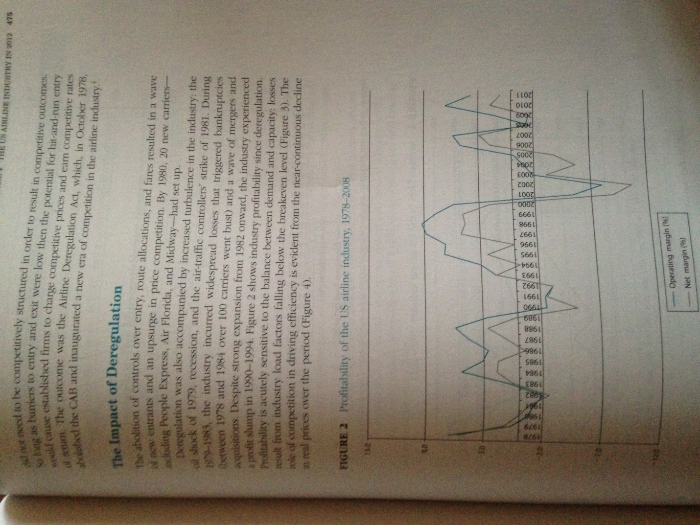

FIRM STRATEGY AND INDUSTRY EVOLUTION
Changes in the structure of the airline industry during the 1980’s and 1990s were primarily a result of the strategies of the airlines as they sought to adjust to the new conditions of competition in the industry and to gain competitive advantage.
Route Strategies: The Hub-and-Spoke System
During the 1980’s, the major airlines reorganized their route maps. A system of predominantly point-to-point routes was replaced by one where each airline concentrated its routes on a few major airports linked by frequent services using large aircraft, with smaller nearby airports connected to these hubs by shorter routes using smaller aircraft. This hub-and-spike system offered two major benefits:
• It allowed greater efficiency through reducing the total number of routes needed to link a finite number of cities within a network and concentrating traveler and maintenance facilities in fewer locations. It permitted the use of larger more cost-efficient aircraft for inter-hub travel. The efficiency benefits of the hub-and-spike system were reinforced by scheduling flights so that incoming short-haul arrivals were concentrated at particular times to allow passengers to be pooled for the linger-haul flights on large aircraft.
• It allowed major carriers to establish dominance in regional markets and on particular routes. Table 2 shows cities where a single airline held a dominant local market share. The hub-and-spoke system also created a barrier to the entry of new carriers, who often found it difficult to obtain gates and landing slots at major hubs.

The hub-and-spoke networks of the major airlines were reinforced by alliances with local commuter airlines. Thus American Eagle, United Express, and Delta Shuttle were franchise systems established by AMR, United Airlines, and Delta, respectively, whereby regional airlines used the reservation and ticketing systems of the major airlines and coordinated their operations and marketing policies with those of their bigger partners.
Mergers
New entry during the period of deregulation had reduced seller concentration in the industry. However, the desire of the leading companies to build national route networks encouraged a wave of mergers and acquisitions in the industry, some triggered by the financial troubles that beset several leading airlines. Had it not been for government intervention on antirust grounds, consolidation would have gone further; however, Department of Justice approval of the Delta-Northwest and United-Continental mergers during 2009-2010 suggested a more lenient approach to airline mergers. Figure 5 shows some of the main mergers and acquisitions. During 202-2011, despite several major mergers concentration declined as a result of capacity reduction by the biggest airlines and market share gains by LCCs.
Prices and Costs
Intensification of competition following deregulation was most evident in the pricing of air tickets. Price cutting was typically led either by established airlines suffering from weak revenues and excess capacity or by LCCs. The new, low-cost entrants played a critical role in stimulating the price wars that came to characterize competition after deregulation. People express braniff, New York Air, and Southwest all sought aggressive expansion through rock-bottom fares made possible by highly efficient cost structures and a bare-bones service (the LCCs economized on in-flight meals, entertainment, and baggage handling). Although most of the low cost
The Quest for Differentiation
Under regulation, price controls resulted in airline competition shifting to non-price dimensions: customer service and in-flight food and entertainment. Deregulation brutally exposed the myth of customer loyalty: most travelers found little discernible difference among the offerings of different major airlines and were becoming more indifferent as to which airline they used on a particular route. As airlines increasingly cut back on customer amenities, efforts at differentiation became primarily focused upon business and first-class travelers. The high margins on first- and business-class tickets provided a strong incentive to attract these customers by means of spacious seats and intensive in-flight pampering. For leisure travelers it was unclear whether their choice of carrier was responsive to anything other than price, and the low margins on these tickets limited the willingness of the airlines to increase costs by providing additional services.
The most widespread and successful initiative to build customer loyalty was the introduction of frequent-flyer schemes. American’s frequent-flyer program was launched in 1981 and was soon followed by all the other major airlines. By offering free tickets and upgrades on the basis of miles flown, and setting threshold levels for rewards, the airlines encouraged customers to concentrate their air travel on a single airline. By the end of 2006, airlines’ unredeemed frequent-flyer distance had surged to over 10 trillion miles. By involving other companies as partners—car-rental companies, hotel chains, credit card issuers—frequent-flyer programs became an important source of additional revenue for the airlines, bring worth $10 billion annually.

THE INDUSTRY IN 2012
The Airlines
At the beginning of 2012, the US airline industry (including air cargo firms) comprised 151 companies, many of them local operators. Table 4 lists those with annual revenues exceeding $100 million. The industry was dominated by five major passenger airlines: United, American, Delta, US Airways, and Southwest. The importance of the leading group was enhanced by its network of alliances with smaller airlines. In addition, domestic alliances with regional airlines, the Big 3, were also core members of international alliances: United with Star Alliance, American with the one world alliance and Delta with Sky Team.
Market for Air Travel
Airlines were the dominant mode of long-distance travel in the US. For shorter journeys, cars provided the major alternative. Alternative forms of public transportation—bus and rail—accounted for a small proportion of journeys in excess of a hundred miles. Only on a few routes (notably Washington-New York-Boston) did trains provide a viable alternative to air.
Most forecasts pointed to continue growth in the demand for air travel, but at a much slower rate than in earlier decades. During the 1980s and 1990s, passenger miles flown grew at a rate of 5% per annum and then slowed during the next decade. Boeing predicted that annual growth in air travel (in terms of revenue passenger

Airline Cost Conditions
Labor and fuel costs were by far the biggest individual cost items (Table 5). A key feature of the industry’s cost structure was the very high proportion of fixed costs. For example, because of union contracts, it was difficult to reduce employment and hours worked during downturns. The majors need to maintain their route networks and flight schedules meant that planes flew even when occupancy was very low. The desire to retain the integrity of the entire network made the airlines reluctant to shed unprofitable routes during downturns. An important implication of the industry’s cost structure was that, at times of excess capacity, the marginal costs of filling empty seats on scheduled flights was extremely low.
Labor The industry’s labor costs were boosted by high levels of employee remuneration: average pay in the scheduled airline sector was $55,640 in 2011 (a slight decline since 2007). In private sector employment as a whole, average remuneration was $38,300. Pilots, co-pilots, and flight engineers earned an average of $119,180; flight attendants $41,640. Labor costs for the major network airlines were boosted by low labor productivity resulting from rigid working practices that were part of the employment contracts agreed with unions. Their employees belonged to one of a dozen major unions: the association of flight attendants, the Air Line Pilots Association, and the International Association of Machinists and Aerospace workers bring the most important. Despite these unions’ tradition of militancy and past success in negotiating pay increases well above the rate of inflation, since 2001 the precarious financial state of the airlines and the flexibility offered by chapter 11 bankruptcy had enabled the airlines to impose pay restrictions and more flexible working practices.
Fuel How much a carrier spent on fuel was dependent on the age of its aircraft and its average flight length. Newer planes and longer flights led to higher fuel efficiency. Fuel-efficiency considerations had encouraged plane manufacturers to develop long-distance, wide-body planes with two rather than four engines. Fuel represented the most volatile and unpredictable cost item for the airlines due to fluctuations in the price of crude oil. Between January 2002 and June 2008, New York spot crude prices rose from $19 to $140 a barrel before falling to $40 in December 2008. Oil prices were on a rising trend during 2009 and 2010, then during 2001 and the first five months of 2012 traded in a range between $80 and $110.
An airline’s fuel costs also depended upon two other factors: the changing relationship between crude prices and jet fuel prices and the airlines’ procurement strategies:
• During 2010 to 2012, the effects of high crude oil prices were exacerbated by a widening margin between the price of jet fuel and the price of crude. Historically, jet fuel had sold at 15-20% premium over crude oil. During 2012, the margin widened to 33%.
• High, volatile fuel prices encouraged the airlines to hedge using options and futures contracts and make forward contacts. The extent of hedging varied between airlines according to their expectations about the future direction of prices and whether they had the financial resources for hedging. In March 2012, hedging of 2012 fuel requirements varied from almost 100% (Southwest) to 0% (US Airways); united was at 32% JetBlue 27%.

Delta Airlines took its fuel hedging one step further by becoming an active trader of jet fuel and crude oil. In 2011, it moved its jet fuel procurement unity into its treasury services department and hired oil traders from Wall Street, including Jon Ruggles from Merrill Lynch. However, its most audacious move was buying the 185,000 barrel/day Trainer oil refinery in Pennsylvania from ConocoPhillips for $180 million. Delta estimated that the purchase would allow it to cut $300 million annually from its $12 billion jet fuel bill. The refinery would be supplied with crude by BP, which would also exchance refined products from the refinery for jet fuel. As a result, the refinery would provide 80% of Delta’s US fuel needs. In addition, it believed that its fuel-trading activities would benefit from having a physical product to trade and access to detailed information on productions costs.
Equipment Aircraft were the biggest capital expenditure item for the airlines. In 2002, with list prices for commercial jetliners ranging from $75 million for a Boeing 757 to $390 million for and Airbus A390, the purchase of new planes represented a major source of financial strain for the airlines. While Boeing and Airbus competed fiercely for new business (especially when their order book was low, as in 2002-2004), aggressive discounts and generous financing terms for the purchase of new planes disguised the fact that a major source of profits for the aircraft manufactures was aftermarket sales. Over the past 20 years, the number of manufactures of large jets declined from four to two Lockheed ceased civilian jet manufacture in 1984; McDonnell Douglas was acquired by Boeing in 1997. The leading supplies of regional jets were Boombardier of Canada and Embracer of Brazil. During 2005-2011, Boeing’s return on equity averaged 36%.
Increasingly, airlines were leasing rather than purchasing planes. The world’s two biggest aircraft owners were both leasing companies: GECAS (a subsidiary of General Electric) with 1,732 planes and ILFC (a subsidiary of AIG) with 1,031. The attraction of leasing was that, first, many US airlines lacked the financial resources to purchase planes and, second, their borrowing costs were higher than those of leasing from companies.
Airport Facilities Airports play a critical role in the US aviation industry. They are hugely complex, expensive facilities and few in number. Only the largest cities are served by more than one airport. Despite the rapid, sustained growth in air transport since deregulation, Denver International Airport is the only major new airport to have been built since 1978. Most airports are owned by municipalities they typically generate substantial revenue flows for the cities. Landing fees are set weight. New York’s La Guardia airport has the highest landing fees in the US, charging over $6,000 for a Boeing 747 to land. In 2011, the airlines paid over $2 billion to US airports in landing fees and a further $3 billion in passenger facility charges.
Four US airports-JFK and La Guardia in New York, Newark, and Washington’s Reagan National-are officially “congested” and takeoffs and landings there are regulated by the government. At these airports, slots were allocated to individuals airlines, who subsequently assumed de facto ownership and engaged in trading them. According to Jeff Breen of Cambridge Aviation Research, “Slots are a lot like baseball franchises. Once you have one, you have it for life.
Cost Differences between Airlines One of the arguments for deregulation had been that there were few major economies of scale in air transport; hence large and small airlines could coexist. Subsequently, little evidence has emerged of large airlines gaining systematic cost advantages over their smaller rivals. However, there are economies associated with network density; the greater the number of routes with a region, the easier it is for an airline to gain economies of utilization of aircraft, crews, and passenger and maintenance facilities. In practice, cost differences between airlines are due more to managerial, institutional, and historical factors than to the influence of economies of scale, scope, or density. The industry’s cost leader, Southwest, built its strategy and management systems around the goal of low costs. By offering services from minor airports, with limited customer service, a single type of airplane, job-sharing among employees, and salary levels substantially less than those paid by other major carriers, Southwest, Jet Blue, and other LCCs had the industry’s lowest operating costs per available seat mile (ASM), despite flying relatively short routes. However, the gap has narrowed: in 2006, US Airways (traditionally the highest-cost airline) had cost per ASM that was double that of JetBlue; in 2011, the difference was tiny (Table 6).
Capacity utilization (load factor) is a key determinant of operating cost per ASM. Profitability depends on achieving breakeven levels of capacity operation. Operating below breakeven capacity means not only that fixed costs are spread over a smaller number of passengers but also that there are big incentives to cut prices in order to attract additional business. The industry’s periodic price was tended to occur during periods of slack demand and on routes where there were several competitors and considerable excess capacity. The industry’s rising average load factor during 2011 and early 2012 was taken as a favorable indicator of moderating competitive pressures.
Achieving high load factors while avoiding ruinously low prices was a major preoccupation for the airlines. All the major airlines adopted yield-management systems-highly sophisticated computer models that combine capacity, purchasing data, and forecasts to continually adjust pricing. The goal is to maximize revenue for each flight.

Entry and Exit
Hopes by the deregulators that the US airline business would be a case of competition in a “contestable market” were thwarted by two factors: significant barriers to both entry and exit and evidence that potential competition (“contestability”) was no substitute for the real thing. The capital requirements for setting up an airline can be low ( a single leased plane will suffice), but offering a scheduled airline service requires setting up a whole system comprising gates, airline, and aircraft certification, takeoff and landing slots, baggage handling services, and the marketing and distribution of tickets. At several airports, the dominance of gates and landing slots by a few major carriers made entry into particular routes difficult and forced start-up airlines to use secondary airports. Despite the challenges of entry barriers and the dismal financial performance of the industry, airlines seemed to offer a strange attraction to entrepreneurs. The most rents major entrant was Richard Branson’s Virgin America, which began service in August 2007. International airlines were also potential entrants into the US domestic market. The second stage of the US-EU Open skies agreement lifted the 25% ownership limit of US airlines and offered greater potential for European airlines to offer services between US cities.

Operating Revenue Operating Expense
Airline ASMs (billions) Load Factor % per ASM (cents) per ASM (cents)
2006 2008 2011 2006 2008 2011 2006 2008 2011 2006 2008 2011
American 175.9 150.4 154.4 82.0 82.2 82.0 12.5 14.5 11.6 12.5 15.7 14.3
United 139.8 123.2 219.4 82.1 81.3 82.8 13.1 14.9 11.8 13.1 16.2 13.2
Delta 133.5 117.3 234.6 77.8 82.3 82.1 13.0 16.3 12.9 13.6 16.3 14.1
Southwest 85.2 94.9 120.5 73.0 71.2 80.9 9.5 10.7 13.0 8.5 10.3 12.4
US Airways 83.9 68.3 72.6 77.6 81.8 83.7 15.7 16.8 11.7 15.2 19.2 13.1
JetBlue 23.8 29.7 8.5 82.5 80.5 81.4 7.6 10.5 10.6 7.5 10.2 11.7
Alaska 23.2 22.3 29.6 76.4 77.3 84.5 11.3 13.3 13.4 11.5 13.4 13.1

A key factor intensifying competition in the industry has been the barriers to exist that prevent the orderly exit of companies and capacity from the industry. The tendency for loss making airlines to continue in the industry for long periods can be attributed to two key exit barriers: first, contracts (especially with employees) gibe rise to large closure costs; second, Chapter 11 of the bankruptcy code allows insolvent companies to see protection from their creditors (and from their existing contracts) and to continue to operate under supervision of the courts. A critical problem for otherwise financially healthy airlines was meeting competition from bankrupt airlines, which had the benefit of artificially lowered costs.
Looking to the Future
At the end of May 2012, the US airline industry presented a mixed picture. The financial picture remained dire—the total market capitalization of all quoted US airline companies was $30.1 billion—less than the market value of Starbucks, less than one third of the market value of Facebook on the day of its initial public offering, and about one-half of that of the industry’s major supplier, Boeing. The credit position was no better: with the sole exception of Southwest, all the US airlines had a “speculative” credit rating. Nor was there any clear sign of relief from crippling fuel prices.
Yes there were positives. As a result of consolidation and the efforts to remove excess capacity, the industry appeared to be on a better structural footing than it had been for decades. These improvements were reflected in the escalation of fares in recent years. In addition, the major network airlines had been successful in reducing their cost base through productivity improvements and reductions in compensation and benefits. As a result, the LCCS no longer had a substantial cost advantage. However, a key issue for the airlines was whether the beneficiaries from improvements in cost efficiency were the airlines’ shareholders (through higher profits) or their customers (through lower fares).

The evidence of previous reveals in the industry suggested that they came to an end either as a result of external events or by the industry’s own propensity to over invest. In the case of the two previous upturns (1996-1999 and 2006-2008) external events were the critical factors (the September 11 terrorist attacks and the financial crisis of 200). The eagerness of the airlines to order new planes suggested that the newfound financial prudence and capacity discipline might evaporate once the industry’s fortunes improved.

