7.4 A Cross-Cultural Perspective
In general, the developmental milestones outlined in the previous chapter will be true of all children whatever the first language. Certainly, in terms of the order and rate in which children acquire the building blocks of language—words, syntax, the sound system—the patterns hold true across culture. When we get into the development of functions and the contexts in which these functions develop in children, namely conversation and constructing narrative uses of language outlined in this chapter, then culture may be more of a factor. For example, the uses to which young children put language—those functions identified earlier—are dependent on the kinds of interrelationships that exist between children and adults in a culture.

Using Language Appropriately
People in different cultures have different reactions to events or situations, and so the language that is appropriate will also be different. In Japan, for example, an expression roughly equivalent to I'm sorry in English is often used to express extreme thanks. A Japanese child using this structure, inappropriately in English, might be assumed not to have acquired the ability to express gratitude, and "thank you," is something that is learned almost from the cradle in the United States. But it would be a mistake to assume any kind of deficit when, in fact, the child might be attempting to express extreme gratitude. Mizne (1997) recounts the example of an Indonesian student who attempted to express concern for his professor's well-being by telling him to eat less fattening foods so that he would feel and look better. In his own country, the giving of unsolicited advice is a way of showing concern. If an Indonesian child were to inform her first grade teacher that she would look better with longer hair or that she should stop eating donuts, the child's concern might be misinterpreted. Being able to use language appropriately is as important as learning to use it correctly. For teachers, however, the problem is determining what has been learned. No, the language was not being used appropriately, but it is a cultural rather than a linguistic misunderstanding, and the teacher can infer little about the child's understanding of language function.
When considering how effectively a child has acquired a function, understanding it is just as important as producing it. Whether we are talking about structure or function, children cannot consistently and meaningfully produce a form they do not yet understand. Our inability to observe a child using a function does not mean that the child has not acquired it, but evidence that the child does not understand the function may mean just that.
Similarly, the fact that a non-English-speaking child does not initiate conversations or tell stories does not mean that she doesn't know how. Some children are shy; some children don't like to make mistakes and need to rehearse something internally until they are certain it is correct before producing it. Reluctance to engage in storytelling in a new language can be related to cultural differences.

Culture and Storytelling
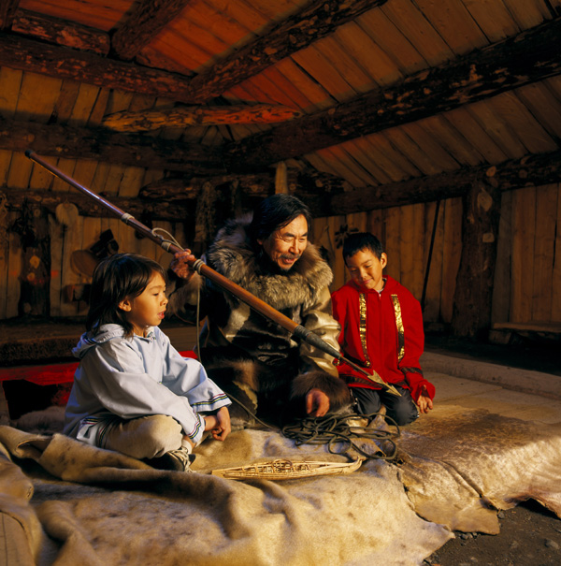
All cultures engage in storytelling, though the form and type of story may differ from culture to culture. Here, an Alaskan Yupik native tells hunting stories to children.
Alaska Stock Images/National Geographic Stock
Storytelling is universal, and there is a great deal of similarity in the stories that are told across cultures and in the way they are structured. Since they tend to recount human experience, and because there is some degree of commonality in all human experience, this is not surprising. Nevertheless, there are culturally determined differences in both the stories that people choose to tell and in the structure of those stories. For example, Japanese children have a very succinct structure to their narratives that is usually told in sets of three episodes.
The organization of stories in the African American tradition is quite different from the organization in the classic European tradition. Rather than being topic-centered, African American stories are usually based around a theme, featuring several episodes or events that illustrate the theme. (Curenton, 2006, p. 1)
This structure is referred to as topic-associating (Hyon & Sulzby, 1994; Dickinson, Wolf, & Stotsky, 1993). Listeners who are unfamiliar with this approach to narrative (see Culture and Story Structure) will have difficulty following the story because the stories tend not to have the expected indicators of a change in time or character.
Another difference between the classic European storytelling tradition and other cultural traditions is the number of characters involved in the story. Stories from the European tradition tend to revolve around one main character, but African American and Latino American children's stories contain several main characters who all relate to the main story theme. (Curenton, 2006, p. 1)
The difference may be attributable to the fact that "Latino cultures highly value interdependence among family and friends and socialize children to think about the needs of others as much as—and perhaps even more than—their own needs" (Melzi, 2001). Researcher Qi Wang found that
. . . when Chinese children and adults remember things in the past, they tend to focus on social interactions and the roles of significant others in those events. European-Americans are more focused on their own roles, their feelings, their preferences and their thoughts in the events. They are the main characters of the story. (Dingfelder, 2008)

Culture and Story Structure
North Americans tend to judge whether a story is a good story based on criteria acquired in childhood, and for the most part these are related to the traditional European story structure. Many North Americans of European descent think a good story has a central character (the hero or heroine), a beginning, a middle, and an end, each consisting of certain properties. The beginning provides an introduction to the characters and setting and a background to the plot, the middle develops the plot to a climactic conclusion, which is the end of the story. But not every culture adheres to this structure. Some cultures use a structure of topic-association. The following story, told by an African American girl, is illustrative:
So we were going to the mall to the shoe store. But first we stopped at this other store that sells jewelry. I need some earrings to go with the bracelet I got for my birthday. Did you see that bracelet that Sonia's been wearing? Her boyfriend gave it to her. My mom says I'm too young for a boyfriend. But I'm old enough to get my ears pierced. So I got the earrings. They're silver and huge. And so I sat down in the shoe store and put them on. I didn't find the shoes I wanted, though.
This story seems rambling unless we understand how topic-association works: The first two sentences tell the story in simple chronological order, and the third gives the reason for stopping at the jewelry store, again in the traditional story frame. But when she introduces the bracelet into the story, the topic-association begins. She associates bracelet with another bracelet that Sonia has been wearing, a bracelet given to her by her boyfriend. This reminds the speaker that her mother won't let her have a boyfriend because she's too young. Being too young takes her to the notion of getting her ears pierced, which brings her back to the earrings she went to the jewelry store to get. She describes them and putting them on in the shoe store, which eventually brings us back to the starting point of going to the mall to get shoes. Ultimately, the story comes to its conclusion—she didn't get her shoes. How might the story be told using the traditional European story structure?
As children grow older, their experiences at school and hearing other kinds of stories will influence the structures of the stories they tell.
Teachers run the risk of making the wrong assumptions about children whose stories do not conform to the classic European tradition. Teachers may think Asian children lack imagination because their stories tend to be succinct, with sparse detail, that African American children are rambling and disorganized or that Latino children lack focus because their stories have so many characters. In fact, all these cultures have rich traditions of storytelling, but the ways in which stories are told differ significantly. Researchers identified particular narrative traits used by African Americans in the Piedmont area of the Carolinas. They are far more likely to use rhyme, alliteration, repetition, and word-play because poetic language was a part of everyday language—the bantering, sermons, and songs that they hear regularly (Heath, 1983; Bardidge, 2009). The result can be a narrative structure that sounds more like poetry than prose. Listeners unfamiliar with this narrative structure may not know how to react or may assume that they are rambling or unfocused. Such assumptions are, of course, unfair, and they are dangerous because they mean that teachers are likely underestimating these children's language and cognitive abilities.
As teachers, it is incumbent on us to provide all children, whatever their language and cultural heritage, with a variety of experiences in English that will help them acquire the language they will need in order to engage in these activities. It is impossible for any child to engage in meaningful conversation or tell a story without the knowledge, experience, and language required to do so. Teachers must also be particularly sensitive to the kinds of assistance provided, such as paraphrasing. For example, if a child is trying to tell a story but is struggling with the words used for sequencing, an adult can repeat or paraphrase the child's utterance and provide the prompt for the next part:
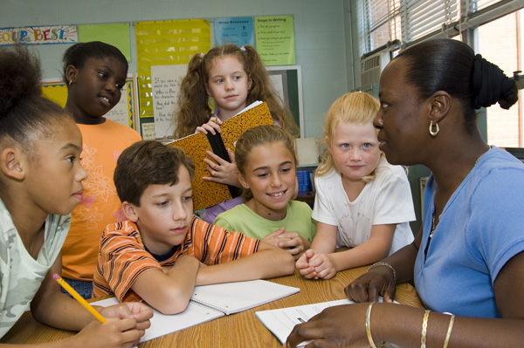
Teachers of English as a second Language have long understood the importance of comprehension checks.
iStockphoto/Thinkstock
Marie: My mommy put the, um, les oeufs in the . . . she put, um, in the—and then—and then . . .
Teacher: She put the eggs in the bowl and then she mixed them up? [Miming the action of mixing]
Marie: Yeah, she put the eggs in the bowl and then she . . . [Hesitates]
Teacher: [Mimes the action of mixing again] She mixed?
Marie: And then she mixed them up and put in flour and then, and then, we put cookies in, um . . .
Teacher: After she put in the flour, she put the cookies in the oven?
Marie: Yeah, in the oven. And then they come out and we eat.
These kinds of paraphrasing and prompting that Marie's teacher did for her are characteristic of child-directed-speech (CDS) (Chapter 3) that adults often use with infants acquiring their first language, and since Marie, at age 4 years and 6 months, is within the critical period of language learning, they are also effective with her. Additional comprehension checks are another characteristic of CDS that can greatly assist young second language learners (see Comprehension Checks). These checks serve to ensure that the child understands the teacher but also that the teacher understands what the child is trying to communicate.

Comprehension Checks
The following classroom conversation illustrates how a comprehension check works and why it is important to the learner. Think about these questions as you read the following dialogue: How do the learners assist the teacher in making her message clear? How do adults use a similar strategy in talking with young children?
Teacher: [Handing out a form to class members] You should ask your mother or father to fill this out. Then bring it back tomorrow.
Learner #1: It is for me?
Teacher: No, you bring it back. Your mother fills it out.
Learner #2: [Hands the form back to the teacher]
Teacher: No, not now. Okay. You take this form home [She writes "Take form home" on the board.]. Understand? You put into your backpack [Taking the form and pretending to put it into a student's backpack]. And then you take it home [Motioning with her hand to indicate a distance].
Learner #1: To father?
Teacher: Yes. Father or mother. Okay?
Learner #2: Mother write on?
Teacher: Yes! See, it is in Spanish and in English.
Learner #1 and #2: Oh, si. Yes.
Teacher: [Writes on board "Fill-out" and mimes someone writing on the form] "Fill-out" means to answer questions on this paper. Then bring back tomorrow. When do you bring it back?
Learner #3: Tomorrow?
Teacher: Yes. [She points to a day on the calendar.] Tomorrow.
Notice the role the children play in helping the teacher to clarify her meaning. When Learner #1 says, "To Father?" he forces the teacher to be more precise. When Learner #2 says, "Mother write on?" he is doing his own comprehension check but also gives the teacher another opportunity to expand her utterance using different words. The learners' responses throughout the exchange encourage the teacher to rephrase, mime, and repeat to make herself understood. Adults talking to young children often use the same strategies as the teacher to ensure that children understand their meaning.

Ch. 7 Conclusion
By the time they reach school age, most children are very proficient with the mechanics of language and are well on their way to acquiring the social aspects of language. They have developed some facility in all five of the basic functions of language and will continue to refine these throughout their school years. By the time they are 6, they have acquired many of the skills required to engage in conversation—being sensitive to the listener's perspective, turn-taking, making repairs when miscommunication occurs, becoming aware of relevance, understanding and making indirect requests, and acquiring the appropriate gender-based distinctions in language. They are able to tell simple stories, a skill that should be encouraged because storytelling helps children frame their thoughts and deal with emotions as well as giving them a head start on learning to read and to write. Children from all cultures engage in conversations and tell stories, but there are differences that can influence how these are shaped and how teachers respond. The teachers' task is to create environments that maximize all children to use language for all the purposes they need it to serve in their lives, academic and social.
Five Basic Functions of Language

00:00
00:00
