Ch. 7 Introduction
Four-year-olds Kam and Ari are both newcomers to their community, a suburb of Portland, Oregon. They attend a combined prekindergarten program with nine other children. Seven of the nine are monolingual English speakers, and the other two are bilingual in English and Spanish. Newly arrived in the United States, neither Kam nor Ari is yet fluent in English, although they are learning quickly. They began to attend the prekindergarten class in September, and by December, both children are functioning well. Kam no longer uses his native Tagalog in school—nobody else speaks it, and he has quickly learned to make himself understood in English and with gestures. Ari does not use her native Hebrew at all, but instead uses a mixture of English and, occasionally, Spanish that she has learned by playing with the two Spanish-speaking children.
At age 4, these children are well within the critical period for language learning, and their English language skills will continue to grow as the year progresses. Their teacher, wisely, has not sought to "teach" them English formally. Instead, she has used objects and visuals to make her meaning clear and, most importantly, she has provided a rich environment that invites the children to participate in storytelling and conversation, that, in short, exposes them to English for many different uses. From their perspective, learning language is not about learning nouns, verbs, plural endings, verb agreement, or the other grammatical paraphernalia that concern adults. Rather, they are interested in learning English in order to play with the children in their class and to fit in with the new world in which they find themselves.
Kam and Ari are biologically equipped to acquire language, and the environment they are in will provide the motivation, the language models, and the practice they need to activate the process. Although the acquisition of language is closely related to brain and cognitive development, children do not learn language just because they are biologically predisposed to do so. They learn language to communicate, and they learn to communicate in order to participate in the family and the broader social community. In fact, one of the major tasks of learning a language, whether first, second, or fourteenth, is learning to use the language appropriately. To do so, children have to learn to use language for a variety of purposes and in an ever-widening social circle. For Kam and Ari, the circle begins to widen in the prekindergarten class where they will start learning the language they need to serve their academic and increasing social needs.
In this chapter, we will take a closer look at what Kam and Ari need to learn by examining the functions of language that children need and acquire in their first 6 years. We will also take a close look at how children learn to construct narratives through hearing and telling stories, and why it is important for their academic and social lives. Finally, we will also consider what children have to learn in order to become competent conversationalists.

7.1 Language Functions in Early Childhood
When it comes to describing what children accomplish when they learn language, it is useful to talk about how they learn words, grammar, and pronunciation. "Learning a language is not simply a matter of learning a system of rules for linking sounds and meanings: it is learning how to use such a system for communication" (Clark, 2004, p. 430). Moreover, to focus exclusively on describing the "nuts and bolts" would greatly underestimate their accomplishment because such descriptions cannot account for what children are able to do with language. It completes the language-learning picture to think also about and to categorize language according to the various functions it can and does serve in children's lives.
It is useful, especially for teachers of young children, because it helps them to assess language from a very practical perspective by considering not only whether a child knows a particular structure or vocabulary item but also whether a child is able to accomplish what he needs to with language.

The Growth of Language Functions
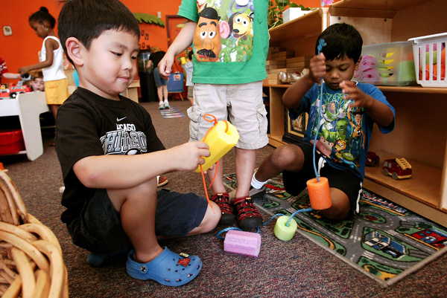
For preschool children, much of language learning involves learning the social functions of language. They learn many of these while engaging in cooperative activities.
Associated Press
As they grow and their network of friends and acquaintances extends beyond the home, children become far more sophisticated and resourceful in their uses of language. They continue to use it to categorize, and, as we have seen, it continues to facilitate cognitive development, but children also develop a broader inventory of uses. In very general terms, language serves to inform, to direct or command, and to express feelings, emotions, or beliefs. In order to analyze children's growth in language during the preschool years, however, it is necessary to further refine these broad functional categories. Several schemes have been developed for analyzing language functions into more precise categories.
In 1975, M. A. K. Halliday rebelled against the structural analyses of language popular in previous decades, especially the work of Noam Chomsky. Contending that these analyses completely missed the point of language—to make meaning—he built on the work of Roman Jakobson (1960), one of the earliest linguists to describe language in terms of function, to analyze children's language learning in terms of their expanding ability to create the different meanings needed in order to function socially and academically. He published an important book in which he eschewed use of the term acquisition in any description or discussion of children's language, arguing that the term suggested that language is a static product when it is more rightly considered a dynamic process. Rather, he asserted, what the child develops is meaning potential. Learning language, in his view, is the process of learning how to mean, which was the name of his well-known book on children's language development. Halliday identified seven functions (see Table 7.1), which later researchers refined into categories that were more useful to educators because they were developed specifically to assist teachers in working with children to develop and expand their uses of language (Shafer, Staab, & Smith,1983; Painter, 2005; Piper, 2007). The descriptions of language functions in this chapter draw upon the work of all these writers.
Table 7.1: Halliday's functional analysis of language
Function | Definition | Example
Instrumental | Language used to express a child's needs. | When 2-year-old Sarah told her mother, "want cancake," or when 4-year-old Kam said, "Get coat," to indicate that he wanted his coat so he could go outside.
Regulatory | Language used to tell others what to do. | When Ari told Kam, on their first day of prekindergarten to "go away!" she was attempting to regulate Kam's behavior.
Interactional | Language used to make and maintain relationships with others requires the interactional function. | When Kam said to Ari, "Do you want to play with this?" (handing her a toy car). When children say, "I love you, Mommy."
Personal | Language used to express feelings, opinions, or individual identity. | Isabelle, at age 4, was in time-out for pinching her baby sister when she asserted, "I'm NOT bad!"
Heuristic | Language used to gain knowledge about one's environment. | When Kam asked, "What he doing?" in reference to a picture of a man hang gliding.
Imaginative | Language used to tell stories and jokes and to create an imaginary environment. | When Ari said, "I am the princess Ari, and you can be the prince."
Representational | Language used to convey fact or information. | "That's a tractor," Maria explained to Ari while the two children looked at pictures in a book.

Are Language Functions Culturally Dependent?
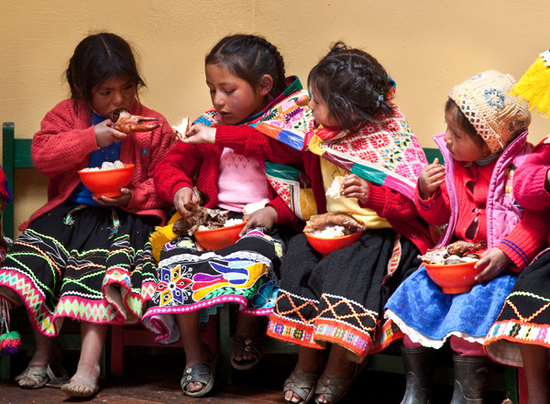
These Quechua Indian preschoolers probably come from a different cultural tradition than you do, but they will still develop similar functions of language. Why is this significant?
Michael & Jennifer Lewis/National Geographic Stock
Before we take a closer look at how language functions develop in young children, it is important to consider the role of linguistic and cultural diversity. The five functions that we will examine in detail in upcoming sections are likely universal, although that is an impossible hypothesis to test. We know that all children learn to function in language in these five broad categories. What differs, depending on language and culture, is the way those functions are realized or observed. For example, "Inuit children are deemed to have acquired their native language when they demonstrate their understanding by doing as they are told" (Piper, 2007, p. 237). Some Asian cultures share this belief. This means that in some situations, Inuit children's actions will speak louder than words in terms of evaluating their repertoire of functions. Alternatively, they might use different expressions than English-speaking children for a common function, or they might use no language at all. We have to be very careful in assuming what children do or do not know based on our observations if we do not share the same culture, and especially careful of reaching conclusions based on what they do not say. The failure to observe a child using a function does not mean that it does not exist in a child's repertoire. With these warnings in mind, let's look more closely at the five functions of language that develop in a child's first 5 years.

The Social Function
The social function of language is the way in which children assert and maintain social needs. When Andy, at age 2, says, "Want juice!" he is asserting a need. When his sister picks up his teddy bear and Andy insists, "That mine!" he is asserting his right to that toy. This is a broad category of use with many subfunctions. Following are five of the most common subfunctions:
- To assert by threatening. "I'm gonna tell!" When Ari tells Kam that she is going to tell the teacher that he is throwing sand outside the box, she is using language to assert herself by making a threat.
- To assert through argument. "It's not fair!" When a child says this, she is also asserting herself by making an argument.
- To criticize. When Ari told her mother that the sweater her mother picked out for her "looks like a baby's," she was using language to criticize. When Kam said, "You're doing it wrong," he was using the same function.
- To assert positive views. Ari was working with two other children in her class on an art project. When one of the other girls added a sparkly star to the collage they were making, Ari observed, "That looks pretty." This is an example of a child using language to state a positive opinion.
- To seek approval. "Do you like this one?" or "I made it pretty, right, Papa?" are examples of language being used for social purposes, in this case to seek approval.

The Projecting Function
Projecting language is the function of language that allows a child to "live" the experiences of others, to enter into fantasy worlds and roles. Also called the imaginative function, it is the use of language to engage in make-believe or pretend. Children as young as 2 can be heard playing with toys and changing their pitch as they take on the role of a doll or an animal. Even before the words are intelligible, the child is using her voice to project into the role. Later, we hear expressions such as, "Mommy, Sheepy doesn't like chocolate!" which illustrates the child's beginning to reach outside her own identity. The following dialogue reflects this function in two 4-year-old girls:
Connie: I'll be the teacher and you be you.
Marissa: No, I'll be the teacher and you can be me.
Connie: No, I'm the teacher. [Changing her pitch to sound more authoritative] You sit down right now! Get out your crayons.
Marissa: I can't get my crayons. Shelby (her sister) broke them!
There is some evidence that boys and girls may differ in the kinds of pretend play they engage in and thus in the kinds of language that emerge. Researchers have found, for example, that preschool girls are more likely to engage in cooperative pretend play focused on daily events and more readily accept different roles, even those requiring gender shifts. Boys, on the other hand, tend to engage more in fantasy play involving objects or machines and are reluctant to assume female roles (Garvey & Kramer, 1989; Black, 1989; Muthukrishna & Sokoya, 2008).

The Controlling Function
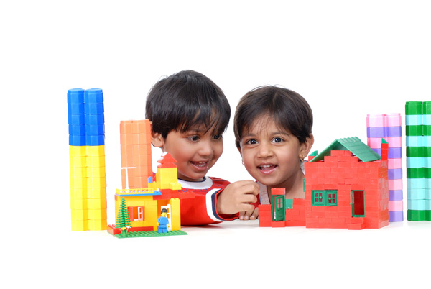
Often children "talk their way through" tasks. These two are using language to help guide their actions in building their village. What functions of language are involved?
Hemera/Thinkstock
Controlling language is the language children use for controlling the self and others. When children direct the actions of others or their own in expressions such as, "Give me that, now!" or "Stop that, Cora!" they are attempting to regulate the actions of others. In older speakers, this function may be realized through a direct command or order, or through an implied one. "Water the flowers" is direct while "I think the flowers could use some water," is implied. In preschool children, however, the implied command is rarely heard, and children often do not interpret it correctly. In the following monologue, a child is regulating his own behavior as he builds a tower with interlocking plastic blocks:
Cameron, age 4 years, 9 months: This one goes like this. Then I can put this one here. The red one goes on the top. Where can I put the green one?
This is an example of a child using the controlling function as he monitors his own actions. It is very similar to what adults do when they "talk through" a complex task. The monitoring function of language is a good illustration of the interrelationship of cognition and language. Many kindergarten and first-grade teachers have observed that children are suddenly able to tie their shoes once they are able to talk themselves through it. Once they have sufficient language to construct the narrative, they can use that narrative to guide their own actions.
The controlling function of language has an even more important purpose than providing a means for getting things done: it plays an important role in learning. When language is used to teach oneself or to direct others in ways that facilitate understanding, it is assisting children to make sense of and to organize the world around them. Therefore, it is an important tool for early cognitive development.

The Informative Function
Informative language covers a number of uses of language, all related to conveying information, whether to the self or others. It encompasses, for example, the following uses of language:
- Commenting on past and present events. When Ari said, "I saw a big monkey at Jungle Island" (past), or Kam observed, "There's a fire truck!" (present), they were both using the informative function to make a comment.
- Labeling. Children hear a great deal of informative language in their early years as helpful adults teach them the names of objects. When Ari told Kam, "That's not a radio, it's an iPod," she was using the informative function to label something that was unfamiliar to Kam.
- Talking about a sequence of events. "We went to see the princesses on ice, and they skated around. Then the prince came and there was a party." Whenever children recount events, more or less chronologically, they are using informative language.
- Talking about details. When Ari described the new sweater she got for her birthday, she was using the informative function to provide detail: "It's pink but not really pink. Kind of white but a little bit pink."
- Making comparisons. When a child says, "I'm faster than Marco," or "Marissa is bigger than I am," she is using informative language to make a comparison.
- Generalizing. This is an important subcategory of the informative function for academic purposes. Sentences such as "The clouds usually mean rain is coming," and "Papa went too fast and so he falled down," demonstrate that a child has learned something about cause and effect.
- Requesting information. This is another subcategory of the informative function that is important for academic learning. Seeking information is one significant way a child learns about the world. "When are we going to the party, Mommy?" and "Is it time to go?" illustrate how the child asks what he needs to know.
Children hear a great deal of language used to inform, and they develop the ability to use it very early. Although the examples just given are all fully formed sentences, children demonstrate ability to use the informative function when they begin to learn words. They begin by labeling the objects in their environment, and this is the informative function. When a 2-year-old points to an object that his mother names, he is demonstrating the informative function. More importantly, he is using language to help him learn.
Children use the informative function to test whether things are as they believe them to be and to question and discover. It thus plays a critical role in cognitive development and helping children to succeed in school because it is one of the most commonly used in classrooms. Language for forecasting and reasoning is another function important in the school years, but it is also important for cognitive development in younger learners.

The Forecasting and Reasoning Function
Forecasting and reasoning language allows children to express their curiosity and allows them to find out about the world. A toddler who asks, "Why?" or "Why can't I?" is seeking information as well as trying to understand the reason or cause for an action. This function operates in three ways:
- To request information. The kind of information requested differs from what is requested in the previous informative function. In this case, children are not just seeking names of objects or actions. "Why can't I go?" is a question asked by a child who seeks to understand a cause or a reason. Understanding that she can't go outside to play because it is raining helps her to develop understanding of cause-effect relationships.
- To predict an event. A child who says, "I think it's going to snow" is using language to predict. If the sky is grey and the wind is blowing, it is obvious that the child has made the prediction based on past experience. In other words, she has learned something about how one event often leads to another.
- To forecast and reason. On the other hand, if the sky is bright and the sun is shining, or if the child lives in South Florida, and the child says, "I think it's going to snow," the usual response from an adult is to question the child: "Why would you say that?" or "What makes you think it will snow?" In drawing out the child's reasoning, the adult then has an opportunity to engage further with the child, offering possible alternative conclusions along with the language for those conclusions so that the child will come to understand the relationship between the color of the sky and the likelihood of snow.
This function of language gives children an extremely useful tool for coming to understand the world and how it works. It also provides valuable insights into the reasoning abilities of children. The following dialogue takes place between Jack, a few months before his 5th birthday, and his older brother Mark, 12. Mark has just received a new baseball mitt for his birthday and is not happy because his brother has been playing with it and apparently got paint on it.
Mark: You got paint on my glove!
Jack: Did not!
Mark: Yes, you did. Look! There's blue paint on it. And there's blue paint on your hands, too.
Jack: Nope. I didn't.
Mark: There's nobody else here, and there is paint on my glove.
Jack: Maybe you . . .
Mark: Don't be silly. I wasn't painting, and you were. And now there's paint on my new glove.
Jack: Maybe it fell in the paint.
Mark: Jack, how would it fall?
Jack: Well. Maybe we can wash it off.
Mark: Go wash your hands and if it comes off, we can try washing it off the glove.
Jack: Okay. [He starts to cry.] Don't tell Mommy!
Mark: I won't tell. Don't cry. Maybe it will wash off. We'll try.
At first, Jack tries to deny causality despite the evidence. He even looks for another explanation, and the fact that he does, shows another kind of causal reasoning—the glove might have fallen into the paint. We also see strong evidence that he understands cause and effect when he asks whether Mark will tell their mother. Jack and the other children we have met in this chapter are active language learners, learning to cope with the parts that make up language, from sounds through sentences. They are learning to use language in ways that accomplishes what they need to accomplish and which also advances their cognitive development. Children do not acquire language functions in a strictly sequential manner— there is overlap—but they do acquire them in roughly the order shown in Figure 7.1.

Figure 7.1: Order in which language functions are acquired
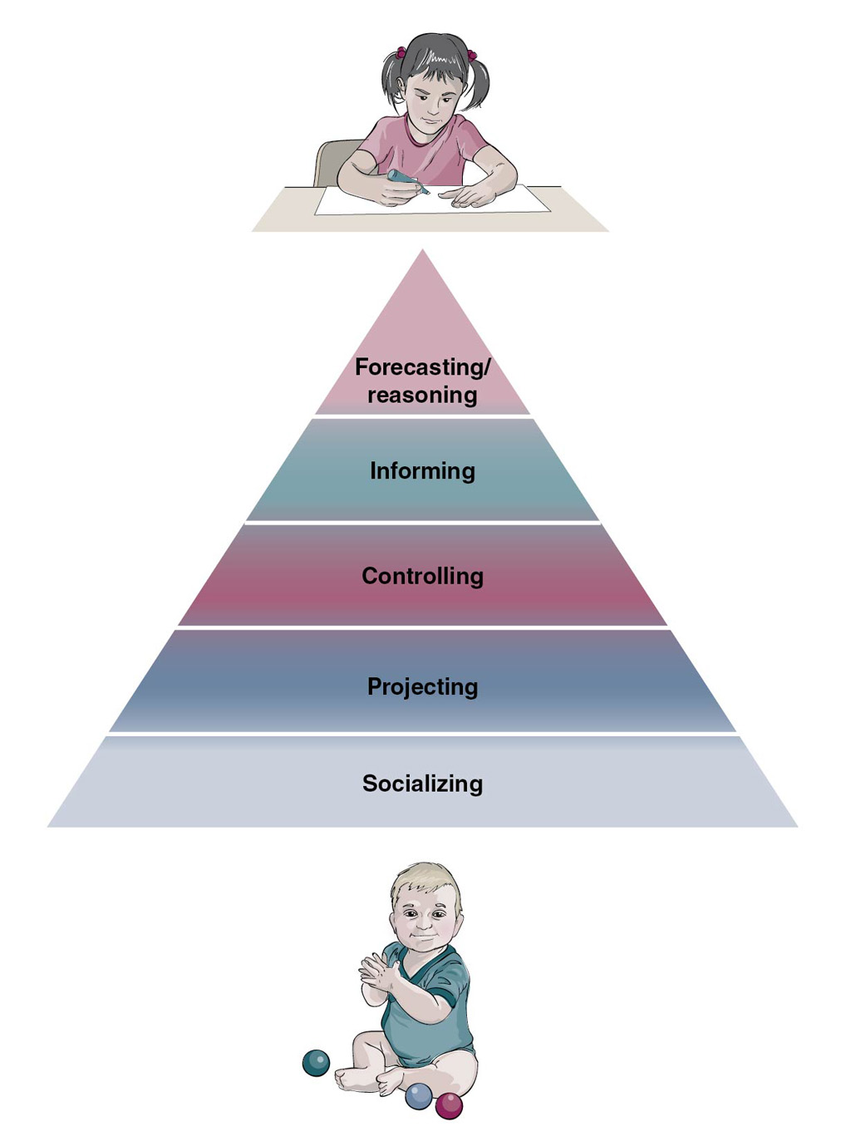
Children acquire language functions over time. The functions overlap one another but develop in the general order shown.
We have seen that learning a language involves learning the rules of that language and to use that language to carry out a variety of social and academic functions. Neither the rules nor the functions are learned in isolation. They are learned in social contexts, so learning a language means learning how to use language appropriately in a variety of social contexts. While they are still acquiring all of the building blocks we have been looking at, children must also acquire the skills needed for developing and maintaining social relationships. For preschool children, learning to match language use with social context involves acquiring two important skills—building conversational skills and learning to construct narrative. These skills begin to develop early, but most actively between the ages of 4 and 6.
Next section

7.2 Acquiring Conversational Competence
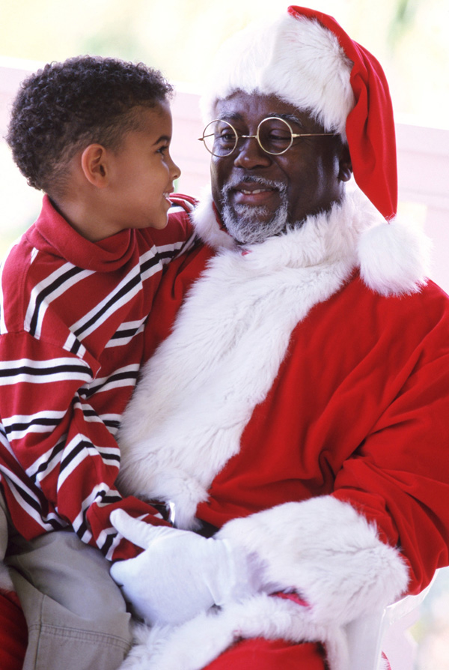
In order to make his request to Santa, this boy will have to have acquired some level of conversational competence.
Cusp/SuperStock
With a firm linguistic foundation in place and with rapidly advancing cognitive skills, children around the age of 4 begin to make very notable progress in the social uses of language. Their interactions with adults and other children reflect the progress they are making and what they have yet to learn. Much rides on the ability to use language appropriately, so we will take a closer look at how conversational and narrative skills are built.
What does learning conversational skills entail? Pioneers in automated telephone services have attempted to answer that question in order to improve the range of services an automated system can handle. Most of us have had the experience of trying to "converse" with a system that does not recognize or respond to more than very basic information gathering; it is unable to recognize anger or frustration. That is because it is difficult to program computers to recognize nuance, and yet a 6-year-old child must have mastered much of this nuance in order to get along with others That child will have to have acquired understandings about how conversations are structured. These elements of conversational competence include
- becoming sensitive to the listener's perspective;
- becoming skilled at taking turns;
- learning to make conversational repairs when there is a miscommunication;
- becoming sensitive to relevance;
- learning to interpret and to make indirect requests; and
- acquiring appropriate gender-based distinctions.

Understanding the Listener's Perspective
Sensitivity to a listener's perspective is a prerequisite for all conversation. It is also the skill on which all the other elements of conversational competence are built. Unless each participant in a conversation is aware of how much the other participants are paying attention or comprehending, it is impossible to structure his narrative or information appropriately.
A good indicator of whether or not children are aware of the listener's perspective can be found in the child's use of definite and indefinite articles. Look at the following pairs of sentences:
- Pick up a toy and bring it to me.
- Pick up the toy and bring it to me.
In (a), the speaker is introducing something unspecified, hence the use of the indefinite (meaning undefined) article, a. In (b), the speaker assumes that the listener knows the object referred to; in other words, it is assumed that the speaker and listener share the same referent for toy. In general, during the years between 4 and 6, children develop a fairly firm command of the definite and indefinite article, but they are not always reliable in using the indefinite article to introduce a new topic into a conversation. Consider the following conversation between Carmelita, age 4 years, 7 months, and her mother:
Carmelita: The boy gived me this [Holding up a sand shovel].
Mother: [Looking around.] Which boy? What was his name?
Carmelita: I don't know. See, it's for digging up shells.
Mother: Can you show me which boy, so we can go thank him?
Carmelita: I don't know. One boy. I'm going to dig here.
This conversation isn't totally ineffective, but it does show how a 4-year-old may be referentially correct in the use of definite and indefinite articles but be conversationally confused. Had she begun "A boy . . ." instead of "The boy . . .," the focus would have been, as she intended, on the shovel.
Other indicators show that a speaker is unaware of or ignoring the listener's perspective. For example, some people habitually begin a narrative somewhere in the middle without providing sufficient information for the listener to know what the topic is. A friend of mine recently began a conversation like this: "I don't know what she was thinking of when she said that." It was a little like Carmelita in the previous example. I had no idea who "she" was or what she said. There were two options available to me. I could ask, or I could respond as though I knew. Most people would simply ask (assuming that they wanted to engage in this conversation). But some would respond, "I don't know either. What do you think happened?" hoping to pick up clues in the responses. Starting in the middle of the story is, thankfully, rarer in adults than in children, but in both cases, the cause is likely the same—the speaker has the information in her head and begins to speak aloud, starting to vocalize the narrative that has been running in her head without any real intent of engaging in conversation. It is more of a monologue than a dialogue. Whatever the reason, it shows little awareness of the listener and is not effective conversation.
Providing insufficient information for the listener is not the only kind of conversational malfunction. Sometimes speakers do just the opposite, providing excessive, redundant, or irrelevant information. Understanding the listener's perspective means being able to judge how much information a listener is likely to have and to need. It entails supplying sufficient information but not superfluous or redundant information. As children become more fluent in conversation, they learn to do comprehension checks. A comprehension check involves the speaker finding out whether the listener understands. Adults talking with young children do it routinely:
Grandmother: Would you go upstairs and get my phone?
Katrina: Okay. Where is it?
Grandmother: Go into my room. It is on the windowsill.
Katrina: Okay.
Grandmother: Do you know what the windowsill is? What part of the window?
Katrina: Like the shelf, under the window.
Grandmother: That's right.
Katrina, at 4 years and 6 months, has understood very well, but her grandmother checks anyway to make sure. Adults do this in different ways:
I was down at Buffy's by the Bay. You know, the rib place that used to be Shannon's? Right. So I was there on Saturday with my sister and her friend, Ruth . . .
Here, the speaker is aware that the listener might not know which restaurant she is talking about, and so she interrupts her story with a comprehension check, thus showing her sensitivity to the listener's perspective. One of the limitations on young children's ability to provide necessary information to a listener is the language required for doing so; it is impossible to provide the listener with information if the child's own understanding is lacking or she doesn't have the language for expressing it. As children gain more knowledge about the world, especially the world outside the home when they begin schooling, they gain the language they need to take the listener's perspective into account and make effective conversation. Being sensitive to the listener's perspective is closely related to another skill necessary for the development of conversational competence, turn-taking.

Turn-Taking
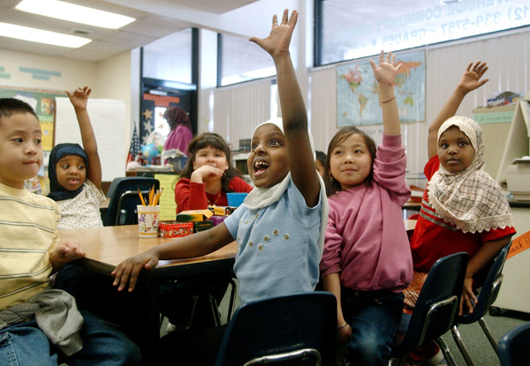
In class, it is easy to signal the wish to contribute to the conversation. In other situations, children must learn the more subtle rules for conversational turn-taking.
Associated Press
Turn-taking is necessary in advancing conversational skills for the simple reason that conversation is not a monologue. "Children need to get both the content and the timing of their turns right on each occasion, and this takes considerable skill. Each turn should be designed to add new information to what is already given" (Brown, 2003, p. 304). Children begin to learn turn-taking almost from birth. When parents respond to their babies' smiling, laughing, crying, with language, they help to establish the patterns of turn-taking. Infants at the precursory stage of language development engage in a kind of turn-taking in their cooing interactions with their mothers or other caregivers. When they begin to babble, this turn-taking can also be observed when they stop and wait for a response. By the time children reach school age, they have become fairly adept at conversational turn-taking and even help to prompt it themselves.
There are two basic "rules" for conversation, both involving turn-taking. One is that only one person talks at a time, and the other is that there should be no prolonged silences. There are a number of ways in which turn-taking is accomplished in conversation. They include
- an "invitation" to comment, such as, "What do you think?" or "Don't you agree?" or "I can see you don't agree with me";
- asking a question such as, "Have you ever been there?";
- a change in intonation; and
- a direct gaze. Normally in conversation, people do not constantly look at each other, so a direct gaze invites a change of speaker.
Violations of turn-taking are more common in younger children. Children of 3 and 4 overlap or interrupt because they have trouble holding in memory what they want to say until there is an obvious turn-change opportunity. By the time they are 6, most children can hold their thought until an appropriate entry into the conversation appears. During this period, they also become increasingly adept at repairing turn-taking violations. A common repair is to stop, wait, and then repeat the last part of what they were saying before the interruption. Again, cognitive maturity makes it easier to remember where they were before being interrupted. A less effective repair, used more often by 3- and 4-year-olds than 6-year-olds, is simply to talk louder.

Making Conversational Repairs
Conversational repairs can occur only if the speakers are sufficiently aware of the other's perspective (i.e., that there has been a miscommunication). Consider these conversations:
Christian, age 3, and Sammy, age 5, are cousins. They are playing on their grandmother's porch. There is a basket of fruit on a table. Christian wanders over, picks up an apricot and shows it to Sammy.
Christian: This is peach. Little peach.
Sammy: No, it's not. It's called apricot.
Christian: [Looking carefully at it] Nope. Peach. Baby peach.
Sammy: No, it's not! It's called apricot. Grandma has a tree that grows them.
Christian: Grandma gots peach trees!
Sammy: Yep, but that's an apricot!
Christian: No, it's a peach, and you're stupid!
Sammy: You're more stupid!
In just a few months' time, Sammy will be able to accept the correction, but until then, more conversations will end in this way.
A child may not yet be able to say, "No, that's not what I meant," when an adult misunderstands their intent, but they do realize that a miscommunication has taken place and attempt to correct it. Consider the following dialogue between Carmelita, age 3 years, 10 months, and her mother:
Mother: (Holding up two Sweaters) Which sweater do you want?
Carmelita: Don't want any sweater!
Mother: You have to have a sweater. It's cold outside.
Carmelita: But I don't like any sweater!
Mother: Okay, so let's go outside without a sweater.
Carmelita: But I'll be cold!
Mother: Yes, but you don't want to wear a sweater.
Carmelita: Yes, I do!
Mother: Well, here then.
Carmelita: No! I want a different sweater.
In this dialogue, Carmelita understands that a miscommunication has taken place before her mother does. The cause of the miscommunication appears to be her misuse of any—an older learner would say either or either one. More importantly, Carmelita repairs the conversation and makes her intentions clearer. At age 3, Carmelita would not have been able to advance the conversation but would have resorted to repetition to try to make herself understood. But here, at almost 4, she is able to change tactics. This ability represents a giant step toward conversational effectiveness. This corresponds with the increasing ability of a 4-year-old child to engage in cooperative play. During that cooperative play, children will also begin to develop their awareness of conversational relevance.

Sensitivity to Relevance
Relevance, broadly speaking, is the ability to stay on topic and contribute useful commentary. Learning topic relevance begins to develop around age 5 and continues well into the school years. In school, children learn that older children will be more likely to include them in their conversations if they introduce interesting and relevant topics, and if their contributions to conversations initiated by others are pertinent or useful. Topic relevance is a skill that some people never fully master. We all know people who begin to talk about anything that pops into their head without considering whether or not listeners will be interested.
The ability to contribute useful commentary is necessary for moving conversations forward. As with most language, this aspect of conversational competence is something that a child learns without being taught. Part of acquiring this ability is coming to realize that the child is not the only arbiter of what is relevant. Preschool children can often be heard engaging in parallel monologues, in part because they have not yet mastered the concept of topic relevance. Consider the following between two 4-year-olds:
James: I don't want to play dolls.
Delia: I don't want to play trucks.
James: Dolls are silly.
Delia: Trucks are boring.
James: Mom won't let me go outside today.
Delia: My mom had to take her car to the garage.
James: It's not fair.
Delia: But it's broken!
James: No it's not. See? [He holds up his toy truck.]
Neither child is paying much attention to what the other is saying, so this extreme case of topic irrelevance can be thought of as dual- or parallel-monologues rather than as dialogue or conversation. In addition to being able to make relevant contributions to a conversation, children have to learn some of the more subtle ways in which others, particularly adults, communicate. The indirect request is a good example.

Understanding Indirect Requests
Understanding indirect requests is an aspect of conversational competence that makes one seem less authoritarian. Sitting in a cold room with a window open and wishing someone else to close that window, a young child will say, "Close the window," while an adult will usually say, "It's a little cold in here, don't you think?" Either way, the window will likely get closed, but the adult's form using the indirect request makes her seem less bossy. It is considered more polite. The indirect request has several forms, and some take longer to learn than others. Children as young as 3 or 4 tend to learn the declarative form, as in "The light is a little dim for reading" earlier than, "Would you mind sitting down?" which the child is more likely to take literally and might answer verbally. It is, however, somewhat difficult to determine how much or exactly what a child understands of such a request. If she sits down, it may be that she ignored everything except "sitting down," and made a good guess. By the time they are 5, most children are able to interpret "It's 8 o'clock" as a request to go to bed, if they know that to be their usual bedtime. Although they understand many forms of indirect requests before they are 6, most children do not use the form until sometime after the 6th or 7th birthday.

Acquiring Appropriate Gender-Based Distinctions
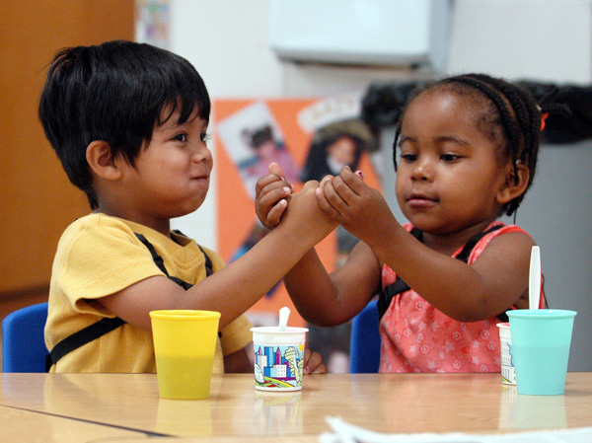
The conversation these children engage in might be thwarted by different interests as well as gender-based differences in conversational style. What other challenges might they encounter?
Associated Press
Understanding gender-based distinctions is an important component of acquiring sociolinguistic competence. Males and females differ in the vocabulary they use and in their style of speech, and there is little doubt that this difference is a result of socialization that begins at home and continues in school. Researchers have found, for example, that males are more assertive in their social interactions than are females (Cook, Fritz, McCormack, & Visperas, 1985). If there were not more similarities than differences in the speech used by males and females, communication between them would be more fraught with misunderstanding than it is already. Still, there are differences that appear very early. Girls tend to use language to negotiate closeness or establish a sense of belonging to a group, while boys are more likely to use it to negotiate status within the group. By the time they are 5 or 6, most children are using gender-appropriate language, and from the time they are about 4, their talk reflects the same kinds of difference in interest reflected in adult speech. Anyone who has tried to engage a 4-year-old boy in talk about princesses or a 5-year-old girl in the rules of football will have noted this early distinction. Not that it always holds true; children differ in their interests.
Conversation is only one of the sociolinguistic skills that children must acquire. The ability to construct a narrative, that is, to tell a coherent story, is important not only to success in school but to getting along in life.
Next section

7.3 Language and Storytelling
As we have seen in the examples in the previous section, effective conversation often entails the telling of a story. But generally speaking, conversation involves mostly dialogue, and the narrative is essentially a monologue. As such, the full burden for telling the story and making oneself understood rests on the speaker. Just about all children love to hear stories, but learning to tell them is also important. "Telling stories helps children frame their thoughts, emotions, and social-cultural identity" (Curenton, 2006, p. 1). Learning how narratives are constructed is an extremely important prerequisite skill for reading comprehension, writing, and oral language development. Storytelling is a skill that begins to develop between the ages of 2 and 3 and continues into the 11th year.

Three Types of Narrative
Children have to learn the components of a narrative as well as how they all fit together. There are three basic types of narrative: the script, personal, and fiction or fantasy (Pan & Snow, 1999; Piper, 2007). Scripts are generalized accounts of procedures or recurring events—how to make a sandwich, what to say when answering the phone, or what happens when a plane lands. The dialogue between Shelby, age 3 years, 6 months, and her teacher illustrates:
Teacher: Do you know your address, Shelby?
Shelby: My what?
Teacher: Do you know where you live?
Shelby: Yes. In my house. My house is at 3124 Camelia Court in Rosedale. My phone number is 211-555-4545, and my daddy is Mr. Frank Carson, and my mommy is Sheila Carson.
Shelby has provided much more information than requested, using a script that she has learned from her parents as a safety precaution.
Personal narratives recount particular events that the individual has experienced—an account of a trip to Disneyland, what happened at a birthday party, or going to the movies with Nana. When Kam came home from preschool, he told his father a story about a significant event in his day, with only a little prompting:
Kam: We went on the bus. But the bus breaked down because no air in tires.
Father: There was no air in the tires? You mean, the bus got a flat tire?
Kam: Yes! There was air and then no air and the tire went down. So we had to get off the bus.
Father: You did? Where did you stand?
Kam: We stood on the sidewalk. Close, so I got to watch. Then a truck came and two men came and they put a new tire on the bus.
Father: They did? How did they do that?
Kam: First, they had to make the bus go higher. So the man got a thing—I don't know its name—and made the bus go up high in the air.
Father: It's called a jack.
Kam: Jack? Okay. So the bus went up high in the air, and we had to stay on the sidewalk 'cause the bus might fall. Then they taked the old tire off and put a new one on. Then they made the bus go down again and we could get on. But we couldn't go to the 'quarium then 'cause teacher said it was too late.
Kam was recounting a specific event that had occurred in his life, a personal narrative.
Fiction or fantasy is the genre of narrative that children use during make-believe. When they engage in make-believe, whether it is by playing dress-up and pretending to be Mommy or in creating a wholly fictional role, children expand their use of language to include the projecting, or imaginative function. The following exchange between Lily and Guy shows them engaged in fantasy and using the language appropriate to their roles.
Kam used personal narrative to tell his father about the school bus incident. Have you ever heard a child tell a story using personal narrative? What do you remember about it?
iStockphoto/Thinkstock
Lily: I am the princess Prissy and you are the princess Pearl.
Guy: I'm NOT a dumb princess. I'm Superman.
Lily: There's no Superman in this pretend.
Guy: Well, I'm no princess.
Lily: You can be a prince, then.
Guy: No.
Lily: Prince Superman?
Guy: Okay. I'm Prince Superman! [He starts zooming around the room.] I am a prince and you are my prisoner.
Lily: I am not. I am the princess and you have to save me.
Guy: Are the bad guys after you?
Lily: Yes, and I'm scared!
Guy: Don't be scared! Superman to the rescue!
Lily: PRINCE Superman!

Storytelling Abilities, Ages 3-5
Children as young as 2 to 2-and-a-half can, with assistance, recount recurring events as long as they are fairly brief—what happens every day when they get to daycare, how to get dressed, or what happens when Daddy comes home. At first, their accounts will sound more like a personal narrative, but gradually they learn how to construct a general rather than a specific narrative, as shown in the following three narratives. Here, Isabelle explains how to build a snowman at three different ages/abilities:
At age 3, this boy's ability to build a snowman likely exceeds his ability to recount the experience later. By next winter, he will be much better at explaining how it's done.
Associated Press
At 3 years, 3 months: Roll up snow. Make big balls. Then put on top of. And Mommy putted hat on snowman and then put carrot for nose. Gived him nose carrot [Laughs at her joke]. Mommy help me because I little girl . . .
At 4 years, 7 months: First, we roll up one ball. Then you roll up another ball and another one, too. And you have to put one on top and then one on the other top. Then you put buttons, but not real buttons, and a nose but not a real nose. You put on hat and scarf, but real.
At 5 years, 9 months: Well, you have to make three balls with snow, but not the same size. I make the little one first 'cause that's the head, but you don't have to. Then you build the snowman by putting one ball on the other one and then the little one on top. Then you put on his face. You can use a carrot for the nose and nuts—walnuts or maybe another kind—for his eyes. Mommy let me put my scarf on him, and we used Papa's hat but you could use a girl's hat.
The first account sounds more like a personal narrative, but she is actually explaining the process of building a snowman after being asked by her father. In the second, we see not only more detail but we see her using the "timeless" present tense to indicate that this is not an account of a particular event but a recurring event. By the time she is nearing her sixth birthday, Isabelle has started to use the general pronoun you and her timeline is perfect. Like Isabelle, most children are able to construct an intelligible and accurate script by the time they are 5 or 6.
Well before they reach school age, children begin to create their own imaginative tales using the devices they have heard in stories and will later encounter in print. These devices include openings, such as Once upon a time . . . or There once was a . . . as well as connectors such as And then he said . . . or just Then . . . . One of the prerequisites to constructing a fantasy narrative is the ability to take alternative stances. Starting around the age of 2, children can engage in make-believe with older speakers, but at first they do not initiate or use the linguistic indicators of pretense (changes in pitch to indicate different characters, for example). They participate, but the language is much the same as the language they use for real life. By the time they are school age, however, children are able to initiate fantasy and use a variety of means to shift characters. They also are able to signal shifts between real-world and fantasy talk, usually by voice pitch. Fantasy talk is normally delivered in a higher pitched falsetto voice. By this time, they will also have mastered the narrative structure. An effective narrative includes background, which may include information about the setting, the location, the characters, and any other relevant information needed to set the stage. The second component is the episode, which is the heart of the narrative. The episode contains information about the event that caused the main character in the narrative to act, the nature of that action, and whether or not the character succeeded in carrying it out. It will also normally include information about the consequences of the plan and the character's own feelings about the action or the consequences. When a listener is unable to understand or is confused by a narrative, it is usually because critical elements of the episode are missing.
In the dominant North American culture, children begin to construct stories around the age of 3. Their first structures lack setting or much organization. They provide little information, and the timeline will seem to be random. Gradually, they begin to organize their narratives chronologically and tell stories with a discernible beginning, middle, and end; but the plot will likely be thin or nonexistent, particularly if the children have not been exposed to a lot of stories. Around the age of 5, a rudimentary plot structure begins to appear, and by age 6 or 7, children begin to acquire the linguistic devices for carrying the plot forward.
Princess Angelina wanted to go to the party, but her mommy said, "No, you have been a very bad girl!" So Angelina started to cry, and her mother said, "Stop crying and clean up your room." So Angelina stopped crying and picked up all her toys. "I'm done, Mommy. Now can I go to the party?" "Not until you hang up your clothes," said her mommy. Then Angelina hanged up her clothes. But she didn't hang up her pink tutu because she wanted to wear it to the party. The end. (Maria, age 5 years, 7 months)
Notice that Maria's story, while light on background information, has a clear temporal structure that is signaled by words such as so, but, and then. She also used prosodic changes to indicate the different speakers—Angelina had a high-pitched voice, and her mother had a lower pitch than Maria's normal tone. She also used her own voice to deliver "The end," thus signaling in two ways that the story was over. It is important for children to hear many stories and to learn to tell them. Some children will be adept at telling a story by the time they are 3 or so; others will need encouragement (see Activities to Encourage Storytelling).

Activities to Encourage Storytelling
Nearly all children love stories, and teachers can take advantage of this fact to assist all children, and especially children who are learning English as an additional language, to develop their storytelling skills in order to facilitate cognitive, language, and academic growth. Some useful activities include:
Audio stories. Those read by the teacher are important, because they allow for comprehension checks and interaction. But prerecorded stories are useful, too, especially with different character voices, because children can play them over and over at listening stations or at home. In either case, hearing these stories helps to hone listening and visual imaging skills, and to expose children to the form of stories. Most of the prerecorded stories available in North America are in the traditional European/ American structure (although there are some available in Spanish).
Ask children's parents or other family members to record their own stories. Hearing stories in their own language will hone their listening and visual imagining skills, skills that they will need in order to understand stories in English.
Take dictation. Teachers or older children can write down the stories that children tell. For children who do not know how or are just learning to write, it is helpful to have a scribe so that their stories are not constrained by their ability to write. Being able to dictate their stories greatly helps children develop oral fluency. Children who can read enjoy reading their stories aloud, and prereaders enjoy having their work read aloud to others in the class. If the stories are very short or incomplete, the scribe can prompt the child or ask others, "What do you think happened next?"
Encourage co-narration. By asking questions, and by inviting other children to ask questions, teachers encourage a kind of cooperative storytelling in which others contribute to the story by prompting more detail, by providing feedback, or by adding to the story. This assists all children in the group, not only as storytellers but to develop their conversational and social skills.
Narrative Language Skills
<span id="w75672" class="werd">&nbsp;</span>
A child's ability to retell stories improves with age. This video compares the ability of children of varying ages to recount a film. Younger children often miss links and certain details in the story, while older children use narrative transitions in their retelling. What stages of language development are each of these children in? How do you know this?

