Since I profited very much from a general link between pressure and irreversibility of an adiabatic process.
I wonder about how one defines mathematically that a process is reversible for a process that has both pressure and temperature differences from definition of total entropy while expressing this reversibility with only temperature and pressure as variables:
$$dS_{tot}=dS+dS_{sur}=\frac{dU}{T_{int}}+\frac{pdV}{T_{int}}+dS_{sur}=\frac{dq-p_{ex}dV}{T_{int}}+\frac{p}{T_{int}}dV+\frac{-dq}{T_{ext}}$$
Is there a mathematical way to show how much a factor the temperature is and how much a factor the pressure is and then find an equilibrium where the process is reversible for a state that has both pressure and temperature differences? That is finding a way to express $dS_{tot}$ while only using p, T, V and $C_{v}$ as variables while there are pressure and temperature differences and showing where the values of T and p are that creates $dS_{tot}=0$? Maybe doing this with the same variables as in the explanation for an irreversible adiabatic process below?

Here is a way I found to show that in general an irreversible adiabatic process must have positive entropy if $p>p_{ex}$ as an illustration for what kind of explanation I really would like since it explains the irreversibility by relating it only to pressure and I wondered about an explanation for my problem by using any combination of the three variables p, V and T. Help is much appreciated on this problem!
My explanation why irreversible adiabatic expansion has $∆S_{tot}>0$
Expansion:
$$It is constrained from p>p_{ext}$$
$$w=p_{ext}∆V p_{ext}∆V<w_{rev}=nRTln\frac{V_{2}}{V_{1}} for expansion$$
$$q=0$$
$$for an adiabatic process that is reversible: ∆U=-W_{rev}$$
$$for an adiabatic process that is irreversible: ∆U=-w$$
$$∆U=nC_{V,m}∆T=-w ∆T=\frac{∆U}{nC_{V,m}}$$
$$reversible: ∆T_{rev}=\frac{-W_{rev} }{nC_{V,m}} irreversible: ∆T=\frac{-w }{nC_{V,m}}$$
$$∆T_{rev}>∆T because W_{rev}>w$$
For reversible adiabatic expansion we can prove that $∆S=0$ like this:
Entropy from volume change isothermal reversible: $nRln\frac{V_{f}}{V_{i}}$
Change in temperature at constant volume: $\int_{T_{i}}^{T_{f}}{\frac{C_{v}}{T}}dT=C_{v}ln\frac{T_{f}}{T_{i}}$
For reversible adiabatic process we must have that: $∆S_{sys}=0$
Because we must have: $∆S_{tot}=∆S_{sys}+∆S_{sur}=0$
That is $nRln\frac{V_{f}}{V_{i}}+nC_{v}ln\frac{T_{f}}{T_{i}}=0 Rln\frac{V_{f}}{V_{i}}=-C_{v}ln\frac{T_{f}}{T_{i}}$
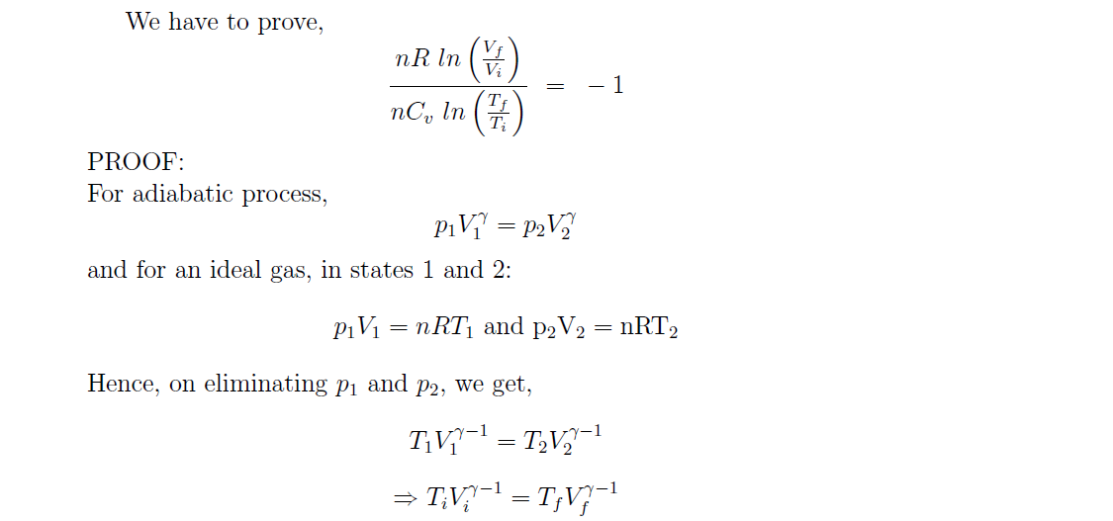
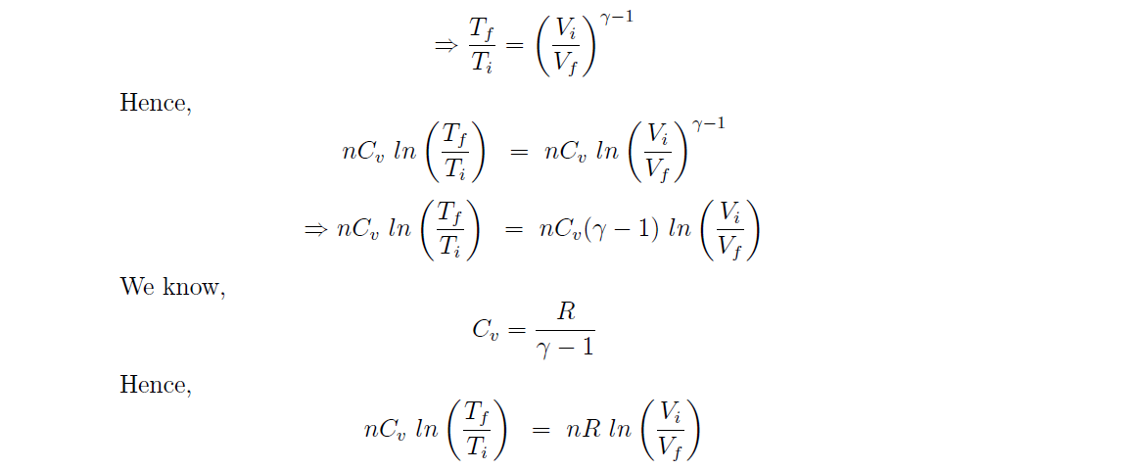

For same volume expansion we have that $nRln\left(\frac{T_{f,irrev}}{T_{i,irrev}}\right)>nRln\left(\frac{T_{f,rev}}{T_{i},rev}\right) so ∆S_{tot, irrev}>0$

