- Find the derivative of the function.
h(t) = t²(3t + 9)³

- Find the derivative of the function.
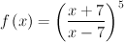

- Find the derivative of the function.
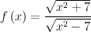

Find the derivative of the function.
- f(x) =
e^{x} + e^{−x}
------------
2
Find the derivative of the function.
- f(x) =
3 ln x
---------------
x⁴

Find dy/du, du/dx, and dy/dx when y and u are defined as follows.
y = √u u = 5x - 7x2
dy/du =

du/dx=

dy/dx=

- Find an equation of the tangent line to the graph of the function at the given point.
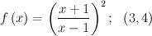
y =

- The population of Americans age 55 and older as a percentage of the total population is approximated by the function
f(t) = 10.72(0.9t + 10)^{0.3} (0 ≤ t ≤ 20)
where t is measured in years, with t = 0 corresponding to the year 2000. At what rate was the percentage of Americans age 55 and older changing at the beginning of 2006? (Round your answer to four decimal places.)
% per year =
At what rate will the percentage of Americans age 55 and older be changing in 2019? (Round your answer to four decimal places.)
% per year =
What will be the percentage of the population of Americans age 55 and older in 2019? (Round your answer to two decimal places.)
% per year =
- Use the graph of the function f to find the limits at the indicated value of a, if the limit exists.

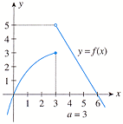

- Find the indicated one-sided limits, if they exist.
f(x) =
 | −x + 2 | if x ≤ 0
 | 3x + 4 | if x > 0

−x + 2 | if x ≤ 0
3x + 4 | if x > 0
lim x→0⁺ f(x) |  | =
lim x→0⁻ f(x) |  | =

- Determine all values of x at which the function is discontinuous.
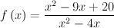
x = (smaller value)
x = (larger value)

- For what value of k will the function f be continuous on (-∞,∞)?
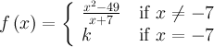

- Determine all values of x at which the function is discontinuous.
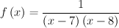
x = (smaller value)
x = (larger value)

- Determine the values of x, if any, at which the function is discontinuous. At each number where f is discontinuous, state the condition(s) for continuity that are violated. (Select all that apply.)
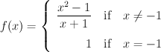
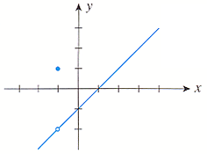
Which of these are true? Select all that apply.
The function of x is discontinuous at x = -1 (because) lim_(x -1)f(x) (exists, but this limit is not equal to)\ f(-1).

- The following graph shows the amount of home heating oil remaining in a 200-gal tank over a 120-day period (t = 0 corresponds to October 1). For which value(s) of t is the function discontinuous. (Enter your answers as a comma-separated list.)
t | =
