Background:
Performance Drinks makes four different kinds of sports drinks. Those drinks are as follows:
- Basic
- Hydration
- Intensity
- Post-Workout
You recall from your Management Accounting class that product costs are comprised of:
- Direct Materials
- Direct Labor
- Manufacturing Overhead
That report is following:
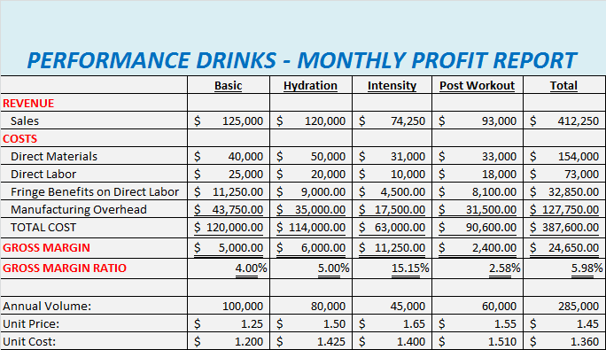
Since your primary area of focus is on the indirect costs you compile the following report which further details your overhead charges:
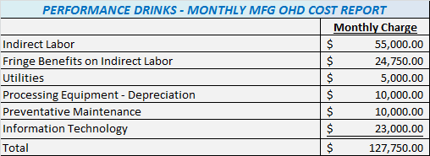
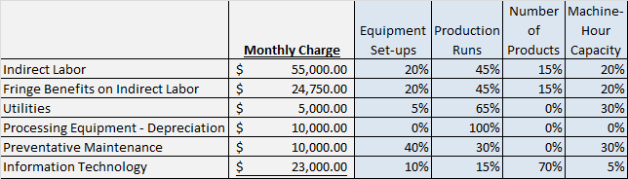
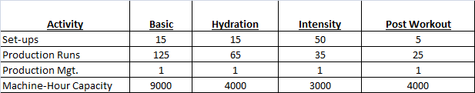

Requirements:
- Based on all of the date provided, compute the cost driver rates for each of the four activities.
- Compute the per unit product costs for each of the four products. Compute this cost using ABC allocation for overhead. Show the computation for each per unit product cost in detail.
- Prepare a “Monthly Profit Report”, like the one provided on page 4 of this packet. Create this report using the results of your ABC overhead allocation.
- Explain why the profit for each product is different when comparing the Traditional report with the ABC report. Explain what the company might consider doing, based on all of this information, to stop the erosion of company profits. Defend your recommendations with data.
Additional Consideration:
If plant capacity was shifted from 20,000 machine-hours a month to 40,000 machine-hours per month!
- Compute the new cost per unit for each of the products considering the increase in capacity. Show the computation for each per unit product cost in detail.
- What is the cost of the unused capacity if it is assumed that the company has 40,000 machine-hours of capacity but it using 20,000 machine-hours? Amend your “Management Report” to include a discussion on how to best use the additional capacity.

