Ruedi Bärlach PLC, a company located in Gümligen, Switzerland, manufactures custom-designed high-precision industrial tools. The company has a traditional job-order costing system in which direct labor and direct materials costs are assigned directly to jobs, but factory overhead is applied to jobs using a predetermined overhead rate based on direct labour-hours. Management uses this job cost data for valuing cost of goods sold and inventories for external reports. For internal decision-making, management has largely ignored this cost data since direct labor costs are basically fixed and management believes overhead costs actually have little to do with direct labour-hours. Recently, management has become interested in activity-based costing (ABC) as a way of estimating job costs and other costs for decision-making purposes.

Management assembled a cross-functional team to design a prototype ABC system. Electrical costs were among the first factory overhead costs investigated by the team. Electricity is used to provide light, to power equipment, and to heat the building in the winter. The ABC team proposed allocating electrical costs to jobs based on machine-hours since running the machines consumes significant amounts of electricity. Data assembled by the team concerning actual direct labour-hours, machine hours, and electrical costs over a recent eight-week period have been entered into the spreadsheet that appears below. (The Swiss currency is the Swiss franc, which is denoted by SFr.)
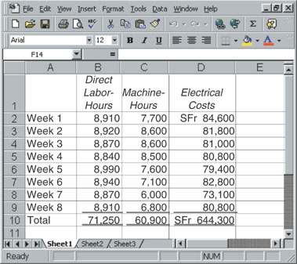
To help assess the effect of the proposed change to machine-hours as the allocation base, the above eight-week totals were converted to annual figures by multiplying them by six.
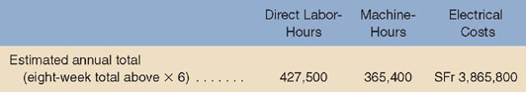
Required:
- Assume that the estimated annual totals shown above are used to compute the company's predetermined overhead rate. What would be the predetermined overhead rate for electrical costs if the allocation base is direct labour-hours? Machine-hours?
- Management intends to bid on a job for a set of custom tools for a watchmaker that would require 30 direct labor-hours and 25 machine-hours. How much electrical cost would be charged to this job using the predetermined overhead rate computed in part (1) above if the allocation base is direct labour-hours? machine-hours?
- What factors, apart from direct labour-hours and machine-hours, are likely to affect consumption of electrical power in the company?

