16–33.
Justin Kealey, CPA, is auditing Tustin Companies, Inc. Kealey has accumulated known and likely misstatements for the current year to evaluate whether there is a sufficiently low risk of material misstatement of the financial statements to issue an opinion. However, Kealey notes that there are several misstatements that have been carried over from prior years.
Required:
a. Distinguish between the iron curtain and the rollover approaches to considering the misstatements from prior years.
b. Describe how SEC Staff Accounting Bulletin No. 108 requires auditors to consider misstatements carried over from prior periods.

The following are typical questions that might appear on an internal control questionnaire for payroll activities:
1. Is there adequate separation of duties between employees who maintain human resources records and employees who approve payroll disbursements?
2. Is there adequate separation of duties between personnel who maintain timekeeping or attendance records for employees and employees who distribute payroll checks?
Required:
a. Describe the purpose of each of the above controls.
b. Describe the manner in which each of the above controls might be tested.
c. Assuming that the operating effectiveness of each of the above controls is found to be inadequate, describe how the auditors might alter their substantive procedures to compensate for the increased level of control risk.

17–24.
While performing your audit of Williams Paper Company, you discover evidence that indicates that Williams may not have the ability to continue as a going concern.
a. Discuss types of information that may indicate substantial doubt about a client’s ability to remain a going concern.
b. Explain the auditors’ obligation in such situations.

17–26.
For each of the following brief scenarios, assume that you are reporting on a client’s financial statements. Reply as to the type(s) of opinion possible for the scenario. In addition.

Unless stated otherwise, assume the matter involved is material.
If the problem does not state that a misstatement (or possible misstatement) is pervasive, assume that it may or may not be pervasive (thus, the appropriate reply may include two possible reports).
Do not read more into the circumstance than what is presented.
Do not consider an auditor discretionary circumstance for modification of the audit report unless the situation explicitly suggests that the auditors wish to emphasize a particular matter. Report Types may be used once, more than once, or not at all.

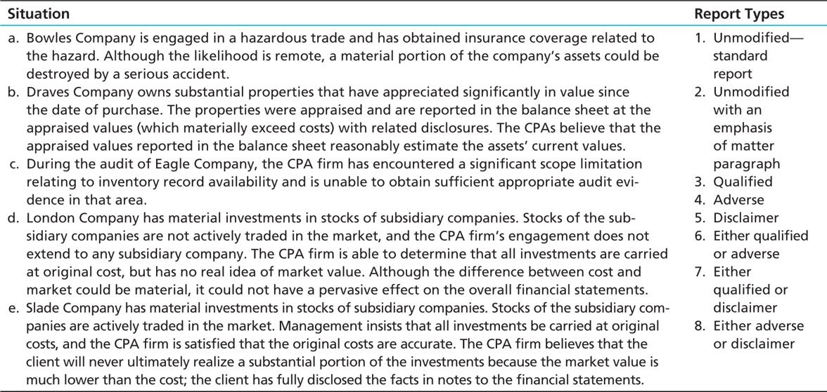

18.1
When you are first retained to audit the financial statements of Wabash Company, you inquire whether a budget is used to control costs and expenses. The controller, James Lowe, replies that he personally prepares such a budget each year, but that he regards it as a highly- confidential document. He states that you may refer to it if necessary, but he wants you to make sure that no employee of the firm sees any of the budget data.
What are your thoughts on this use of the budget?

