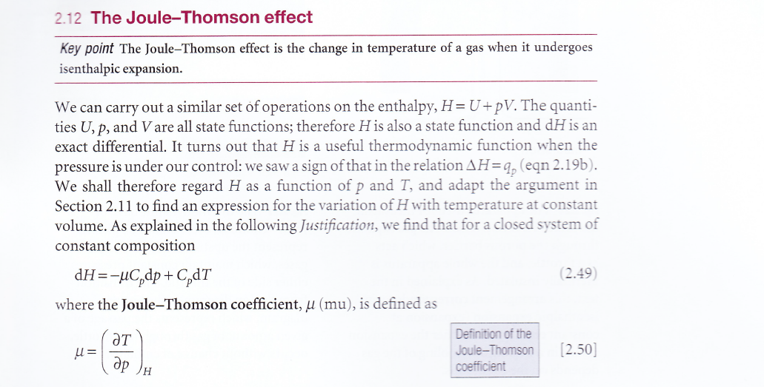
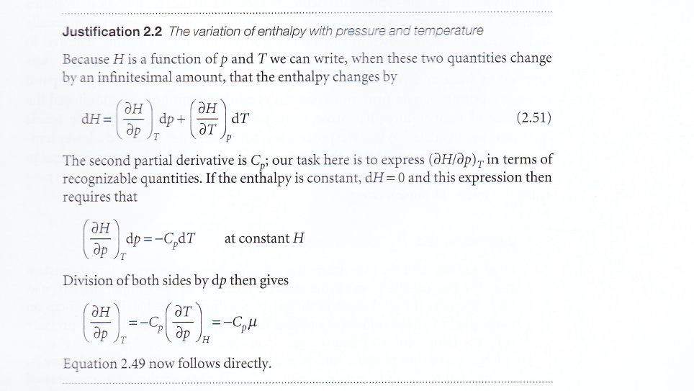
In the derivation I don’t get why they can assume that dH=0. After they have assumed that dH=0 in justification 2.2 I get that
$${\left(\frac{∂H}{∂p}\right)}_{T}dp=-{\left(\frac{∂H}{∂T}\right)}_{p}dT$$
Which I can illustrate like this
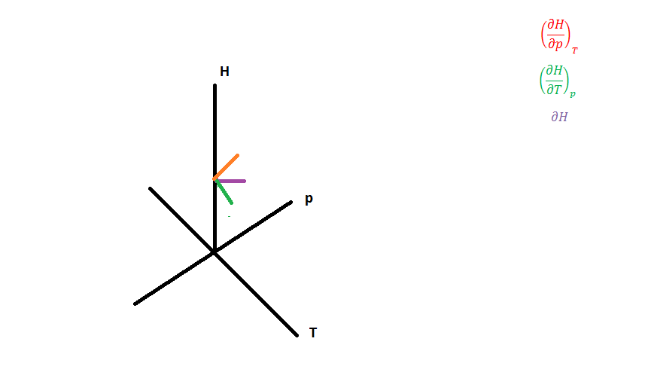
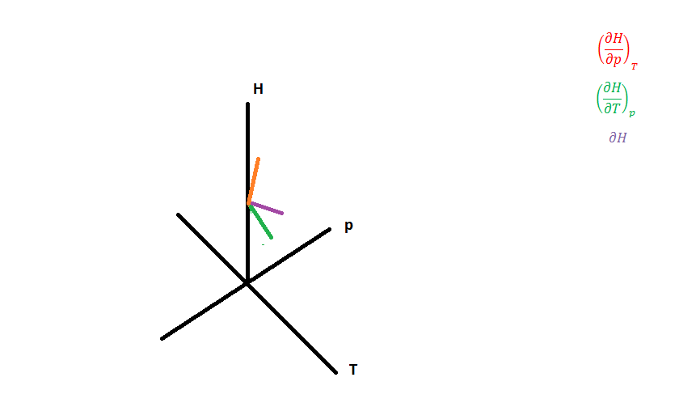
And since we are in dH=0 we must be in the p,T-plane that is since H is constant we get ${\left(\frac{∂T}{∂p}\right)}_{H}$ :
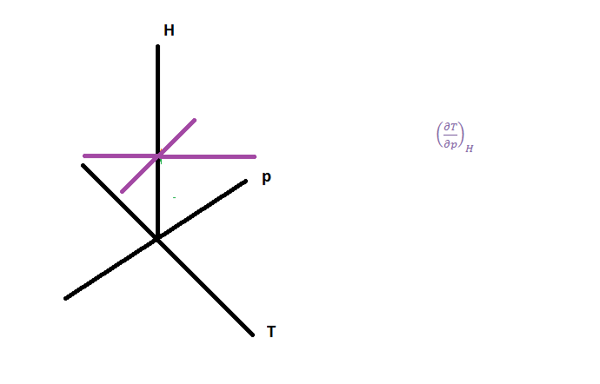
What I don’t get is why we can use
${\left(\frac{∂H}{∂p}\right)}_{T}=-{\left(\frac{∂H}{∂T}\right)}_{p}{\left(\frac{∂T}{∂p}\right)}_{H}$
For $dH≠0$
You use a condition that says that
$${\left(\frac{∂H}{∂p}\right)}_{T}dp=-{\left(\frac{∂H}{∂T}\right)}_{p}dT$$
So that dH=0. But for $dH≠0$ you can not have
$${\left(\frac{∂H}{∂p}\right)}_{T}dp=-{\left(\frac{∂H}{∂T}\right)}_{p}dT$$
For example:
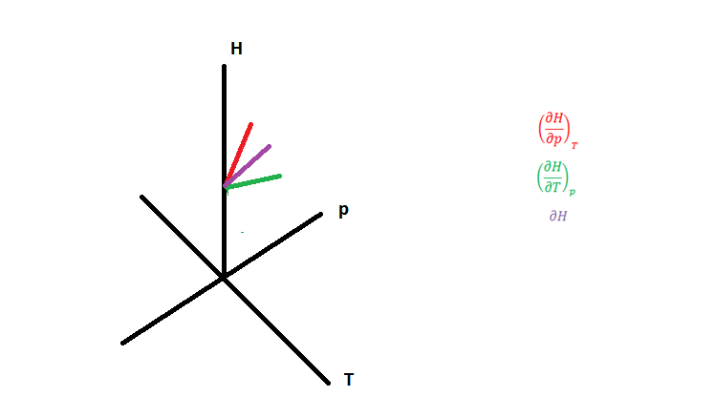
Or:
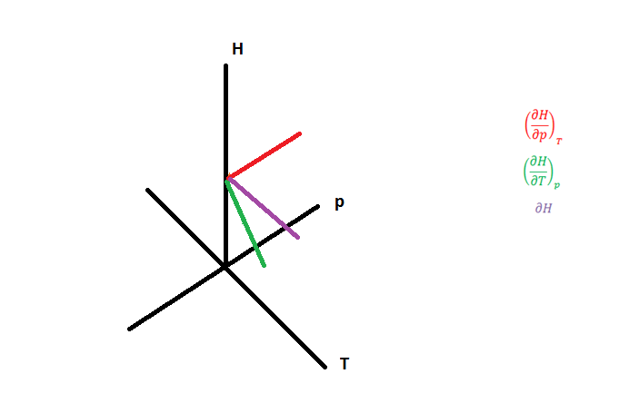
How can one use dH=0 as constrain and then afterwards use
$${\left(\frac{∂H}{∂p}\right)}_{T}=-{\left(\frac{∂H}{∂T}\right)}_{p}{\left(\frac{∂T}{∂p}\right)}_{H}$$
In
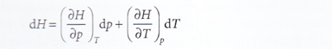
I would like an explanation of why we always must have
$${\left(\frac{∂H}{∂p}\right)}_{T}dp=-{\left(\frac{∂H}{∂T}\right)}_{p}dT$$
When clearly the second last graph I made had positive slope for
${\left(\frac{∂H}{∂p}\right)}_{T} and {\left(\frac{∂H}{∂T}\right)}_{p}$for $dH≠0?$ Hpw does this add up in the joule Thompson equation?
This is just an example for what I don’t think add up. In general I think it does not add to demand
$${\left(\frac{∂H}{∂p}\right)}_{T}dp=-{\left(\frac{∂H}{∂T}\right)}_{p}dT$$

Can you explain how this works by illustrating in a graph? And in general just provide an explanation in addition as well?

