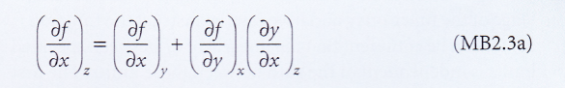
This is my interpetration of (MB2.3a)
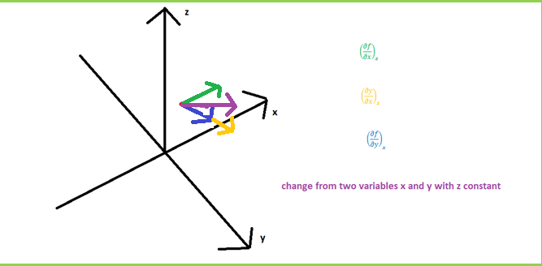
My main thought was that since they write ${\left(\frac{∂f}{∂x}\right)}_{z}$ the change in z direction must be 0 and from this graphical representation it did add up.
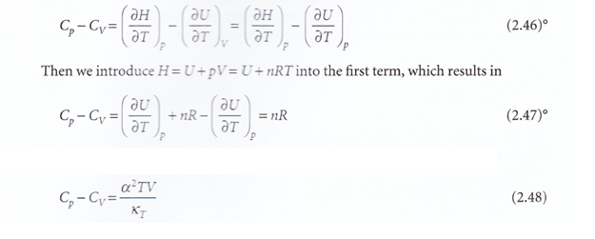
In (2.46) why do they have ${\left(\frac{∂U}{∂T}\right)}_{p}={\left(\frac{∂U}{∂T}\right)}_{V}$?
Where:
How can we have an expression with derivative with constant T and p in the same fraction? If T is not constant will still $κ_{T}$ still change? If not will (2.48) not be defined for constant T? I would like to show the changes for (2.48) in a 3d graph? Can you do that and explain where the fact that we have derivation with constant p in [2.42] and constant T in [2.43] and how they are shown in the 3d graph by arrows for them respectively? That is show how they coexist in the same way as I did in my interpetration of (MB2.3A)?
And I also have another question about partial derivatives:
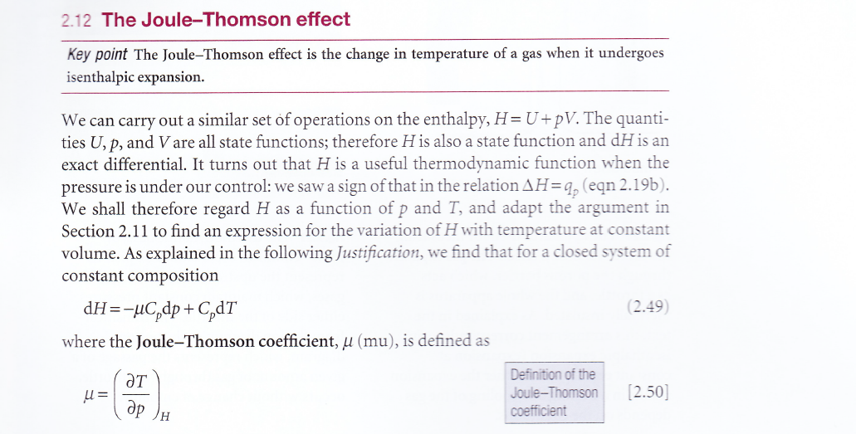
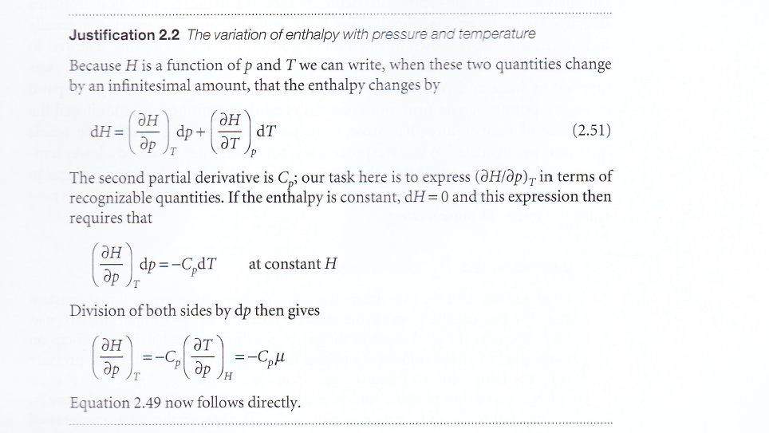
Why can we assume that dH is constant in justification 2.2 when we are looking at enthalpy change that is a rewriting of (2.51):
$$dH=nC_{p}dT C_{p}=\frac{dH}{ndT} dH=\frac{dH}{ndp}dp+\frac{dH}{ndT}dT$$
$$dH=\frac{dH}{ndp}dp+C_{p}dT=-C_{p}μdp+C_{p}dT$$
?
Why this this also hold when enthalpy is changing like we are interested in in (2.49)?

