Organic Chemistry Part III
- Consider the alkane shown in the model.
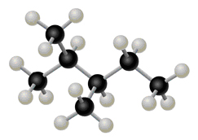
- What is the molecular formula for the alkane shown in the model? Express your answer as a chemical formula.
- Name the alkane shown in the model. Express your answer as the IUPAC name.
- Draw the structure of the cycloalkane 1,4-dimethylcyclohexane.

- Name each alkane.
CH 3 − C | C H 3 H−CH 3 Spell out the full name of the compound.
CH 3 − C | C H 3 H−CH 2 − C | C H 3 H−CH 2 −CH 3 Spell out the full name of the compound.
CH 3 − C | C | C H 3 − H 3 C | C | C H 2 −CH 3 −CH 2 −CH 3 H 3 Spell out the full name of the compound.
CH 3 − C | C | C H 3 H 2 H−CH 2 − C | C H− H 3 C | C | C H 3 H 2 H−CH 2 −CH 2 −CH 3 Spell out the full name of the compound.

