Electrochemistry Part V
- What is the correct name for the compound depicted in the skeletal structure below?
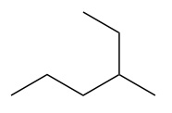
- Which of the following is a structural isomer of 3-ethylheptane? Choose from:
2-methylbutane
cyclohexane
3,4-dimethylpentane
3-ethylnonane
4-methyloctane

- How many of the carbons in the molecule depicted below are chiral?
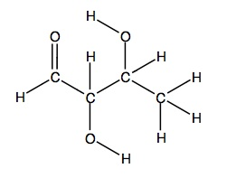
- What is the cell potential for the reactionMg(s)+Fe 2+ (aq)→Mg 2+ (aq)+Fe(s) at 67 ∘ C when [Fe 2+ ]= 3.80M and [Mg 2+ ]= 0.310M.Express your answer to three significant figures and include the appropriate units.

- Calculate the standard free-energy change at 25 ∘ C for the following reaction: Mg(s)+Fe 2+ (aq)→Mg 2+ (aq)+Fe(s) Express your answer to three significant figures and include the appropriate units.

