1, 3, 5 and 7
- construct a Gantt chart for the following set of activities and indicate the project completion time:
activity activity predecessor time(weeks)
1 5
2 4
3 1 3
4 2 6

3. Construct a Gantt chart and project network for the following set of activities, compute the length of each path in the network, and indicate the critical path:

Activity Activity Predecessor Time (months)
1 ___ 4
2 ___ 7
3 1 8
4 1 3
5 2 9
6 3 5
7 3 2
8 4,5,6 6
9 2 5

5. Just number 5. 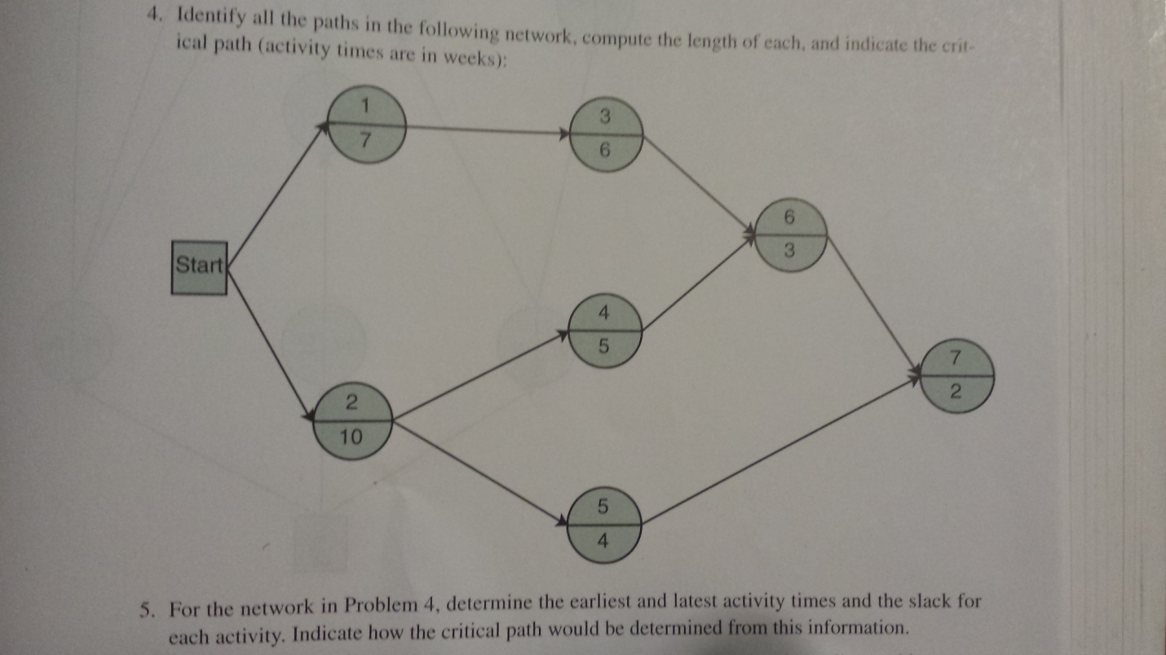

7. Given the following network with activity times in weeks, determine the earliest start and finish times, latest start and finish times, and slack for each activity. Indicate the critical path and the projectduration.

