This question is taken from:
http://en.wikipedia.org/wiki/Maxwell–Boltzmann_statistics
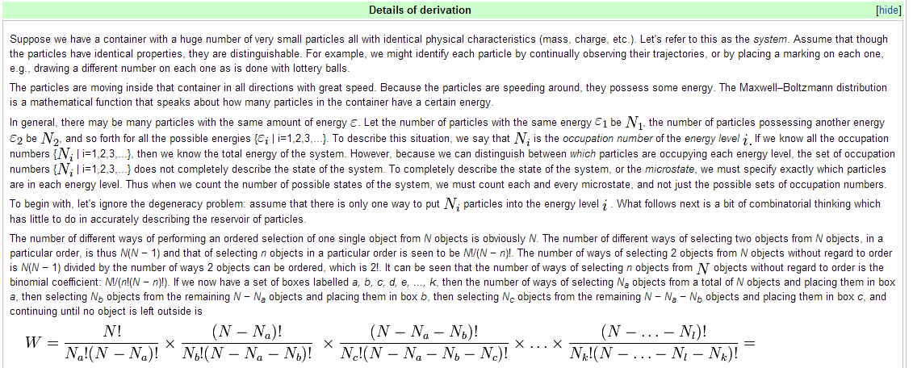
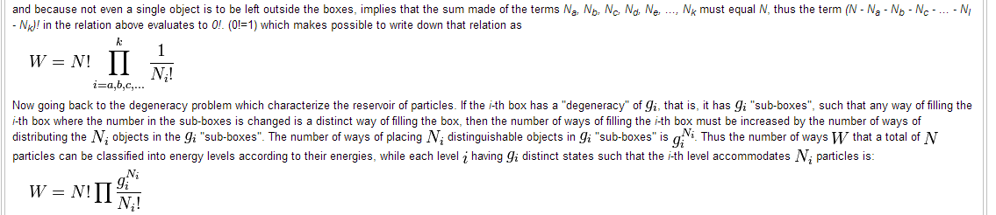
Question:
I don’t get why they first define
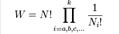
Where they say:

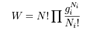
Then they say:
I don’t get the difference between the same energy defined by $ε_{i}$ and degeneracy. From a definition I found of degeneracy it seems it also is ad efintion of energy level. Why do they define the energy level twice?:
