1. The approach for collecting requirements for the project described in the Running Case is the formation of a requirements traceability matrix. This includes the following:
Requirement | Details
Budget | Working capital, Long term capital
Labor requirements | At different levels
Time and schedule | Work breakdown structure
Scope of the project | Strategic objective
Material | Material requirements

2.

Scope Statement

Project Title: Running case
Date: Prepared by:
Project Justification:
Required to implement the Recreation and Wellness Intranet Project

Product Characteristics and Requirements:
- Technology based
- Capital intensive
- Long term and strategic benefits
- Short deadlines

Summary of Project Deliverables
Project management-related deliverables: business case, charter, team contract, scope statement, WBS, schedule, cost baseline, status reports, final project presentation, final project report, lessons-learned report, and any other documents required to manage the project.
Product-related deliverables: research reports, design documents, software code, hardware, etc.
- Project plan and scope statement
- Design of the software
- WBS and schedule
- Budget and cost baseline

Project Success Criteria:
1. Completion on time and within budget
2. Improved intranet facilities in Recreation and Wellness Intranet Projects

3.
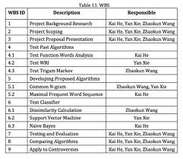
4.
