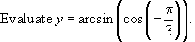

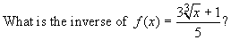

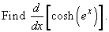

Below are the graphs of four functions. Which function is invertible?

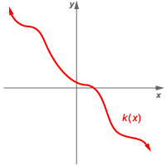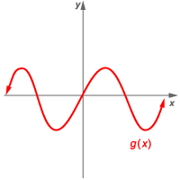

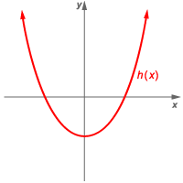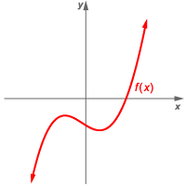

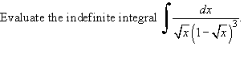

Set up the integral for the length of the smooth arc y = e x on [0, 10].

What is the area of the triangle bounded by the lines x = 1, y = x − 1, and y = 3 − x ?

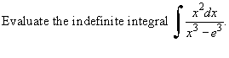

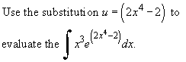

Suppose that a bicyclist is biking with a velocity function of v (t) = 2t − 1 ft / min. Starting at t = 0, how long does it take the bicyclist to go 30 ft?

What does sech (0) equal?

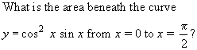

What is the area between the curve g (x) = 3x ² + 2 and the x-axis from x = −2 to x = 0?

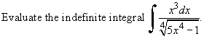

You are throwing paper airplanes in class, and you throw them hard enough they start out at a horizontal speed of 10 ft / s. However, they have a horizontal deceleration of 4 ft / s. What is the greatest distance away from the intial position that an object can be if it can be struck by the airplane?

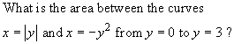

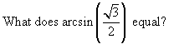

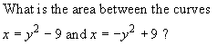

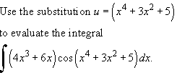

What is the area of the region bounded by the curves y = x ³ − x and y = 7x − x ³?

