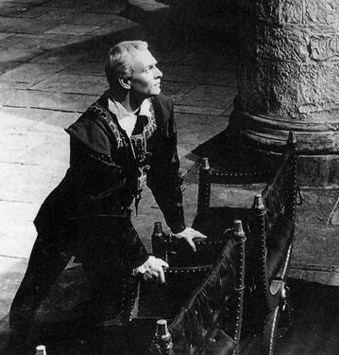
LIT1000 Introduction to Literature
Unit Test—Drama—Hamlet
Answer 5 among 7 questions below:
For questions 1-7answer the questions in complete, well-developed short essays. Support your answers with evidence from the play, both text and film. Include reference to Act, scene, and line numbers as follows-- (I, iv, 14-18). This would be a reference to Act I, scene 4, lines 14-18.

Answers must be prepared on a word processor and double-spaced according to standard MLA formatting guidelines.

1. Every tragic hero has a fatal flaw, some component of his character that causes his own downfall. What is Hamlet’s fatal flaw, and how does it contribute to his ultimate demise?

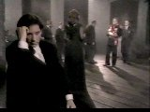
2. Discuss Gertrude. Was she involved with Claudius before Old Hamlet’s death? Was she a part of the murder plot? Is it wrong that she has married Claudius? Does she betray Hamlet at any time? Does she believe Hamlet when he tells her that Claudius has killed Old Hamlet? Does she betray Denmark?

3. When his father’s ghost informs Hamlet that he is the victim of murder, Hamlet pledges immediate revenge upon Claudius. Yet his revenge is anything but speedy; why does Hamlet wait so long to avenge the murder?
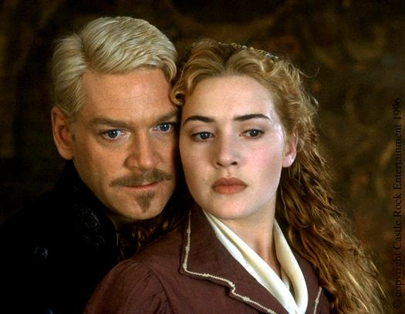

4. Does Hamlet love Ophelia? Did he ever love Ophelia? Is he simply toying with her, as Laertes suggests? Why does he become so angry with her in Act III,
Scene i? Why does Ophelia go mad?
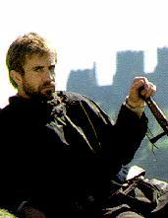
5. Think about Hamlet and Ophelia’s relationship, and move them into the 21st century. What would they do on their first date? Where would they go? What sort of transportation would they use? What would each wear? What would the date be like as far as mood and tone? Be creative, and support your answer with reference to the text.

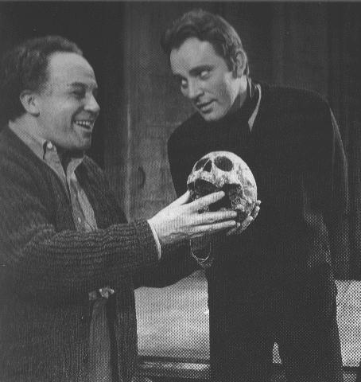

6. Placing them in today’s world, think about Gertrude and Hamlet. What would Hamlet and Gertrude buy each other for Christmas presents? What would they buy each other for Valentine’s Day presents? Why? Be sure to support your answers with reference to the text.

7. Hamlet is a student. Place him in today’s world. Where would Hamlet go to school? What would his major be? Would he be a good student? What sort of extra-curricular activities would he be involved in? Would you want to work with him in a peer group?

