For each of the SLP assignments, you will be provided with a hypothetical experimental scenario or data. These assignments are more opened-ended than the case assignments. You will speculate about possible explanations and the ways they might be tested, but be sure to that your hypotheses are grounded in accepted biological science. In doing this, you will mimic the action of scientists who are continuously collecting new data, formulating hypotheses, and testing their ideas.
In this SLP you are tasked with analyzing the transmission of a genetic disease through several generations. Males are indicated by square, females by circles. Individuals with the disease are colored solid black. Speculate on the genetic basis by which this disease is inherited. If any known carriers (those carrying the gene, but not manifesting symptoms of the disease) can be identified, list the individuals.
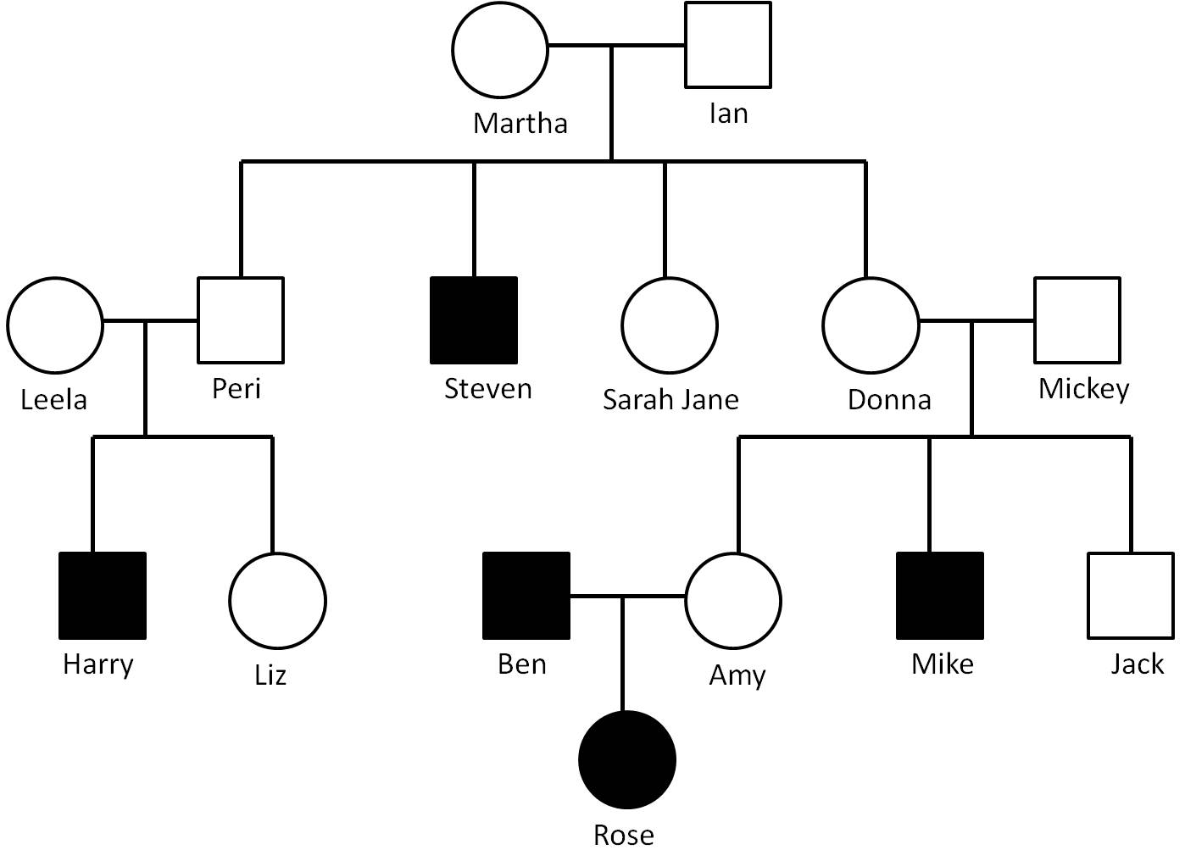

Assignment Expectations:
For this SLP, use your understanding of the principles of heredity and the provided information. Analyze the trait’s presence in the various individual and speculate on the underlying molecular basis.
Write a short paper approximately 1-2 pages in length.

