Question 1
Psychologists often hear statements such as, "My child is in the 75th percentile in reading," or "The child has an IQ one standard deviation below the mean." Using Figure 3-6 below, describe to a novice the meaning of these statements, comparing them to other terms used when describing scores within a normal distribution.
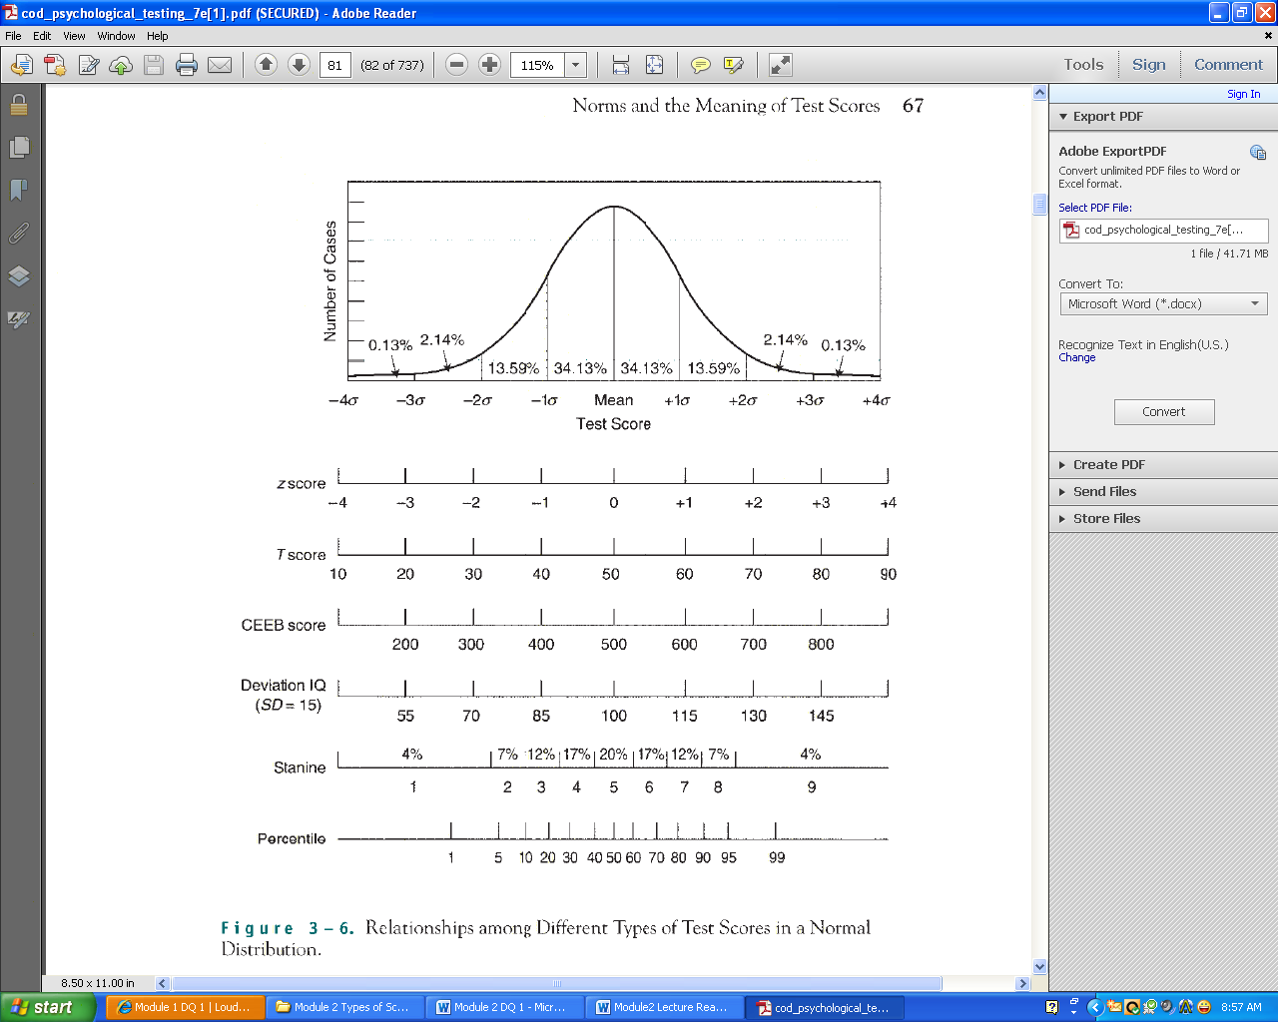
Anastasi, A., & Urbina, S. (1997). Psychological testing (7th ed.). pg. 48-83. Upper Saddle River, NJ: Prentice Hall. [250 Word Count excluding In text and References.]
Question 2
What is the greatest drawback of percentile scores? Why? How can this be overcome most effectively?
[250 word count Max. In text, citation required. Two scholarly references should be included in addition to Anastasi, A., & Urbina, S. (1997). Psychological testing (7th ed.). Upper Saddle River, NJ: Prentice Hall. Write in 3rd person scholarly writing. No quotes please.] This is a personally developed question not an assignment or home work.

