- In surveys, what special problems do open-ended questions have? How can these be minimized? In what situations are open-ended questions most useful?
- Independent random samples selected from two normal populations produced the following sample means and standard deviations.

Sample 1 Sample 2
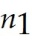 = 14 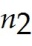 = 11
1 = 7.1 2 = 8.4
s1 = 2.3 s2 = 2.9

Conduct the test 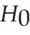: (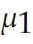 - 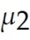) = 0 against. 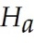: ( - ) ≠ 0, Use α = .05.

3) A multinomial experiment with k = 4 cells and n = 300 produced the data shown in the following table.

Cell
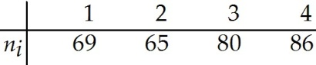

Do these data provide sufficient evidence to contradict the null hypothesis that Test using α = .05

