For each of the SLP assignments, you will be provided with a hypothetical experimental scenario or data. These assignments are more opened-ended than the case assignments. You will speculate about possible explanations and the ways they might be tested, but be sure to that your hypotheses are grounded in accepted biological science. In doing this, you will mimic the action of scientists who are continuously collecting new data, formulating hypotheses, and testing their ideas.
A biologist is studying the behavior of a newly discovered enzyme. The optimum physical conditions for the enzyme’s function are unknown. Likewise, nothing is known about the enzyme’s potential substrates or inhibitors. Several experiments have been performed so far. Examine the graphs and present your conclusions about the behavior of this enzyme. Speculate on optimum conditions, substrates, coenzymes, inhibitors, etc. Use these data and your knowledge of enzymes to be as thorough as possible, but do not draw any conclusions that cannot be supported by the data.
Experiment One: Data were collected at several different temperatures. Enzyme was mixed with compounds A, B, and C. The concentration of the enzyme’s product (P) was recorded after 5 minutes at each temperature.
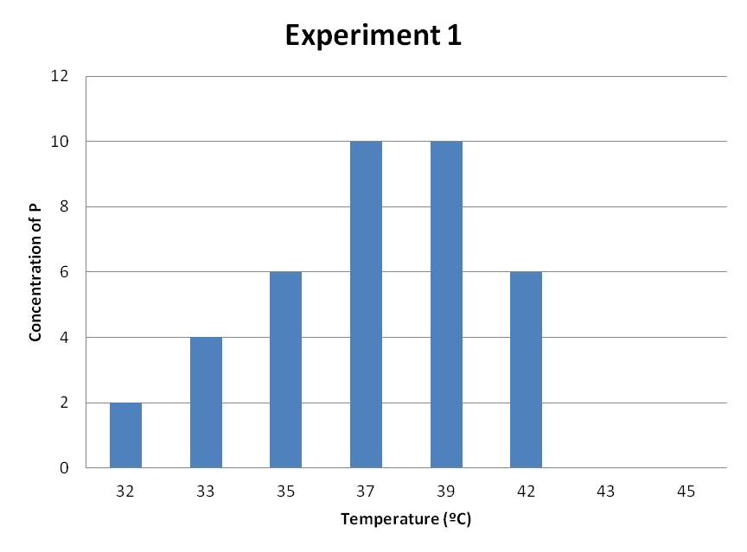
Experiment Two: Data were collected at several different values of pH. Enzyme was mixed with compounds A, B, and C. The concentration of the enzyme’s product (P) was recorded after 5 minutes at each pH.
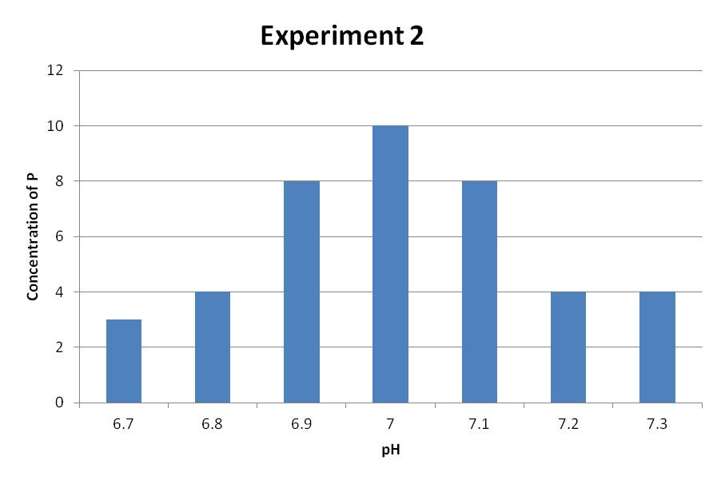
Experiment Three: Enzyme was mixed with compounds A and C. The concentration of each compound was monitored over time.
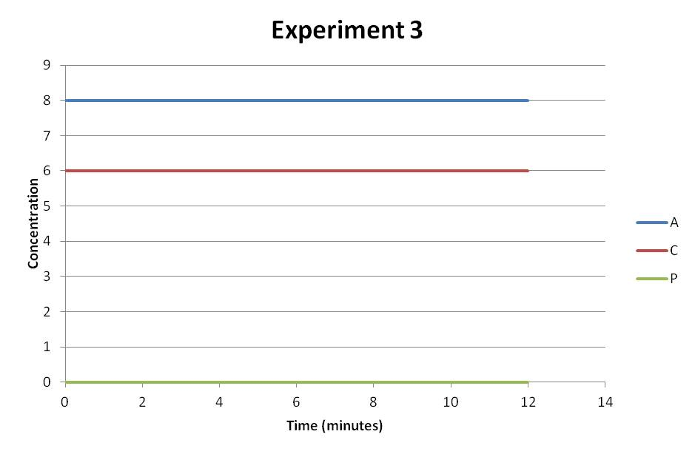
Experiment Four: Enzyme was mixed with compounds A and B. The concentration of each compound was monitored over time.
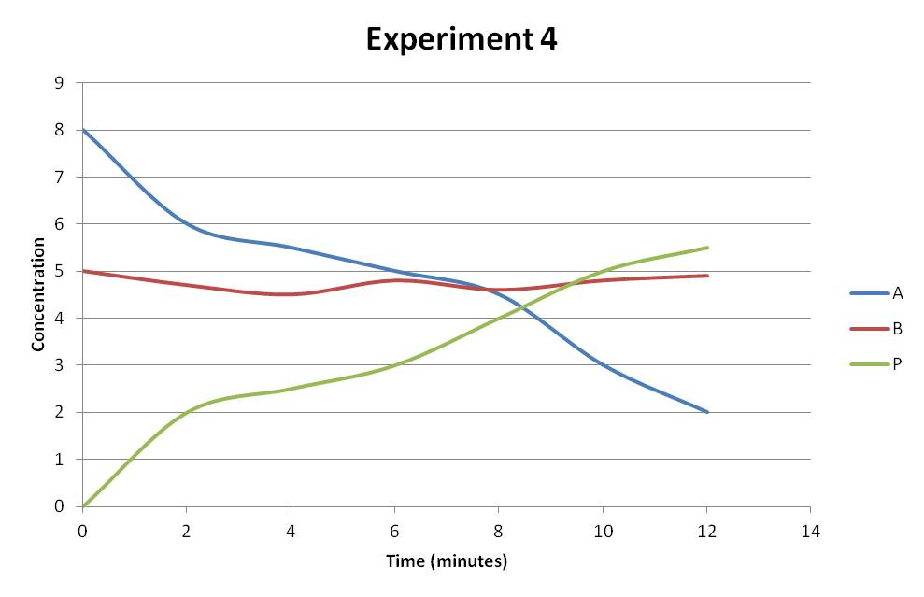
Experiment Five: Enzyme was mixed with compounds A, B, C, and D. The concentration of each compound was monitored over time.
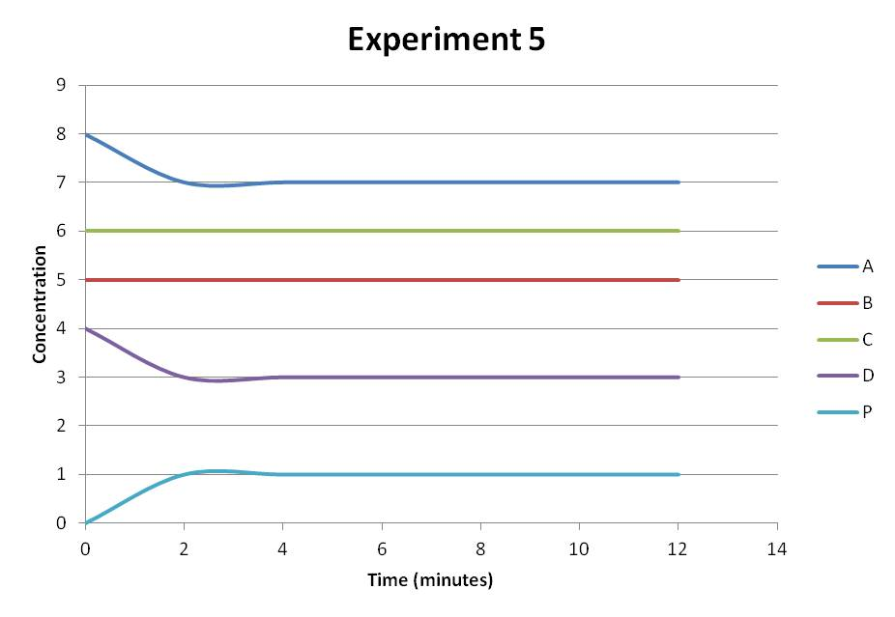
Assignment Expectations:
For this SLP, use your understanding of enzymes along with your scientific reasoning skills. This assignment provides you the opportunity to demonstrate your grasp of this module’s concepts along with your capacity to interpret scientific data and draw conclusions from it.
Write a short paper approximately 1-2 pages in length.

